**Objective**

Write a C++ program for helping fruit businesses track sales, orders, and stock levels.

**Pseudocode**

# **void loadingbar()**

Using appropriate data types to declare and set i = 1, x = 219, and y = 177;

Output header “LOADING”and design using ASCII character;

FOR i = 1 to 80

Output a horizontal bar using y characters, 80 times;

Output a carriage return character to return to the beginning of the line;

FOR i = 1 to 80

Set the console text colour to pink;

Output an x character to simulate loading;

Wait for 30 milliseconds using the Sleep() function;

# **bool itemExists(const fruitItem& newItem, const fruitItem inventory[], int numItems)**

FOR i = 0 to numItems - 1

Compare the name of the newItem to the name of the inventory[i] using the strcmp() function;

IF they are equal THEN

Return true;

Return false, as the newItem was not found in the inventory;

# **int getIntegerInput()**

WHILE true

Read the input from the user;

IF the input is not a valid integer using cin.fail() to check, THEN

Clear the error flags using cin.clear();

Ignore any invalid input using cin.ignore();

Output an error message asking the user to enter an integer;

ELSE

Ignore any extra characters using cin.ignore() when input was successful;

Return the valid input value as an integer;

# **double getDoubleInput()**

WHILE true

Read input from user;

IF the input is not a valid double using cin.fail() to check, THEN

Clear the error flags using cin.clear();

Ignore any invalid input using cin.ignore();

Output an error message asking the user to enter a double;

ELSE

Ignore any extra characters using cin.ignore() when input was successful;

Return the valid input value as a double;

# **void updateFile(fruitItem inventory[], int& numItems)**

Update the fruitFile with name, price and quantity of the current fruit item if the file is successfully opened, else just display error message.

# **void currentInventoryHeader()**

Output the ASCII art for the header “CURRENT INVENTORY”in pink text colour;

# **void addNewItem(fruitItem inventory[], int& numItems)**

Call currentInventoryHeader function and currentInventory (inventory, numItems) function;

Output the header “ADDING ITEM” in yellow text colour;

Create a new fruitItem variable named newItem;

DO

Ask the user politely to input the newItem.name;

FOR i=0 to the length name of newItem

Convert the input of name to uppercase using toupper() function;

IF newItem.name exists according to the itemExists() function to check, THEN

Output error message;

WHILE item exists according to the itemExists() function to check

DO

Ask the user politely to input the newItem.price according to getDoubleInput() function,

Check valid Input;

WHILE (newItem.price <= 0)

DO

Ask the user politely to input the newItem.quantity according to getDoubleInput() function,

Check valid Input;

WHILE (newItem. quantity <= 10)

Set itemIndex to -1;

Create fruitItem tempItem = inventory[itemIndex];

DO

Ask the user politely to input confirmation;

IF confirmation is ‘N’ using toupper() function, THEN

Output fruit item is canceled;

Set inventory[itemIndex] to tempItem;

ELSE IF confirmation is ‘Y’ using toupper() function, THEN

IF numItems is less than MAX_ITEMS, THEN

Set inventory[numItems] to newItem;

Increment numItems;

Output new fruit item is successfully added to inventory;

Then, update the logFile with name, price and quantity of the current fruit item that has added   
 if the file is successfully opened, else just display error message.

ELSE

Output error message that the maximum capacity of inventory has reached. Cannot add more   
 item;

Then, update the fruitFile with name, price and quantity of the new fruit item if the file is   
 successfully opened, else just display error message.

ELSE

Output invalid input, ask the user to input again;

WHILE (toupper(confirmation) = 'Y' and toupper(confirmation) = 'N')

# **void deleteItem(fruitItem inventory[], int& numItems)**

Call currentInventoryHeader function and currentInventory (inventory, numItems) function;

Output the header “DELETING ITEM” in yellow text colour;

Set itemIndex to -1;

WHILE itemIndex=-1

Ask user politely to input the number of fruit item they want to delete;

itemIndex=getIntegerInput()-1;

IF itemIndex less than 0 OR itemIndex larger than or equal numItems, THEN

Output invalid input and ask user to input again the itemIndex;

Set itemIndex to -1;

DO

Ask the user to input the confirm for deleting the item;

IF confirm is ‘Y’ using toupper(0 function, THEN

FOR i = itemIndex to numItems – 1, inventory[i] = inventory[i + 1];

Decrement numItems;

Output fruit item deleted;

Call updateFile(inventory, numItems);

Then, update the logFile with name, price and quantity of the current fruit item that has   
 deleted if the file is successfully opened, else just display error message.

ELSE IF confirm is ‘Y’ using toupper(0 function, THEN

Output fruit item deleted cancel;

Call updateFile(inventory, numItems);

ELSE

Output invalid input and ask the user to input again the confirm;

WHILE (confirm != "Y" AND confirm != "N")

# **void changeItem(fruitItem inventory[], int& numItems)**

Call currentInventoryHeader function and currentInventory (inventory, numItems) function;

Output the header “CHANGING ITEM” in yellow text colour;

Declare itemIndex as an integer type and set it to -1;

WHILE itemIndex is -1

Ask user politely to input the itemIndex of fruit item they want to change;

itemIndex = getIntegerInput() - 1;

IF itemIndex less than 0 OR itemIndex larger than or equal to numItems

Output error message and ask user politely to input again the itemIndex of fruit item;

Set itemIndex to -1;

Set fruitItem tempItem = inventory[itemIndex];

Initialize a character array 'newName' of size 50 and a boolean variable 'nameExists'

DO

Ask user politely to enter the new name of the changed item and convert it to uppercase, store it   
 newName; Set nameExists to false;

Traverse the inventory array using a for loop and check if any item with the same name exists in  
 the inventory; If an item with the same name exists, set 'nameExists' to true and break out of the   
 loop; print an error message and continue the loop until a unique name is entered;

WHILE (nameExists)

Copy the new name to the name field of the item at the given index in the inventory array using strcpy_s.

DO

Ask the user politely to input the inventory[itemIndex].price according to getDoubleInput()   
 function,

IF inventory[itemIndex].price less than or equal to 0, THEN

Output Invalid input. Please enter a value greater than 0.

WHILE (inventory[itemIndex].price <= 0)

DO

Ask the user politely to input the inventory[itemIndex].quantity according to getDoubleInput()   
 function,

IF inventory[itemIndex].quantity less than or equal to 10, THEN

Output Invalid input. Please enter a value greater than 10.

WHILE (inventory[itemIndex].quantity <= 10)

DO

Ask user politely to input the confirmation;

IF confirmation is ‘Y’ using toupper() function, THEN

Output item updated successfully;

Call updateFile(inventory, numItems);

Then, update the logFile with name, price and quantity of the current fruit item that has   
 changed if the file is successfully opened, else just display error message.

ELSE IF confirmation is ‘N’ using toupper() function, THEN

Output item change canceled;

Set inventory[itemIndex] to tempItem;

ELSE

Output error message and ask user politely to input again their confirm;

WHILE toupper(confirmation) != 'Y' AND toupper(confirmation) != 'N'

# **void viewLog()**

Open inventory_log text file as logFile for reading;

IF logFile is open, THEN Declare line as string

WHILE there are lines in logFile

Output line;

ELSE Output error message about not able to open the file to read;

# **void historyheader()**

Output the header of “History of Actions” using ASCII art in green text colour;

# **void viewModule()**

Open inputFile using fruitFile for reading;

Create an array of fruitItem structs with size MAX_ITEMS;

Declare numItems as an integer type and set it to 0;

FOR i=0 to MAX_ITEMS

Set the name, price, and quantity fields of each element in the array to default values;

Read name, price and quantity from inputFile if it is successfully opened and closed; otherwise, display error message if unable to open to read.

Call loadingBar() function;

ELSE

Output error message about unable to open the inventory file to read;

Output header “View Module” using ASCII art in cyan text colour ,set back to default;

Declare choice as an integer type and set it to -1;

WHILE choice is not equal to 0

Display a menu to the user and prompt them to choose an option according to getIntegerInput() function;

IF choice equal to 1, THEN Call currentInventoryHeader function and currentInventory (inventory, numItems) function to see current inventory;

ELSE IF choice equal to 2, THEN Call viewLog() to view history of actions;

ELSE IF choice equal to 0. THEN Exit the view module, exit the while loop and go back to menu;

ELSE Output and error messasge and ask user politely to input again the option;

# **void stockHeader()**

Output the header of “STOCK” using ASCII character of 219;

# **int stock(int x)**

Open inputFile using fruitFile for reading;

Create an array of fruitItem structs with size MAX_ITEMS;

Declare numItems as an integer type and set it to 0;

FOR i=0 To MAX_ITEMS

Set the name, price, and quantity fields of each element in the array to default values;

Read name, price and quantity from inputFile if it is successfully opened and closed; otherwise,   
 display error message if unable to open to read.

Increment numItems;

Call loadingBar() function;

Output message “Inventory Loaded From File”;

ELSE

Output error message unable to open the inventory file;

Declare choice as an integer type and set it to -1;

WHILE choice is not equal to 0

Call stockHeader() function;

Display a menu to the user and prompt them to choose an option according to getIntegerInput() function;

IF choice equal to 1, THEN Call addNewItem(inventory, numItems);

ELSE IF choice equal to 2, THEN Call deleteItem(inventory, numItems);

ELSE IF choice equal to 3, THEN Call changeItem(inventory, numItems);

ELSE IF choice equal to 4, THEN Call viewModule();

ELSE IF choice equal to 0, THEN Exit the stock menu, exit the while loop and go back to menu;

ELSE Output and error messasge and ask user politely to input again the option;

return x;

Then, update the fruitFile with the name, price and quantity of the current fruit item that has if the file is successfully opened and closed, else just display an error message.

**Void ch1()**

Open input file “inGoods” and declare input as Ifstream object

Declare cost_inventory as array of costItem struct type with MAX_ITEMS size;

Declare numItems as integer type and initialize it to 0;

For int i from 0 to less than MAX_ITEMS; i++

Initialize cost_inventory[i].name[0] to an empty string;

Initialize cost_inventory[i].cost and cost_inventory[i].stock to 0;

IF the input file stream is open

While numItems is less than MAX_ITEMS and peek of inputFile is not end of file

Read name,cost,stock from the input file;

Postfix increment of numItems by 1;

Close input file;

Call warning_bar();

Output "Inventory Loaded From File."

ELSE

Output "Error: Could not open inventory file!"

Output "Detect inventory change!";

Output "Please update bought inventory accordingly!";

Call addNewCostItem function with cost_inventory and numItems as arguments

Output "Please enter any key to exit ";

**Void ch2()**

Open input file “inGoods” and declare input as ifstream object;

Declare cost_inventory as array of costItem struct type with MAX_ITEMS size;

Declare numItems as integer type and initialize it to 0;

For int i from 0 to less than MAX_ITEMS;i++

Initialize cost_inventory[i].name[0] to an empty string;

Initialize cost_inventory[i].cost and cost_inventory[i].stock to 0;

IF the input file stream is open

While numItems is less than MAX_ITEMS and peek of inputFile is not end of file

Read name,cost,stock from the input file;

Postfix increment of numItems by 1;

Close input file;

Call warning_bar();

Output "Inventory Loaded From File."

ELSE

Output "Error: Could not open inventory file!"

Output detects inventory change and update message to user;

Call deleteCostItem function with cost_inventory and numItems as arguments

Output "Please enter any key to exit ";

**Void ch3()**

Open input file “inGoods” and declare input as ifstream object

Declare cost_inventory as array of costItem struct type with MAX_ITEMS size;

Declare numItems as integer type and initialize it to 0;

For I from 0 to MAX_ITEMS;i++

Initialize cost_inventory[i].name[0] to an empty string;

Initialize cost_inventory[i].cost and cost_inventory[i].stock to 0;

IF the input file stream is open

While numItems is less than MAX_ITEMS and peek of inputFile is not end of file

Read name,cost,stock from the input file;

Postfix increment of numItems by 1;

Close input file;

Call warning_bar();

Output "Inventory Loaded From File."

ELSE

Output "Error: Could not open inventory file!"

Output detects inventory change and update message to user;

Call changeCostItem function with cost_inventory and numItems as arguments

Output "Please enter any key to exit ";

**Double cost_goods()**

Open input file “inGoods” and declare input as Ifstream object

Declare cost_inventory as array of costItem struct type with MAX_ITEMS size;

Declare numItems as integer type and initialize it to 0;

For I from 0 to MAX_ITEMS;i++

Initialize cost_inventory[i].name[0] to an empty string;

Initialize cost_inventory[i].cost and cost_inventory[i].stock to 0;

IF the input file stream is open

While numItems is less than MAX_ITEMS and peek of inputFile is not end of file

Read name,cost,stock from the input file;

Postfix increment of numItems by 1;

Close inputFile;

ELSE

Output “Error”

Call GoodsItems function with cost_inventory and numItems as arguments

For i from 0 to 80:i++

Set cost_of_goods to cost_inventory[i].cost multiplied by cost_inventory[i].stock

Set total_cost to total_cost add cost_of_goods;

Output "Total cost of goods : RM " concatenated with total_cost;

Return total_cost;

**void GoodsItems(costItem inventory[], int& numItems)**

Output "No. ", "Type of fruit", "Cost of Goods", and "Number of stocks per kg" ;

For i from 0 to numItems;i++

Output inventory[i].name, inventory[i].cost and inventory[i].stock

**void financial_report()**

CREATE and open report file named "Financial Report.txt" for write;

Set revenue to total_revenue() and set cost_of_goods to cost_goods();

Set gross_profit to revenue subtract cost_of_goods and set software_maintenance to 200.00;

Set no_worker to 1 and set salaries to 1500.00 multiply no_worker;

Set total_expenses to software_maintenance add salaries

Set earnings_bf_tax to gross_profit subtract total_expenses

Set net_earnings to earning_br_tax subtract tax;

IF earnings_bf_tax lessthan or equal to 5000

Set tax to 0;

ELSE IF earnings_bf_tax more than 5000 AND less than 20000:

Set earn_being_taxed to earnings_bf_tax subtract 5000;

Set tax to (1.0 / 100) multiply earn_being_taxed;

Record income statement into file;

Call income_statement();

Output "The business is currently experiencing profit or loss: "

IF net_earnings more than 0:

Output "profit";

ELSE:

Output "loss";

CLOSE report file

**void income_statement()**

Output "Income Statement" ,"Revenue: ", revenue , "Cost of Goods Sold (COGS): ", cost_of_goods", Gross Profit: ", gross_profit"Expenses: ", " Software maintenance: ", software_maintenance, " Salaries: ", salaries, "Total Expenses: ", total_expenses , "Earnings before tax: ", earnings_bf_tax,"Tax: " , tax ,"Net Earnings: " , net_earnings with proper spacing ;

**void payment_options()**

Output "Payment Options: " ,"1. Online Banking" ,"2. Credit Card" , "3. Debit Card" ;

**void getPaymentOpt(string& payMethod)**

DO

Output "Your option: ";

Input paymethodOpt;

IF paymethodOpt is equal to 1, Set payMethod to "Online Banking"

ELSE IF paymethodOpt is equal to 2, Set payMethod to "Credit Card"

ELSE IF paymethodOpt is equal to 3, Set payMethod to "Debit Card"

ELSE, Output "Invalid option!"

WHILE paymethodOpt is not equal to 1 AND not equal to 2 AND not equal to 3

**double total_revenue()**

open report file named "transaction.txt " for read;

Initialize totalpayment and revenue to 0.0 and initialize orderno to 0.

IF itransactionfile is open

While itransactionfile is not end of file

Read orderno, totalpayment and the paymethod from itransactionfile;

Set revenue to revenue add totalpayment;

ELSE

Output "Failed to open file."

Close the itransactionfile.

Return revenue

**Void discount(double& total_cost)**

IF total_cost more than or equal to 200 THEN

Output "Your total cost is RM ", total_cost, ". You are eligible for a 10% discount";

Set total_cost to total_cost multiply (90.0/100);

Output "After 10% discount, your total cost is RM " and total_cost;

ELSE

Output "Your total cost is RM " and total_cost;

**void updateCostFile(costItem cost_inventory[], int& numItems)**

Open outFile using inGoods for writing;

Write the name, cost and stock of the goods to the file followed by a new line character;

 Close outFile;

**void currentCostInventory(costItem cost_inventory[], int& numItems)**

Output “Owned Invenotry”;

Output a table header with three columns: No., Type of fruit, Price, Number of stocks per kg;

FOR each goods item in the inventory array

        Display the goods item's index plus one as the number, goods item's name, cost , stock;

**void addnewCostItem(costItem cost_inventory[], int& numItems)**

Call currentCostInventory(cost_inventory, numItems);

Output the title “ADDING ITEM” in yellow text colour;

Create a new costItem variable named newItem;

Output "IF nothing is shown below, press any key to continue";

Ignore new line character;

Ask the user politely to enter the name of new fruit item;

FOR i=0 to the length name of newItem

       Convert the input of name to uppercase using toupper() function;

WHILE item exists according to the itemCostExists() function

Output error message;

Ask the user politely to input again the name of newItem;

FOR i=0 to the length name of newItem

            Convert the input of name to uppercase using toupper() function;

DO

     Ask the user politely to input the newItem.cost according to getDoubleInput() function,

Check valid input;

WHILE newItem.cost less than or equal zero

DO

     Ask the user politely to input the newItem.stock according to getDoubleInput() function,

     Check valid input;

WHILE newItem. stock less than or equal zero

Set itemIndex to -1;

Create costItem tempItem = cost_inventory[itemIndex];

Declare confirmation as character type;

DO

     Ask the user politely to input confirmation;

     IF confirmation is ‘N’ using toupper() function, THEN

          Output fruit item is canceled;

          Set cost_inventory[itemIndex] to tempItem;

     ELSE IF confirmation is ‘Y’ using toupper() function, THEN

          IF numItems is less than MAX_ITEMS, THEN

Set cost_inventory[numItems] to newItem;

Increment numItems;

Output new fruit item is successfully added to inventory;

         ELSE

              Output error message that the maximum capacity of inventory has reached;

Open outFile using inGoods for writing;

Write the name ,cost , stock of the new goods item to the file;

 Close outFile;

WHILE (toupper(confirmation) = 'Y' and toupper(confirmation) = 'N')

**void deleteCostItem(costItem cost_inventory[], int& numItems)**

Call currentCostInventory(cost_inventory, numItems);

Output the title “DELETING ITEM” in yellow text colour;

Set itemIndex to -1;

WHILE itemIndex=-1

Ask user politely to input the number of fuit item they want to delete;

itemIndex=getIntegerInput()-1;

Check valid input

DO

      Ask the user to input the confirm for deleting the item;

      IF confirm is ‘Y’ using toupper(0 function, THEN

FOR i = itemIndex to numItems – 1

       Cost_inventory[i] = cost_inventory[i + 1];

Decrement numItems;

Output fruit item deleted;

Call updateCostFile(cost_inventory, numItems);

      ELSE IF confirm is ‘Y’ using toupper(0 function, THEN

Output fruit item deleted cancel;

Call updateCostFile(cost_inventory, numItems);

      ELSE

Output invalid input and ask the user to input again the confirm;

WHILE (confirm != "Y" AND confirm != "N")

**void changeCostItem(costItem cost_inventory[], int& numItems)**

Call currentCostInventory(cost_inventory, numItems);

Output the title “CHANGING ITEM” in yellow text colour;

Declare itemIndex as an integer type and set it to -1;

WHILE itemIndex is -1

Ask user politely to input the itemIndex of fruit item they want to change;

itemIndex = getIntegerInput() - 1;

Check valid input;

Set costItem tempItem = cost_inventory[itemIndex];

Ask user politely to input cost_inventory[itemIndex].name in maximum 100 items;

Convert the input of cost_inventory[itemIndex].name to uppercase using toupper() function;

DO

     Ask user input the cost_inventory[itemIndex].cost according to getDoubleInput() function,

    Check valid input;

WHILE cost_inventory[itemIndex].cost less than or equal to zero;

DO

     Ask user input the cost_inventory[itemIndex].stock according to getDoubleInput function,

Check Valid Input ;

WHILE cost_inventory[itemIndex].stock less than or equal to zero ;

DO

     Ask user politely to input the confirmation;

     IF confirmation is ‘Y’ using toupper() function, THEN

Output item updated successfully;

Call updateCostFile(cost_inventory, numItems);

ELSE IF confirmation is ‘N’ using toupper() function, THEN

Output item change canceled;

Set cost_inventory[itemIndex] to tempItem;

ELSE

Output error message and ask user politely to input again their confirm;

WHILE toupper(confirmation) != 'Y' AND toupper(confirmation) != 'N'

**void Bought_ItemStock()**

Open inFile using inGoods for reading;

Create an array of costItem structs with size MAX_ITEMS;

Declare numItems as an integer type and set it to 0;

FOR i=0 to MAX_ITEMS

      Set the name, cost, and stock fields of each element in the array to default values;

Read and set to name, cost and stock from inputFile;

Close inFile;

Call loadingBar;

Output message “Inventory Loaded From File”;

Declare choice as an integer type and set it to -1;

WHILE choice is not equal to 0

Output “Owned Stock”;

Display a menu to the user and prompt user to choose an option according to getIntegerInput;

Switch (choice)

Case1:

Call addNewCostItem(cost_inventory, numItems);

Break;

Case2:

Call deleteCostItem(cost_inventory, numItems);

Break;

Case3:

Call changeCostItem(cost_inventory, numItems);

Break;

Case4:

Call currentCostInventory(cost_inventory, numItems);

Break;

Case 0:

Break;

Default:

Output and error messasge and ask user politely to input again the option;

Continue;

Open outFile using inGoods;

Write cost_inventory[i].name, cost_inventory[i].cost and cost_inventory[i].stock to outFile;

Close outFile

bool itemCostExists(const costItem& newItem, const costItem cost_inventory[], int numItems)

Compare the name of the newItem to the name of the cost_inventory[i] using the strcmp() function;

IF they are equal THEN

Return true;

Return false, as the newItem was not found in the cost_inventory

**void mainHeader()**

display header “AURORA FRUIT STALL”, set the console text colour to light yellow, dark yellow, red, green and light blue.

**void saleHeader()**

display header “SALE MODULE” , set the console text colour to yellow.

**void transactionHeader()**

display header “TRANSACTION”, set the console text colour to light yellow and yellow.

**int getOrderNo()**

Declare orderno as integer data type and intitialize to zero;

Declare an Ifstream object named itransactionfile, open "transaction.txt" using itransactionfile For read;

Read orderno, totalpay, paymentmethod from file;

Close itransactionfile;

Return orderno;

**void updateSale(fruitItem inventory[], int no_fruit)**

Declare an ofstream object named outstockfile, open fruitFile using outstockfile For write;

write inventory[i].name, inventory[i].price ,inventory[i].quantity into file;

Close outstockfile;

**void currentInventory (fruitItem inventory[], int no_fruit)**

Display header of menu;

FOR index = 0 To numItems

Output index +1,name,price, quantity;

IF inventory[index]. quantity equal to zero, Display “Sold Out”;

ELSE, Display available quantity;

**void purchaseItem(fruitItem inventory[], int optionIndex, double& fruitamount, double& totalpayment)**

Set validamout is false,declare as bool data type;

WHILE validamount equal to false

Display "Please enter the amount of the fruit in kg that you wish to purchase:";

Call getDoubleInput, assign the return value to fruitamount;

IF fruitamount less than or equal to zero,

Output "Invalid quantity! Please key in a positive integer value.\n";

Set validamount to false;

ELSE IF fruitamount more than fruit inventory quantity,

IF inventory[optionIndex].quantity equal to zero,

Output the sold-out message to user;

Set fruitamount to zero;

Set validamount to false;

ELSE

Output a message of current inventory quantity of fruit to user;

Set validamount to false;

ELSE

Calculate itemprice by using fruitamount multiply by price;

Output the order message to user;

Add itemprice to totalpayment;

Set validamount to true;

**void updateTransactionRecord(double& totalpayment, int& orderno, string paymethod, string getdiscount)**

Declare an ofstream object named otransactionfile , open "transaction.txt" using otransactionfile for writing in append mode;

Write orderno, totalpayment, paymethod into file;

Close otransactionfile;

**bool salesmodule(int& orderno,string purchaseitem[],double purchaseamount[])**

Create an array name inventory of fruitItem structs with size MAX_ITEMS;

Set no_fruit to zero, declare as integer data type;

Set fruitamount and totalpayment to zero, declare as double data type;

Set p_decision to 'Y' , declare p_decision as char data type;

For i=0 To MAX_ITEMS

Set inventory[i].name[0] to empty string, inventory[i].price and quantity to zero;

Declare an Ifstream object named instockfile and open the fruitFile using instockfile For read

Read name,price,quantity from file;

Close instockfile;

Call saleHeader;

Call currentInventory and pass in inventory array and no_fruit;

Do

Output "Please select an option from the list:"

Call getIntegerInput(), assign returned value to option;

IF option is less than one or option is more than no_fruit

Output "Invalid Input. Please pick a number from the list.";

set p_decision to 'Y';

ELSE

Set optionIndex to option minus one;

Call purchaseItem(inventory, optionIndex, fruitamount, totalpayment);

IF fruitamount more than zero

Subtract fruitamount from inventory[option - 1].quantity;

Set inventory[option - 1].name to purchaseitem[noitem];

Set fruitamount to purchaseamount[noitem];

Add one to noitem;

Do

Output "Do you want to order other fruits? (Y/N): ";

Input p_decision;

Check valid input of p_decision;

While p_decision to uppercase is not equal to ‘Y’ and ‘N’;

While p_decision not equal to 'N';

Do

Output "Do you confirm your order?(Y to process to payment or N to process to exit): ";

Input gopay;

Check valid input of gopay;

While gopay to uppercase is not equal to ‘Y’ and ‘N’;

IF gopay to uppercase is equal to ‘Y’

Call discount, passing totalpayment as an argument;

Call payment_options;

Call getPaymentOpt, passing paymethod as an argument;

Call updateSale, passing inventory array, no_fruit as arguments;

Call updateTransactionRecord, passing totalpayment, orderno, paymethod as arguments;

Add one to orderno;

Do

Output "Do you want to view receipt? (Enter Y-Yes or N-No):";

Input viewreceipt;

IF viewreceipt to uppercase not equal to ‘Y’ and ‘N’

Display receipt;

While viewreceipt to uppercase is not equal to ‘Y’ and ‘N’;

Return true;

ELSE

Return false;

**void displayTransaction(string orderNo, string paymentmethod, double totalpayment)**

IF length of orderNo is less than six

Add zero infront orderNo , assign to transactionid;

ELSE

Assign orderNo to transactionid;

Output transactionid, paymentmethod, totalpayment;

**void loadTransactionHistory(int orderno)**

Set i to zero, declare i as integer data type;

Declare an Ifstream object named itransactionfile, open "transaction.txt" using itransactionfile For read;

IF itransactionfile is fail to open

Output "Unable to open transaction record file.\n";

ELSE

While i less than orderno and and the next character from input stream is not endOfFile character

Read orderNo,totalpayment,paymentmethod from file;

IF totalpayment more than or equal to zero

Call displayTransaction(orderNo, paymentmethod, totalpayment);

Add one to i;

IF i is equal to zero,

Output "No transaction record !";

Close itransactionfile;

**void searchResult(int orderno, string payMethod, string transactionID)**

Set i, searchNo to zero, declare as integer data type;

Declare an ifstream object named itransactionfile, open "transaction.txt" using itransactionfile For read;

IF itransactionfile is fail to open

Output "Unable to open transaction record file.\n";

ELSE

While i less than orderno and and the next character from input stream is not endOfFile character

Read orderno, totalpayment,paymethod from itransactionfile;

IF orderNo equal to transactionID or paymentmethod equal to payMethod

Call displayTransaction(orderNo, paymentmethod, totalpayment);

Add one to searchNo;

Add one to i;

IF searchNo is equal to zero

Output "Sorry, we cannot find any matched transaction record.\n";

Close itransactionfile;

**void search(int& orderno)**

Set paymethodOpt to zero, declare as integer data type;

Display search option;

Call getIntegerInput, returned the value to searchdecision;

Check valid input of searchdecision;

IF searchdecision is equal to one

Ask politely user to input the transactionid;

ELSE

Output option to search payment options;

Call payment_options;

Call getPaymentOpt, passing payMethod as argument;

Call searchResult, passing orderno, payMethod, transactionID as arguments;

**void transactionHistory(int& orderno)**

Call transactionHeader;

Call loadTransactionHistory, passing orderno as an argument;

Output "Do you want to search transaction history? (Y/N): "

Input searchOpt;

Check valid input of searchOpt;

IF searchOpt to uppercase is equal to ‘Y’

Call system to clear the screen;

Call transactionHeader;

Call search, passing orderno as an argument;

**Void main_menu()**

Declare selection, selection1, selection2, x, choice1, choice2 and exit_menu with appropriate data type and set orderno to getOrderNo() and set prefix increment of orderno by 1;

Do

Do

Call mainHeader() function;

Prompt the user a message and the user politely to select their role;

selection1 = getIntegerInput();

Switch (selection1)

Case1:

Do

Call loadingbar() fucntion;

Declare an array called purchaseitem of size MAX_ORDER, initialized with empty strings;

Declare an array called purchaseamount of size MAX_ORDER, initialized with zeros

Call salesmodule(orderno, purchaseitem, purchaseamount);

Output "0- Exit or 1 - Reorder \n";

Ask user politely for their selection;

Check and get valid input;

while selection2 is equal to 1;

Break;

Case2:

Do

Call menu();

Output "Please select what you want to view : ";

Ask user for their selection politely

selection = getIntegerInput();

switch (selection)

case 1:

choice1 = stock(x);

IF choice1 equals to 1

ch1();

break;

ELSE IF choice1 equals to 2

ch2();

break;

ELSE IF choice1 equals to 3

ch3();

break;

ELSE IF choice 1 equals to 4

Bool exit_view=false;

do

Output "Do you want to view bought inventory? [y/n]: ";

Input choice2;

IF choice2 equals to ‘y’ or ‘Y’

Call Bought_ItemStock();

Set exit_view to true;

ELSE IF choice2 equals to ‘n’ or ‘N’

Output "Please enter any key to exit "

Set exit_view to true;

ELSE

Output "Invalid selection! "

Output "Please re-enter!"

WHILE !exit_view;

Case 2:

Call loadingbar();

Call transactionHistory(orderno);

Output "Please enter any key to exit;

Break;

Case 3:

Call Bought_ItemStock();

Output "Please enter any key to exit:

Break;

Case 4:

Call financial_report();

Output "Please enter any key to exit: ;

Break;

WHILE selection is not equal to 5;

exit_menu=false;

WHILE !exit_menu;

WHILE selection is not equal to 1 and 2;

Int main()

Call main_menu() fucntion;

Pause the system;

Terminate;

**Flowchart**

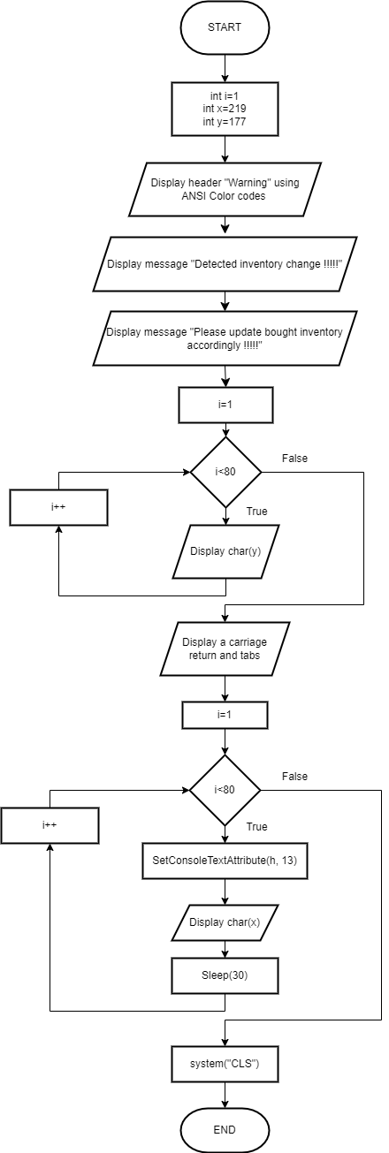**void loadingbar() void warning_bar()**

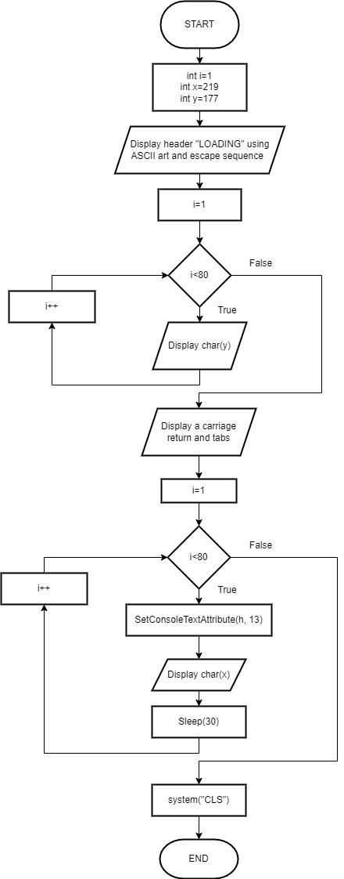

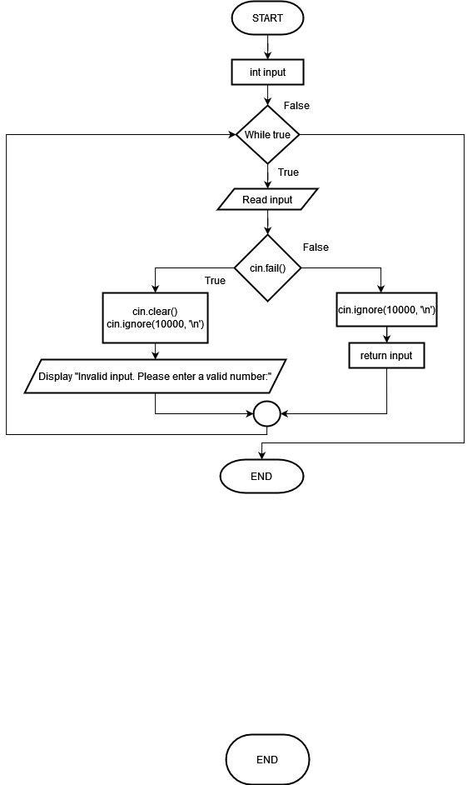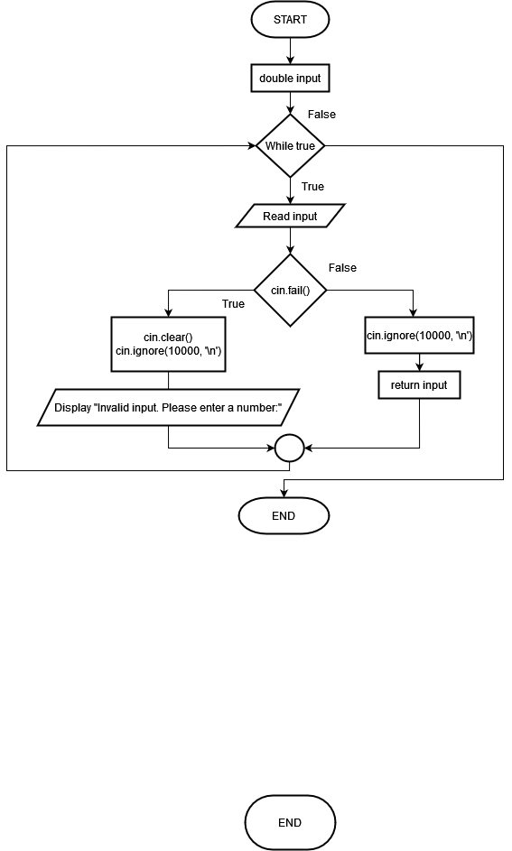**int getIntegerInput() double getDoubleInput()**

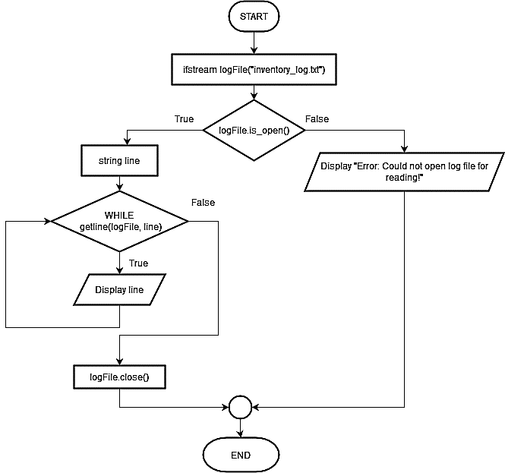**void currentInventoryHeader() void viewLog()**

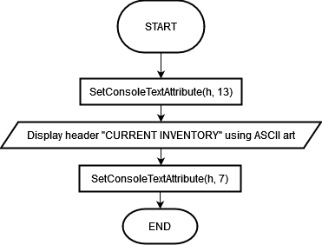

**void displayTransaction(string orderNo, int main()**

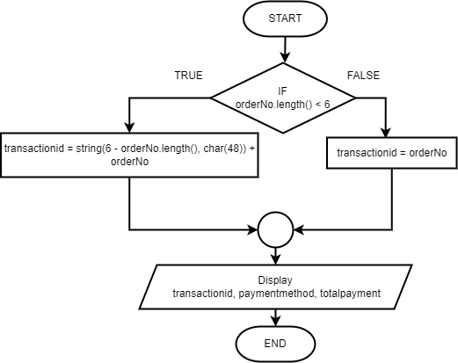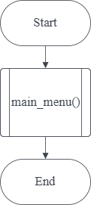**string paymentmethod, double totalpayment)**

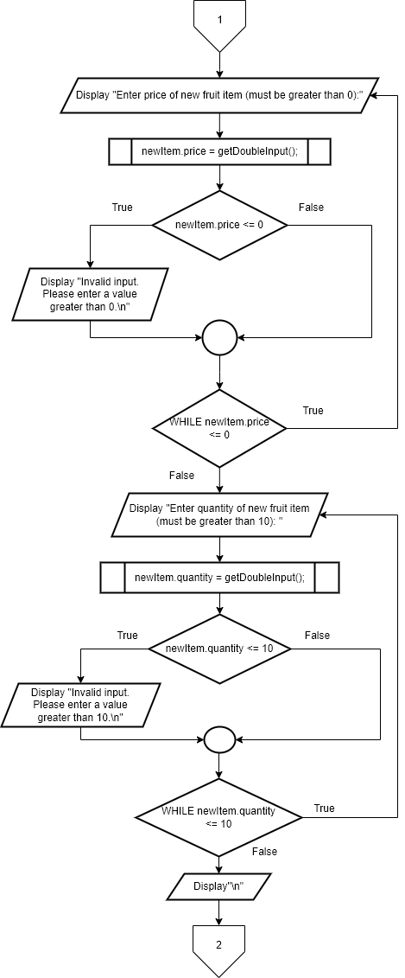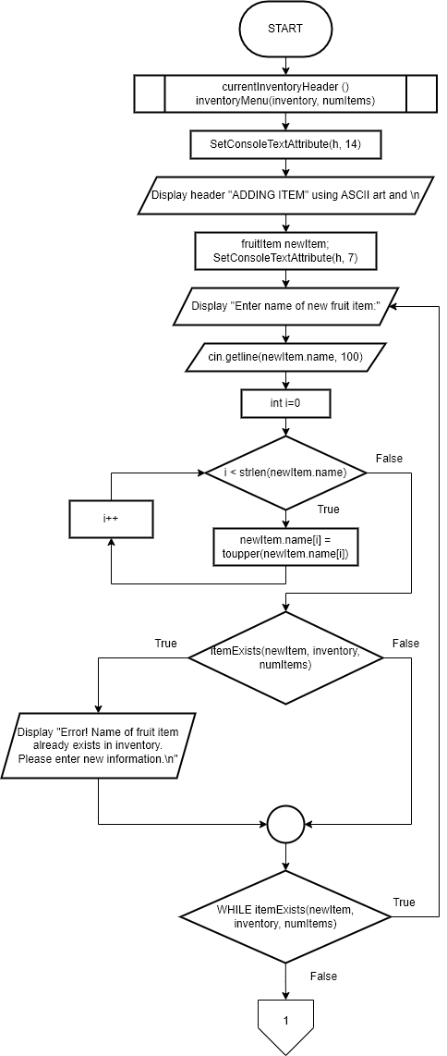**void addNewItem(fruitItem inventory[], int& numItems)**

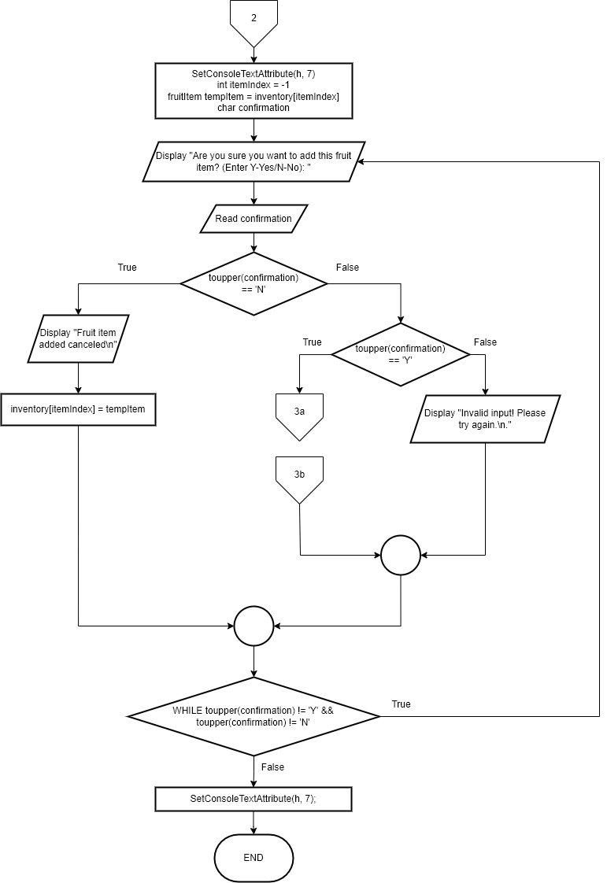

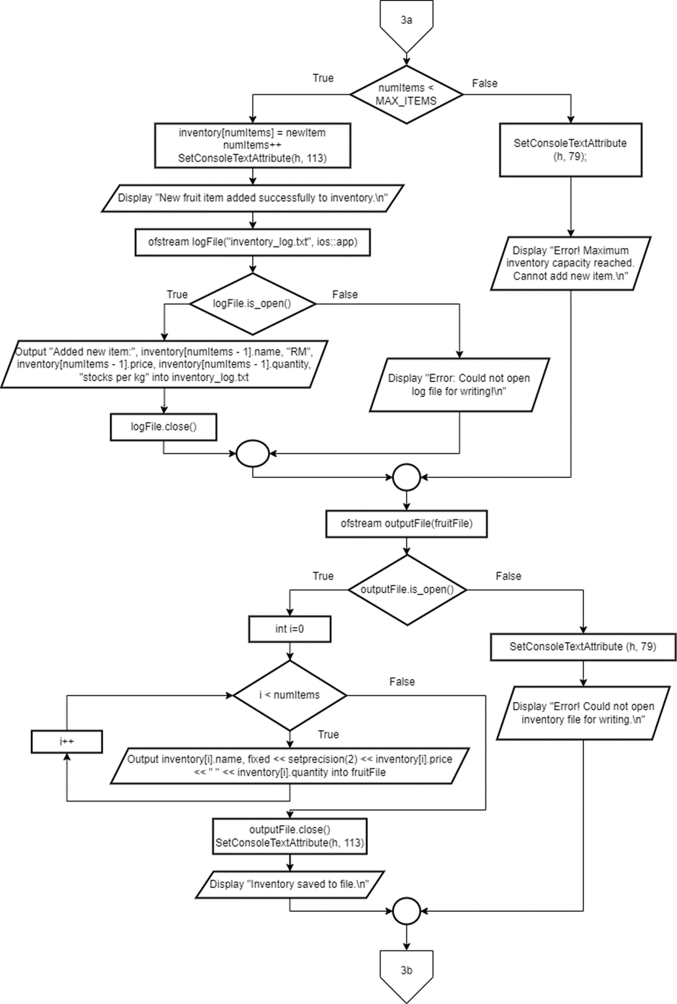

**void updateTransactionRecord(double& totalpayment, int& orderno, string paymethod)**

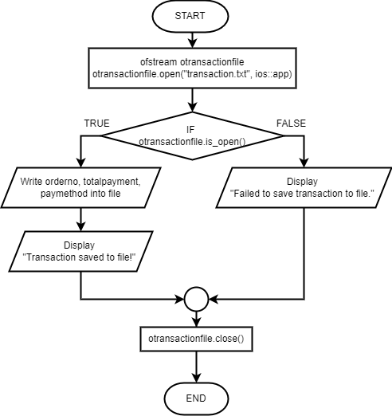

**void discount(double& total_cost)**

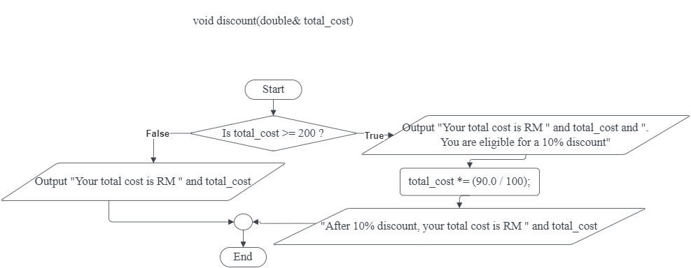

**void deleteItem(fruitItem inventory[], int& numItems)**

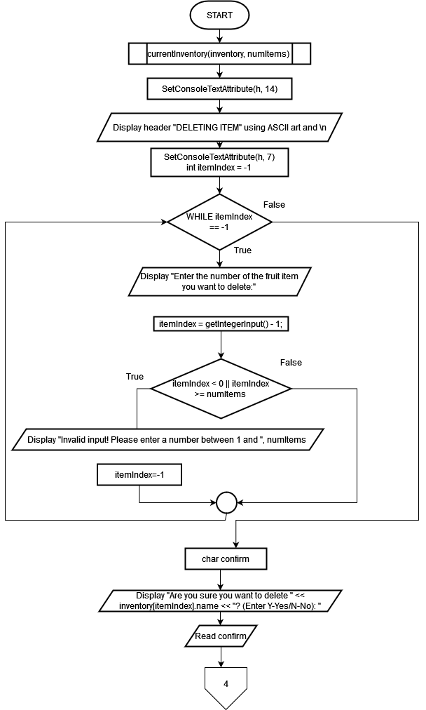

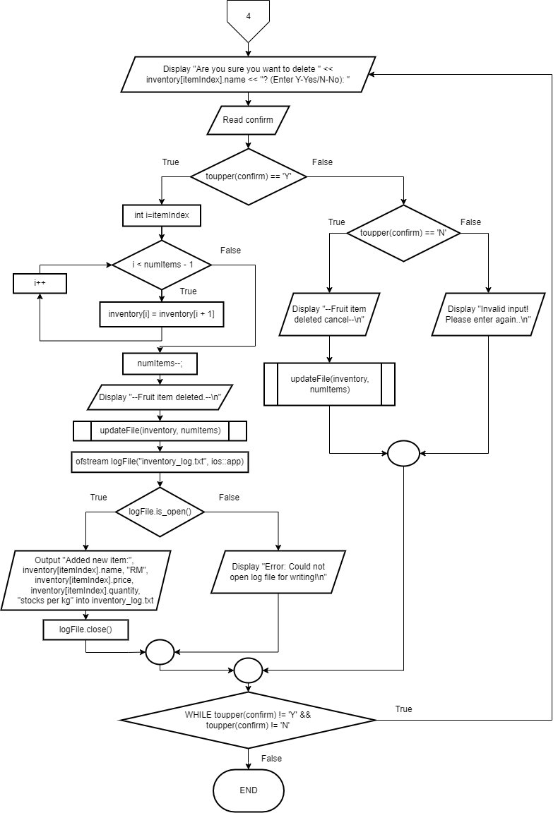

**void changeItem(fruitItem inventory[], int& numItems)**

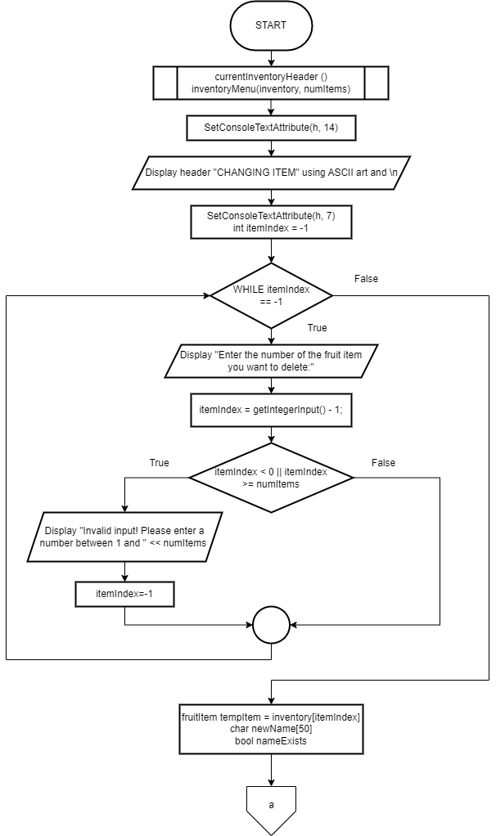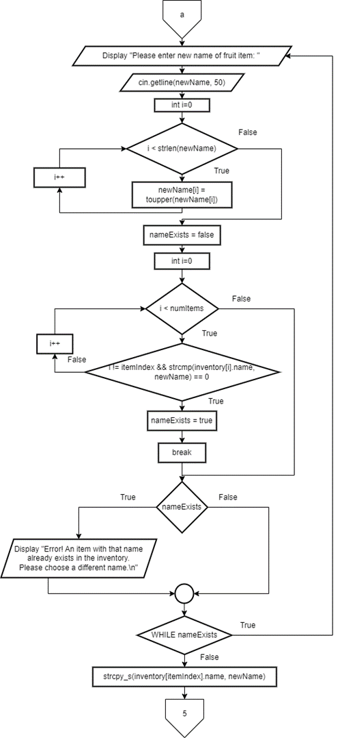

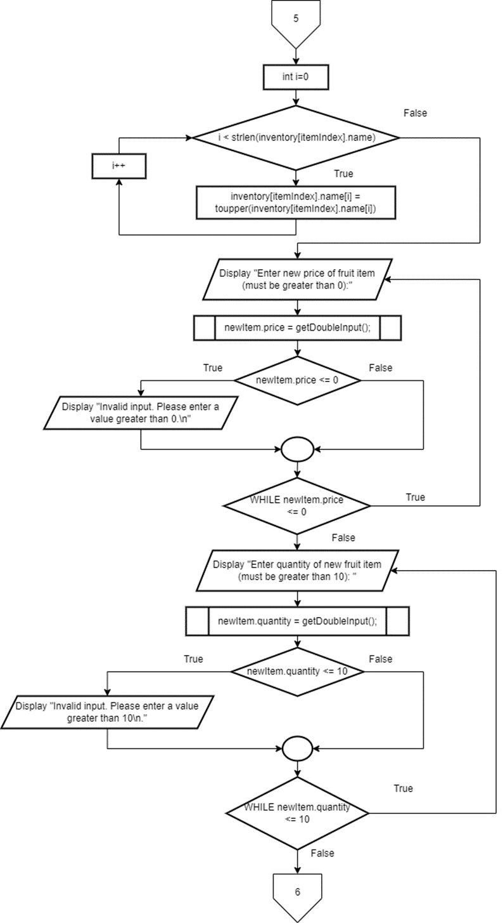

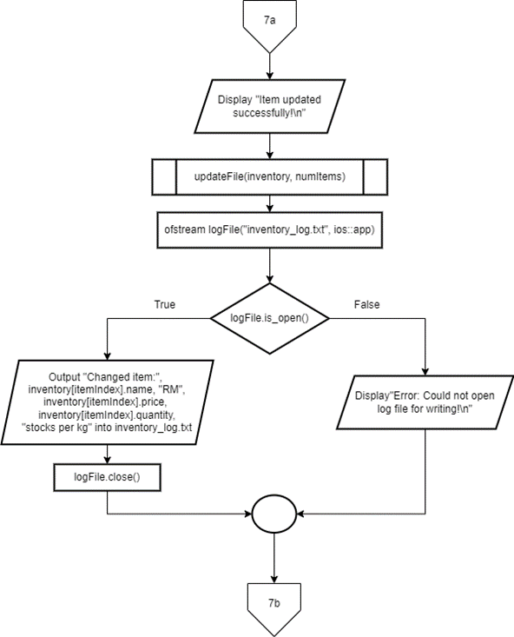

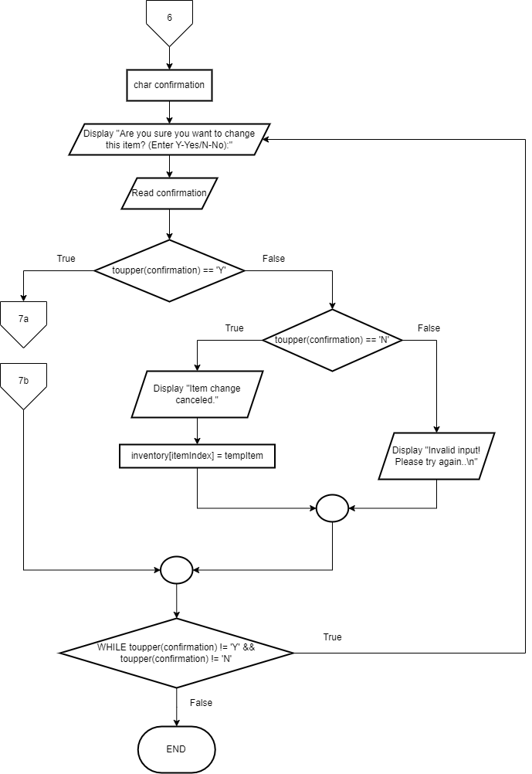

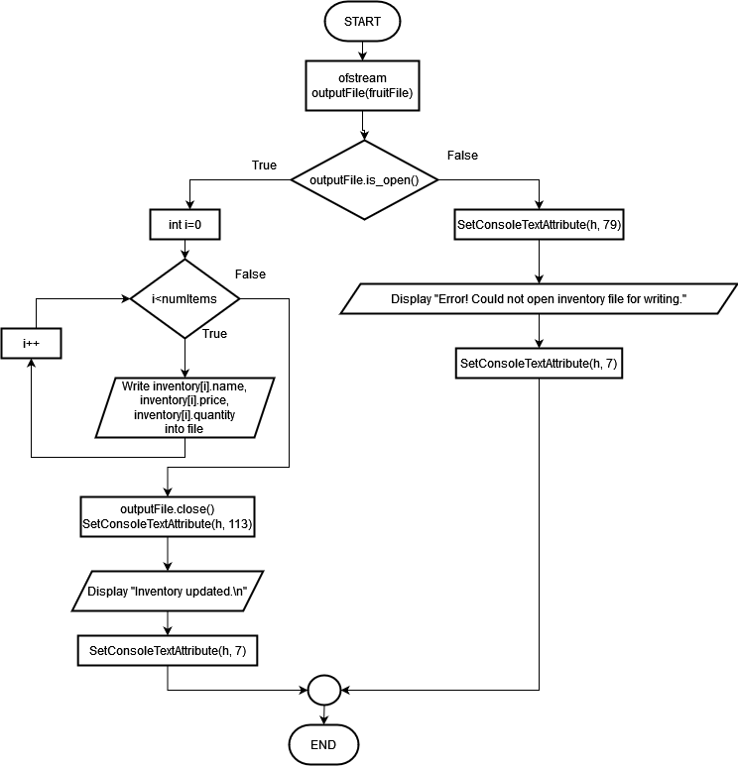**void updateFile(fruitItem inventory[], int& numItems)**

**void viewModule()**

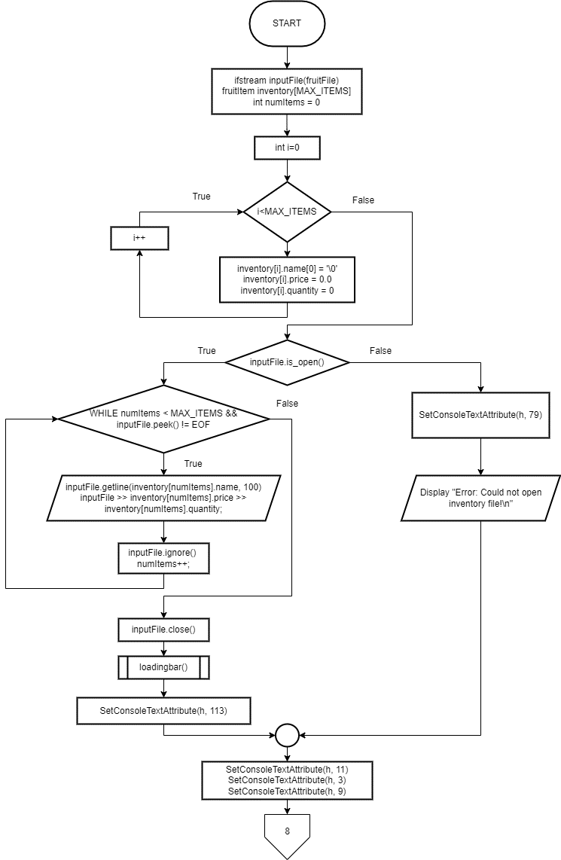

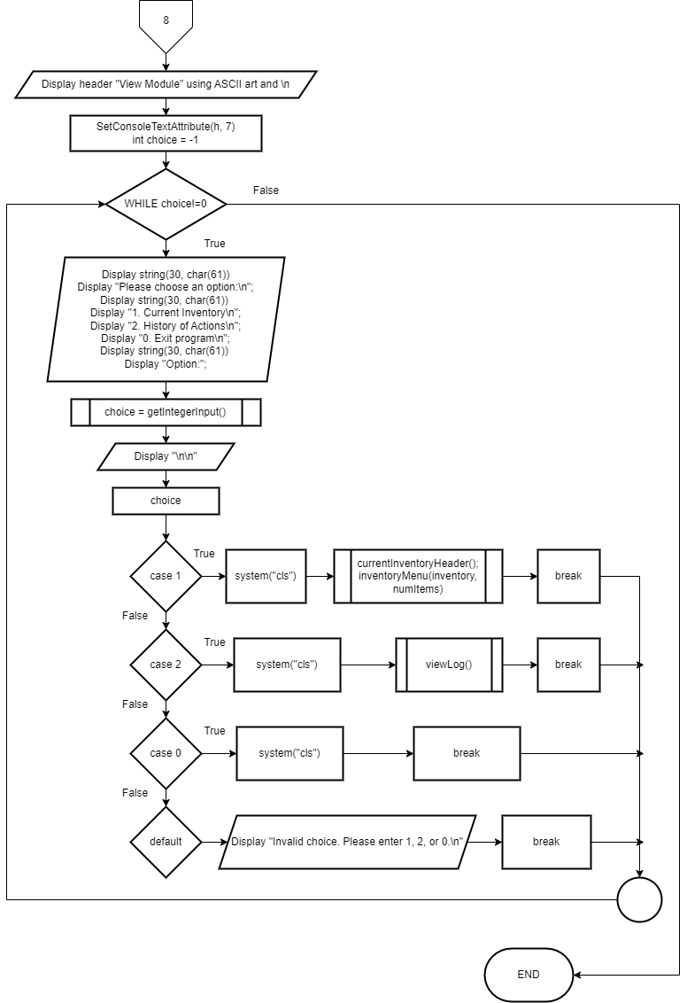

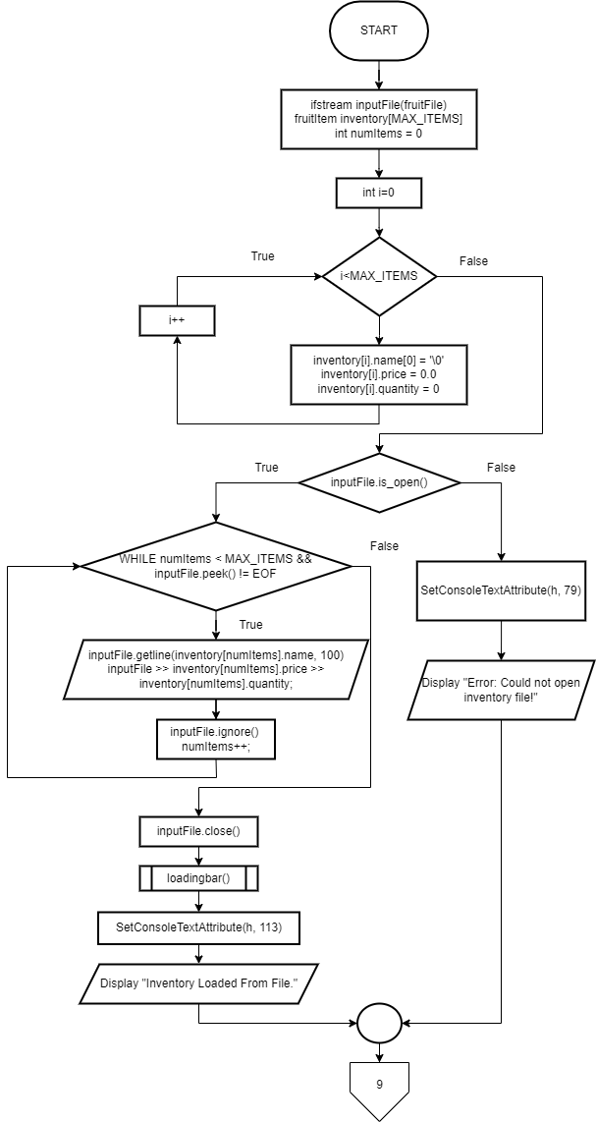**int stock(int x)**

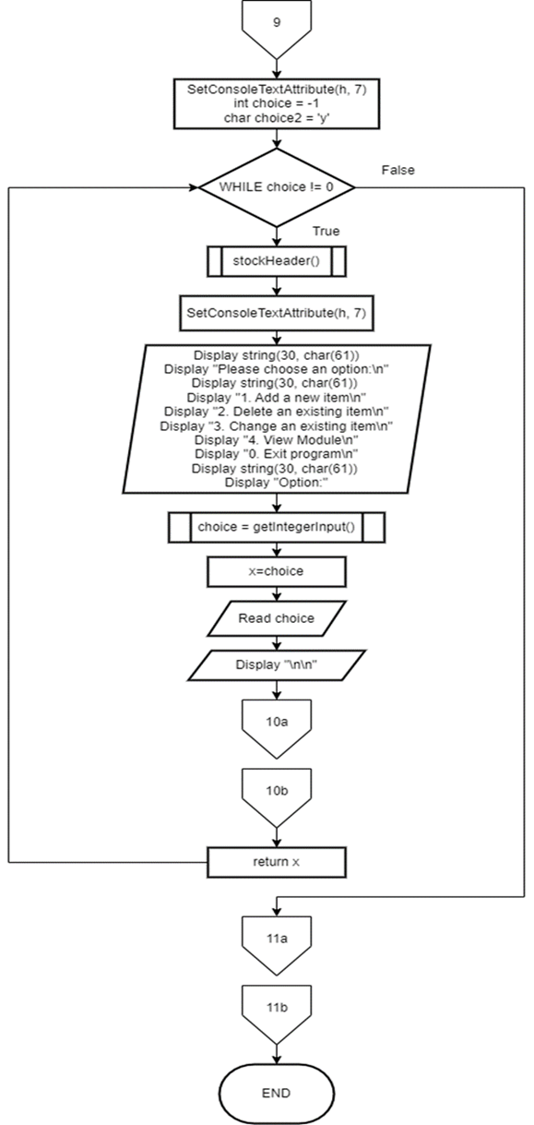

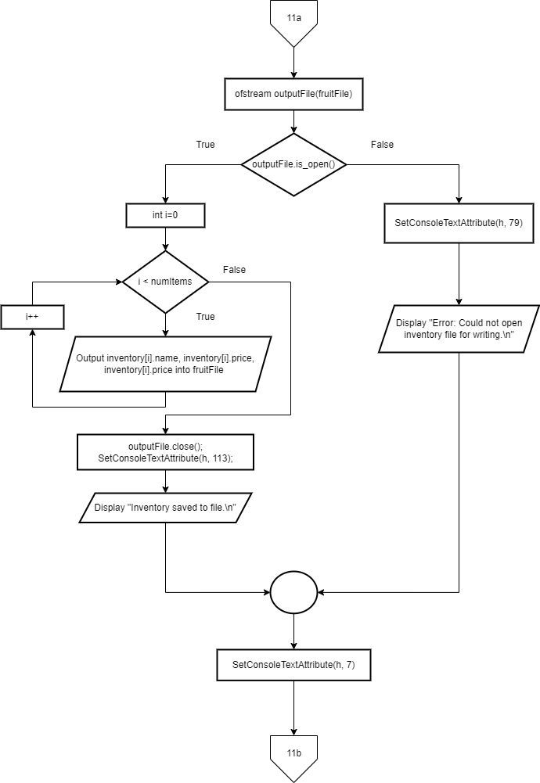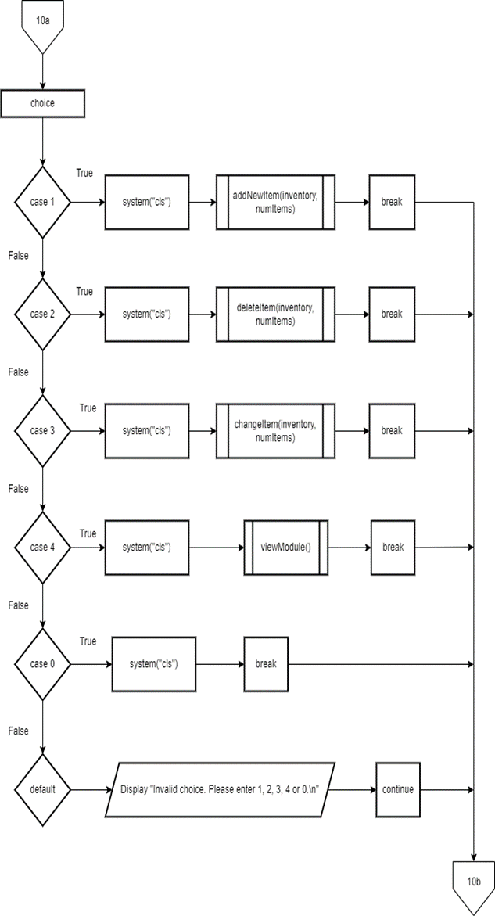

**void saleHeader() void mainHeader()**

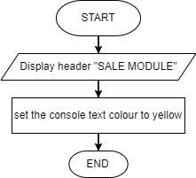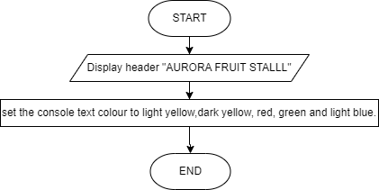

**void transactionHeader() void historyheader()**

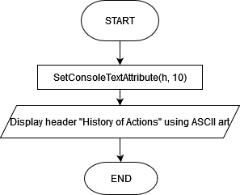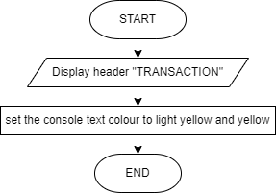

**int getOrderNo() void currentInventory (fruitItem inventory[], int numItems)**

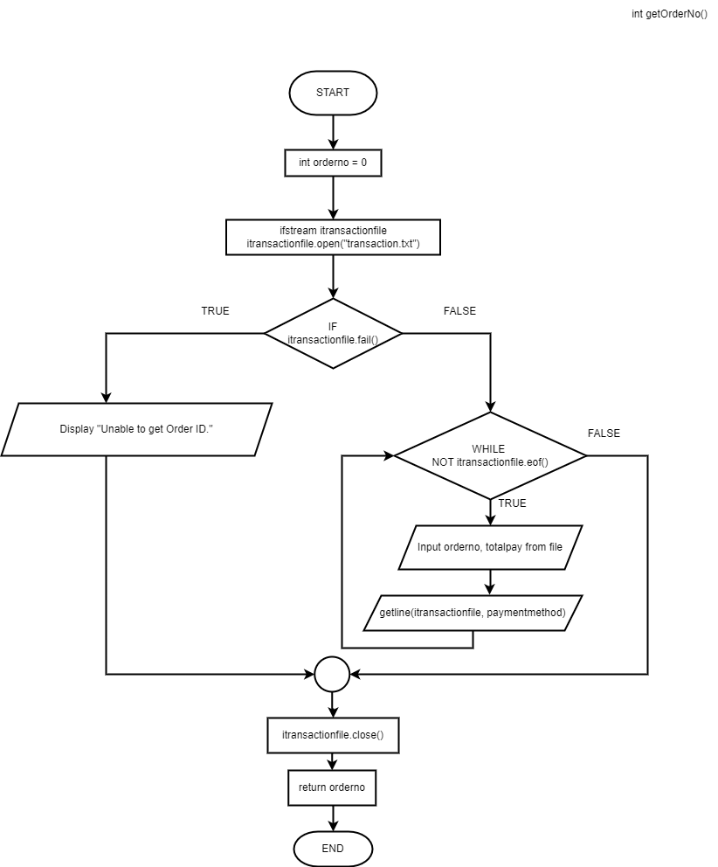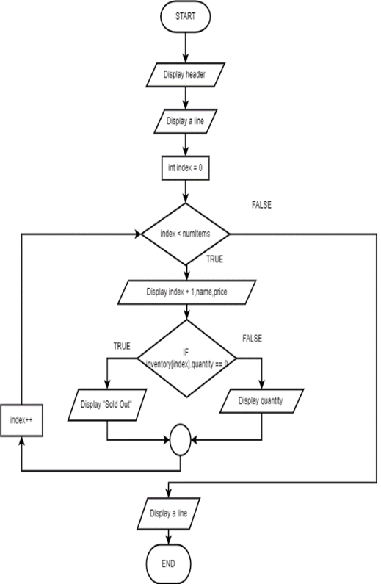

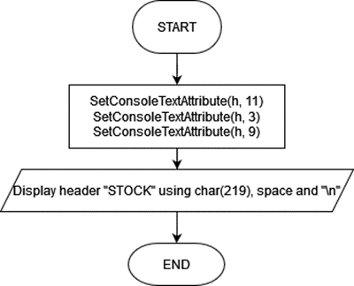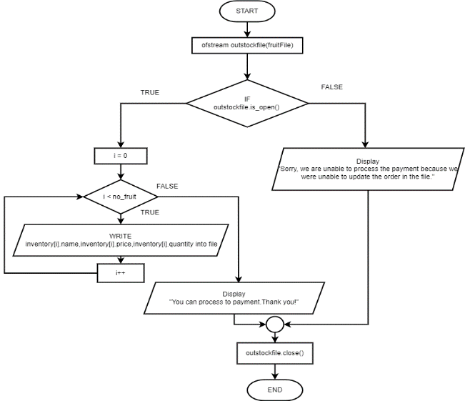**void updateSale(fruitItem inventory[], int no_fruit) void stockHeader()**

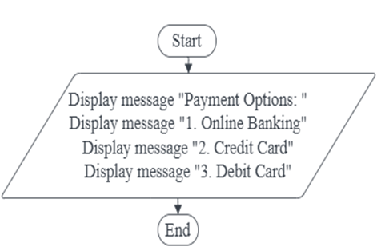 **Void payment_options()**

**bool itemExists(const fruitItem& newItem, const fruitItem inventory[], int numItems)**

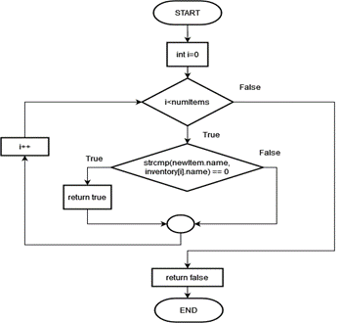

**void purchaseItem(fruitItem inventory[], int optionIndex, double& fruitamount, double& totalpayment)**

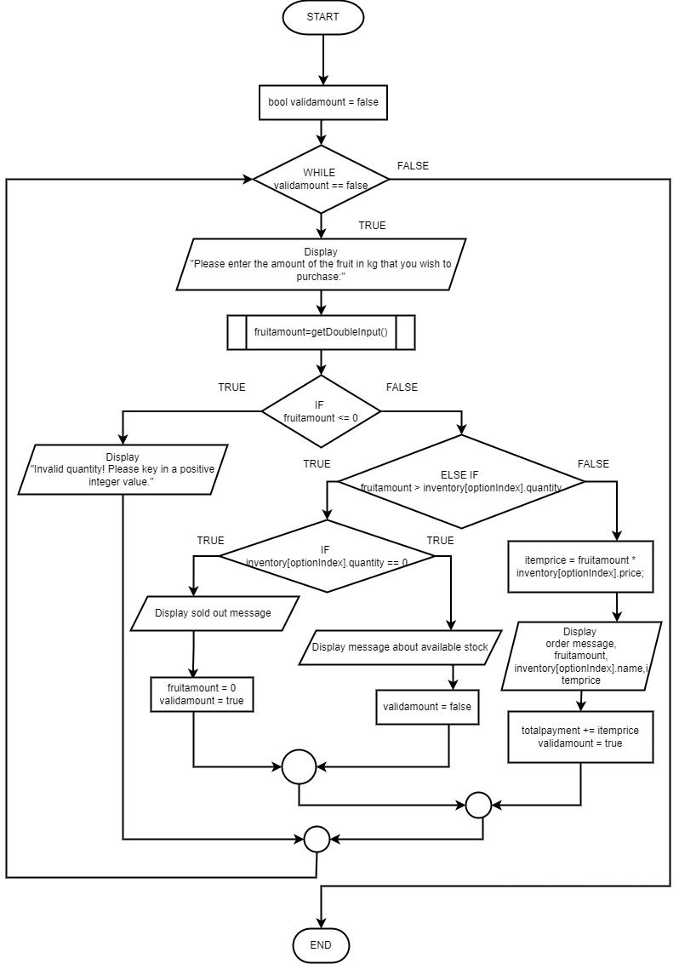

**bool salesmodule(int& orderno,string purchaseitem[],double purchaseamount[])**

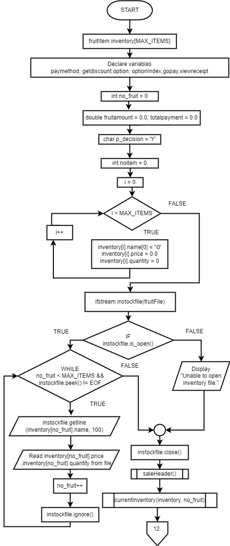

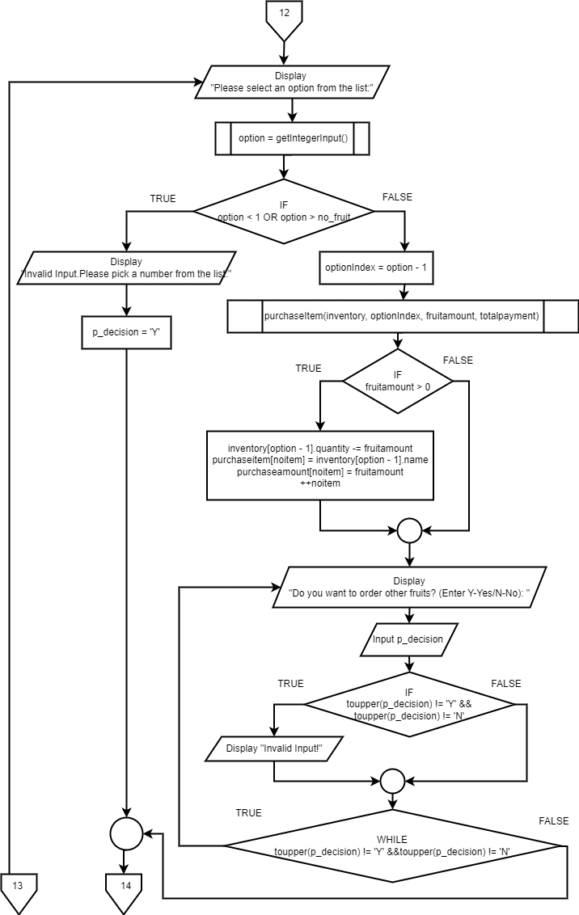

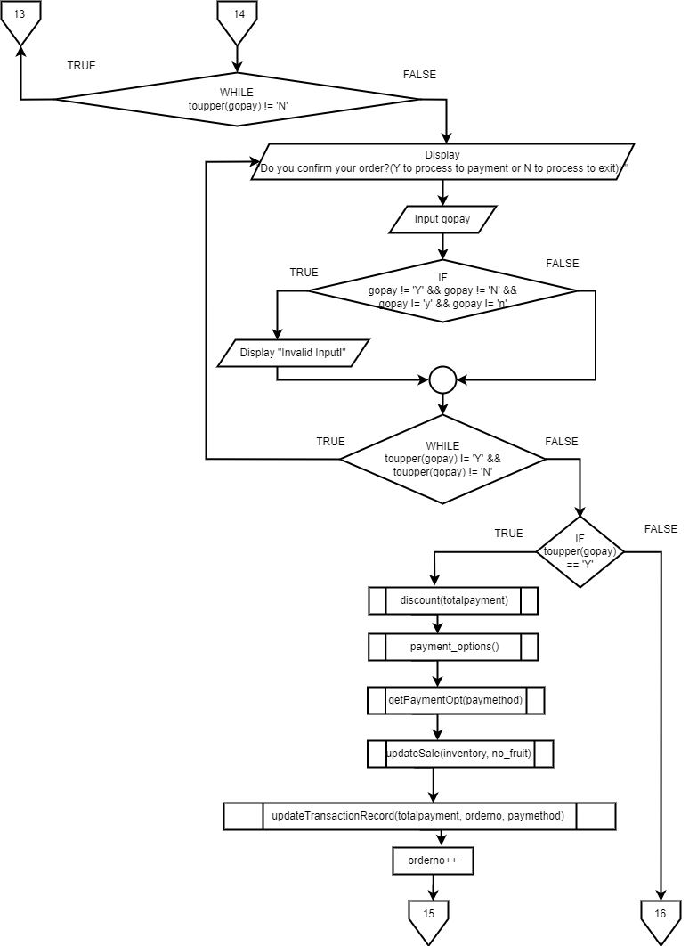

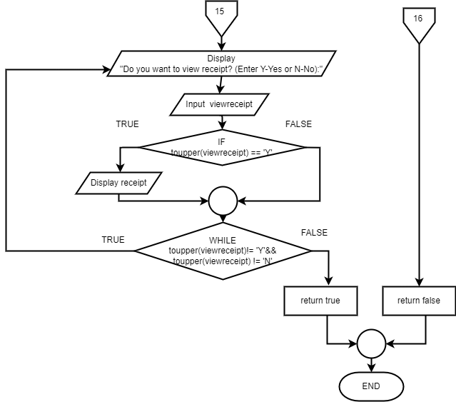

**void loadTransactionHistory(int& orderno)** 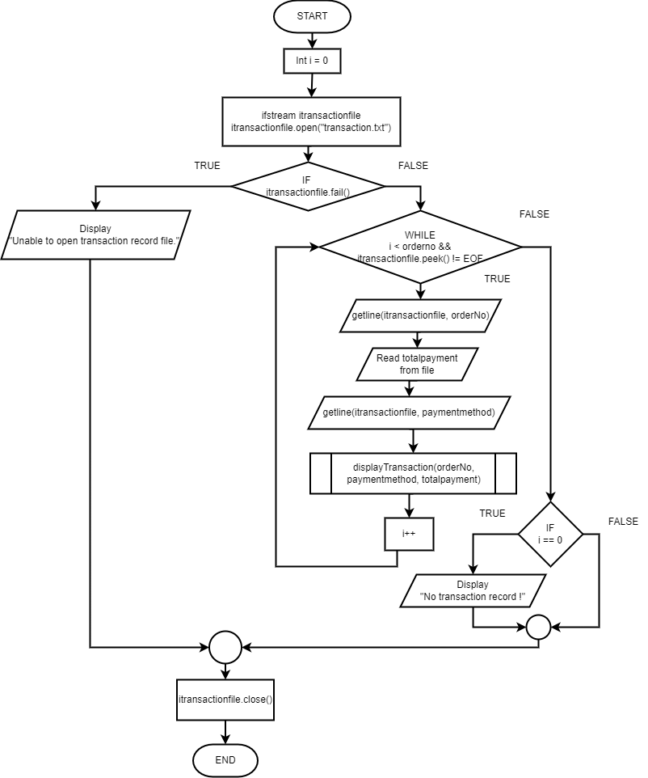

**void searchResult(int orderno, string payMethod, string transactionID)**

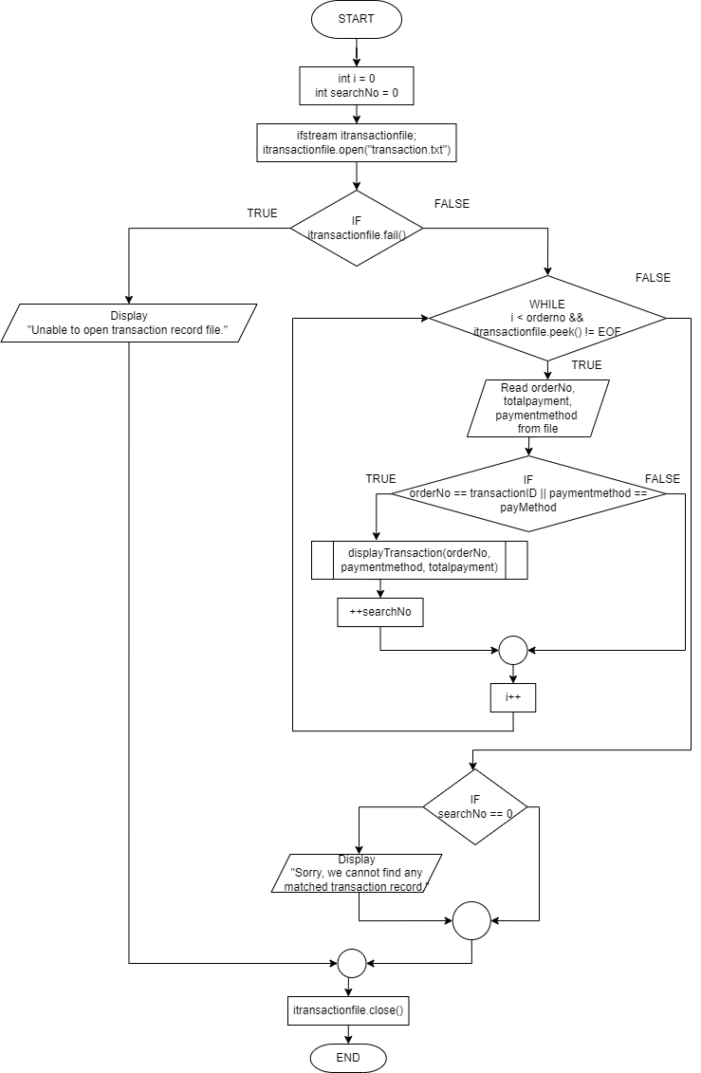

**void search(int& orderno)**

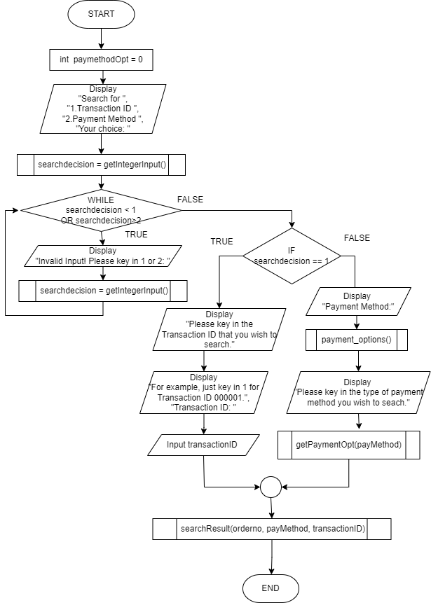

**void transactionHistory(int& orderno)**

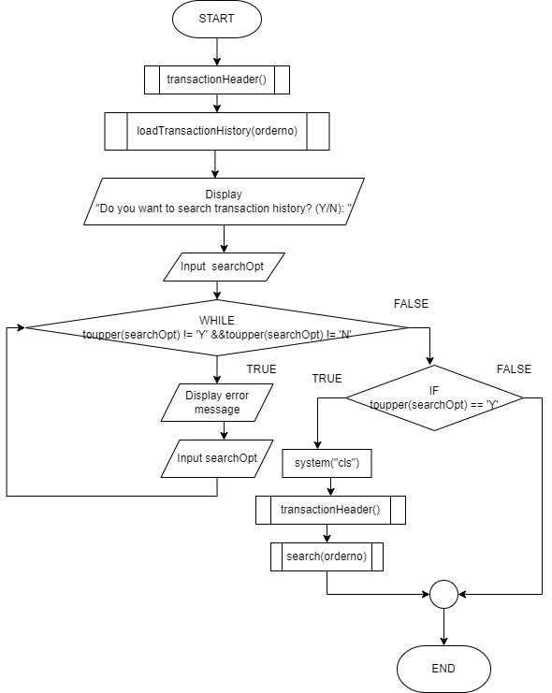

**void getPaymentOpt(string& payMethod)** 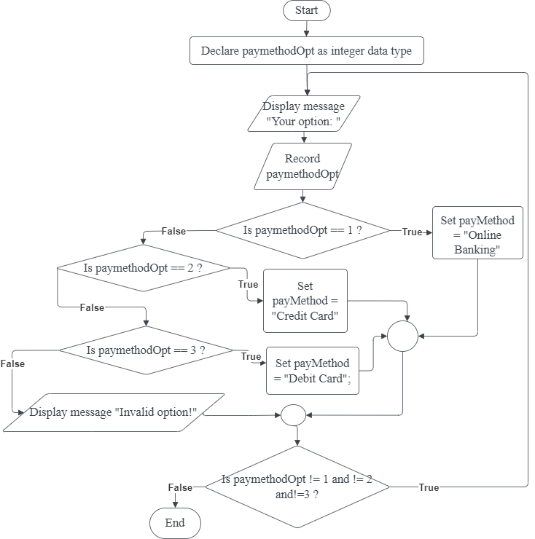

**void updateCostFile(costItem cost_inventory[], int& numItems)**

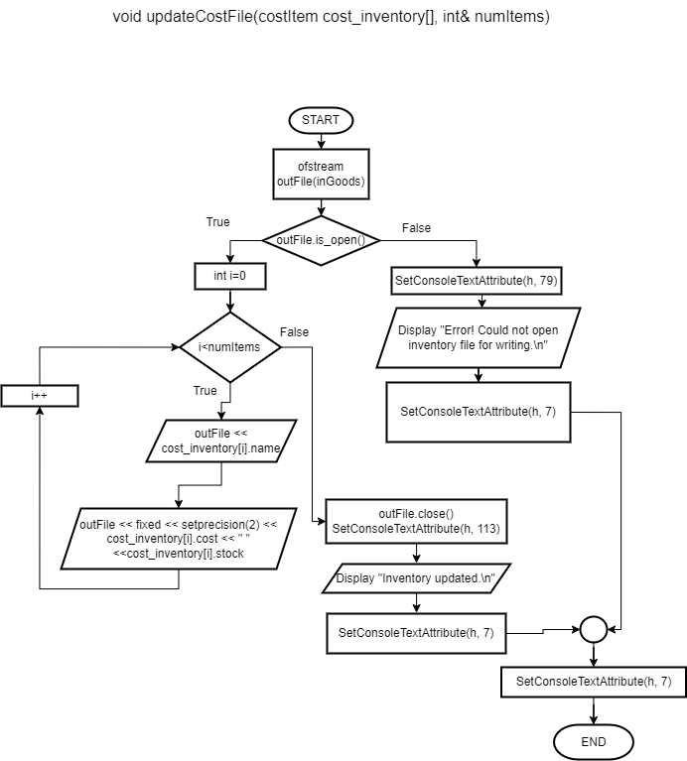

**void currentCostInventory(costItem cost_inventory[], int& numItems)**

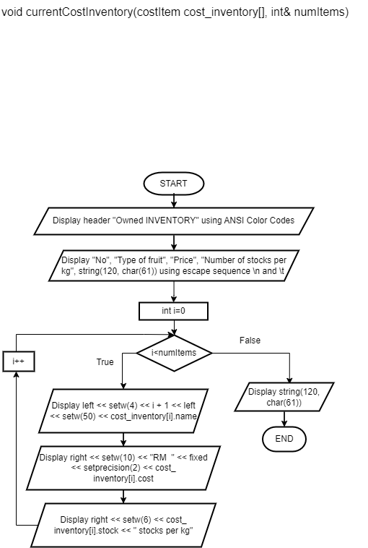

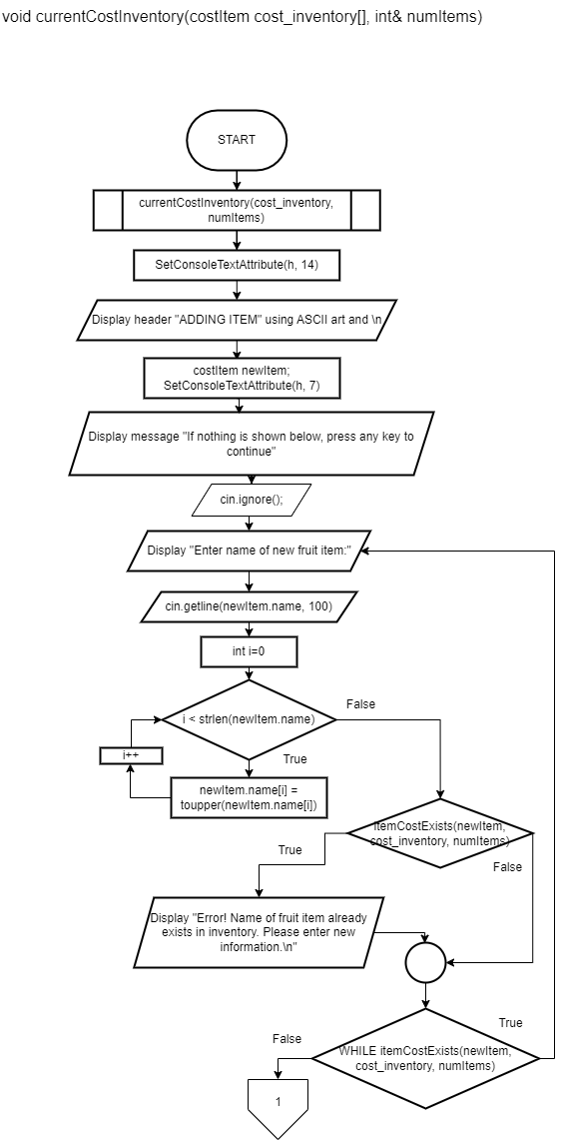**void addNewCostItem(costItem cost_inventory[], int& numItems)**

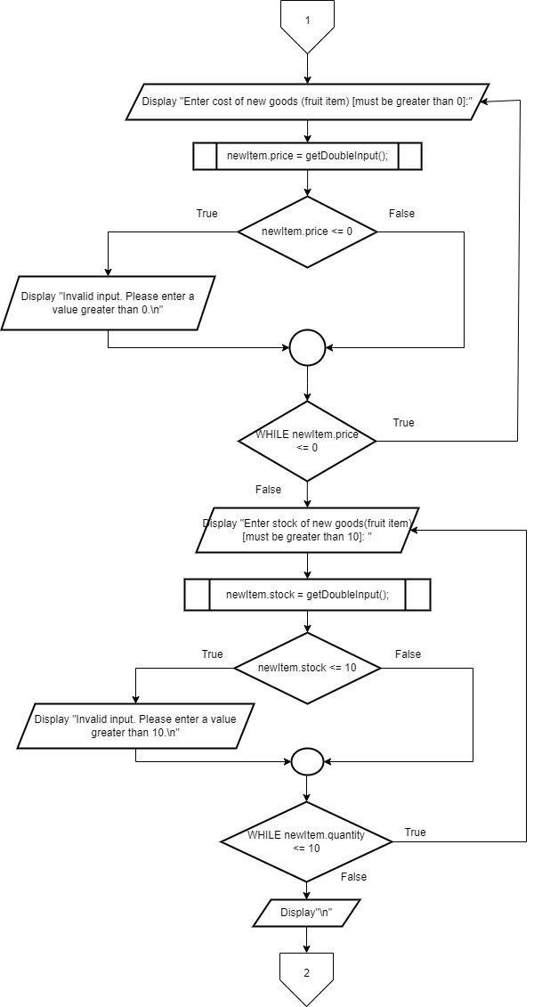

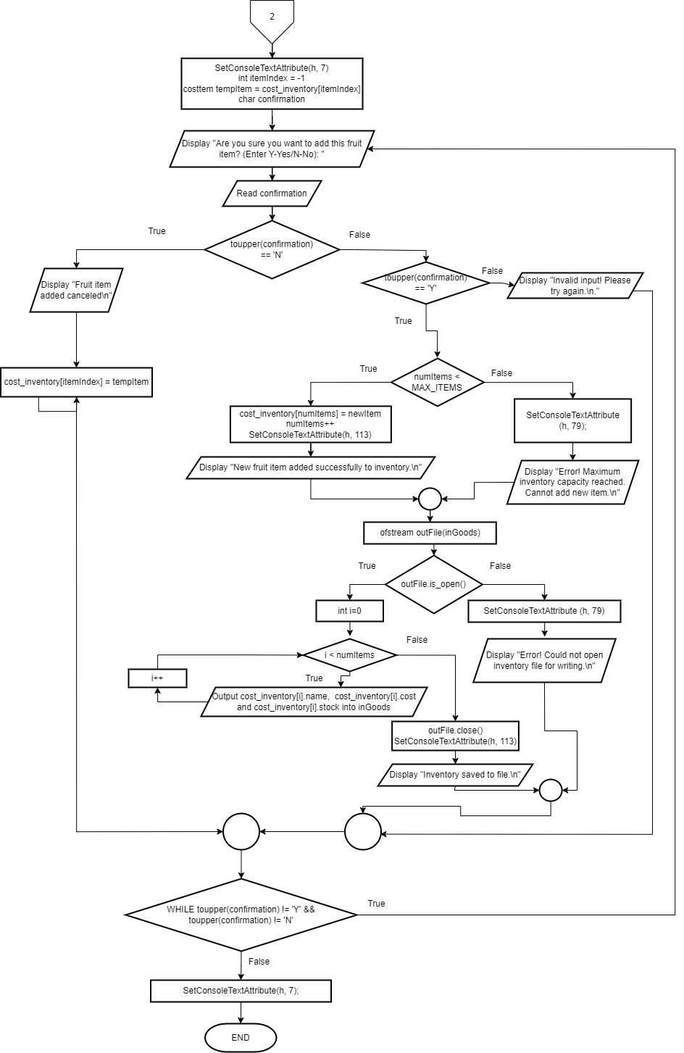

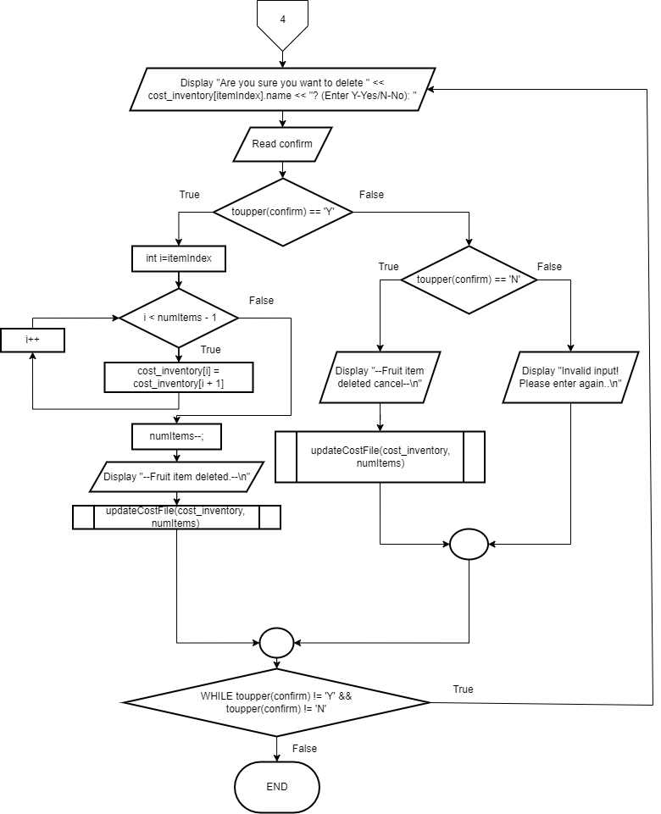**void deleteCostItem(costItem cost_inventory[], int& numItems)** 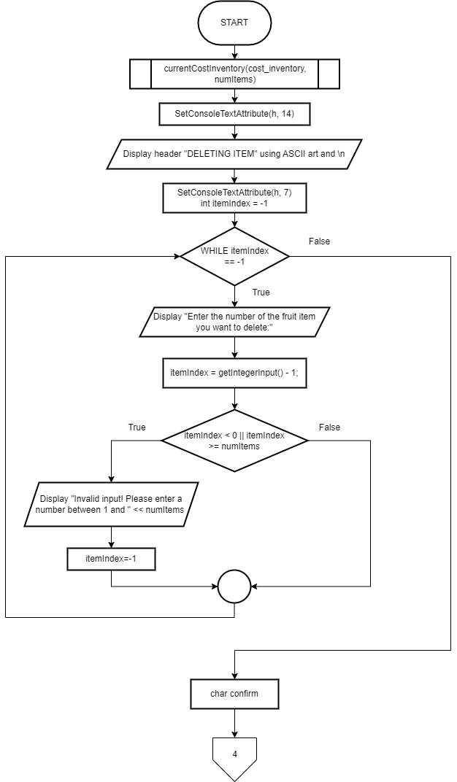

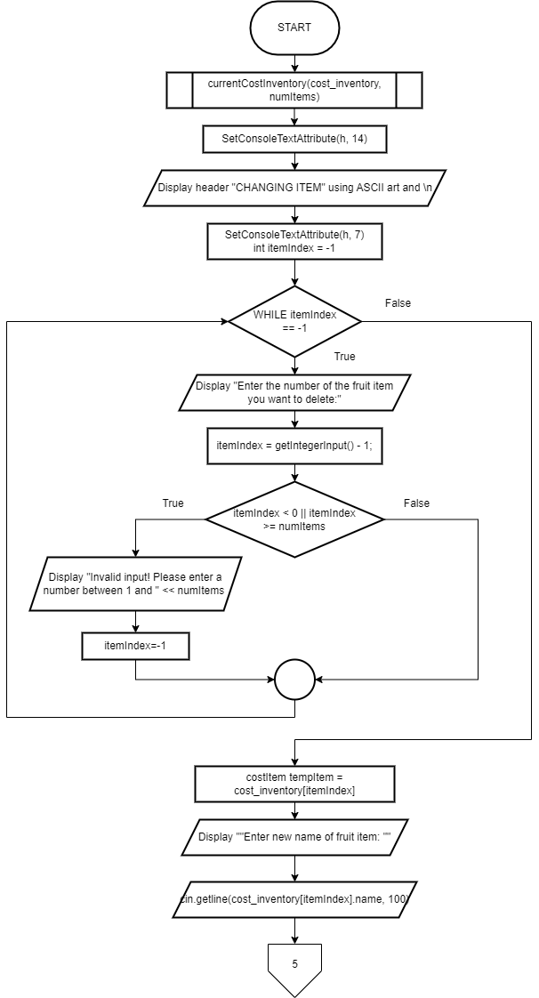 **void changeCostItem(costItem cost_inventory[], int& numItems)**

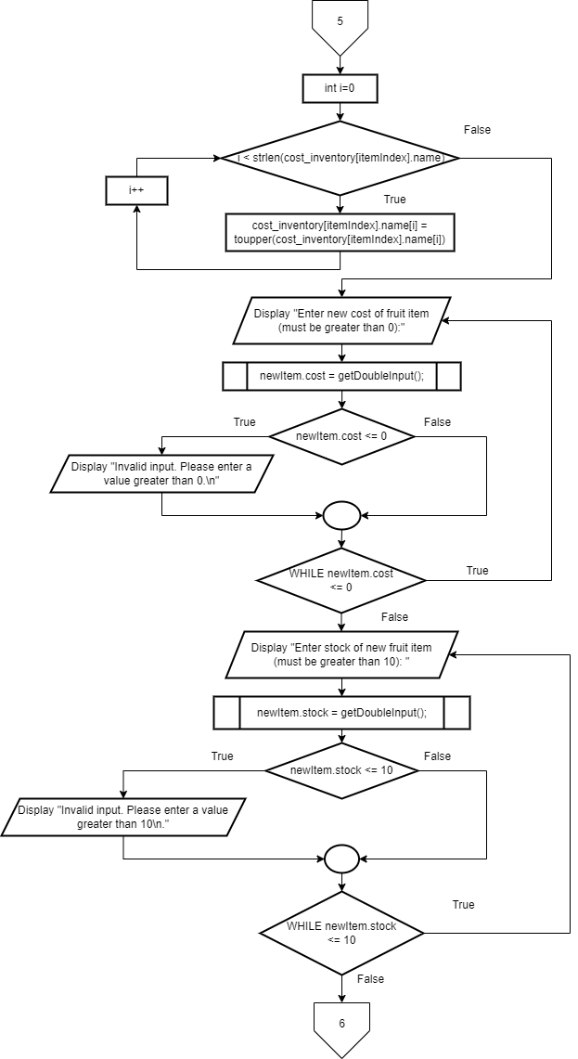

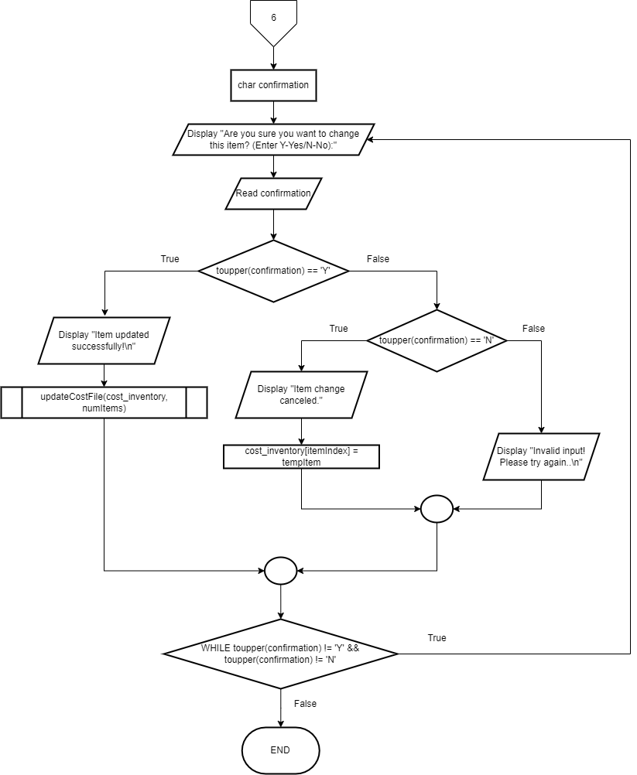

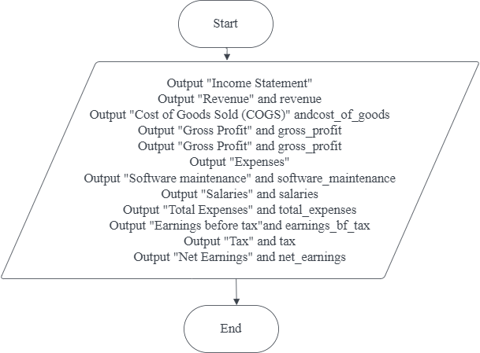**Void income_statement() Void GoodsItems(costItem inventory[],int& numItems()**

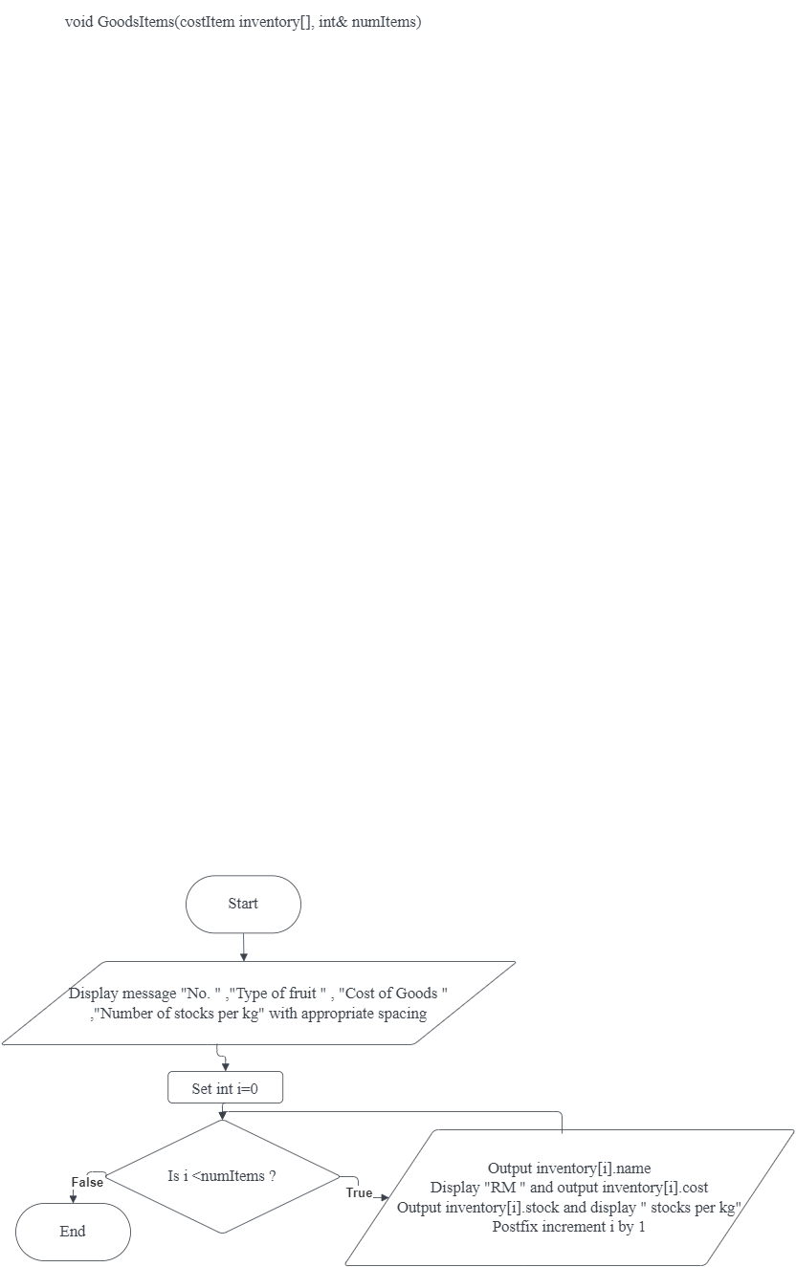

**void Bought_ItemStock()**

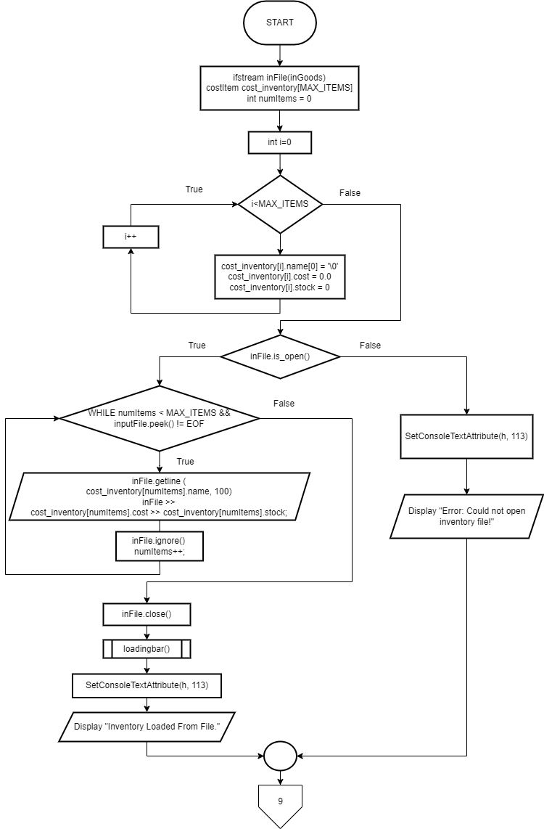

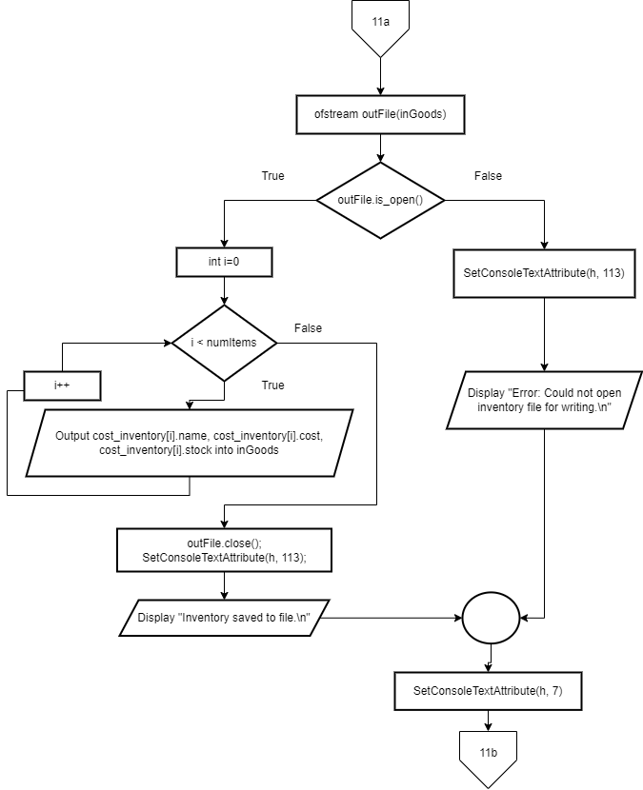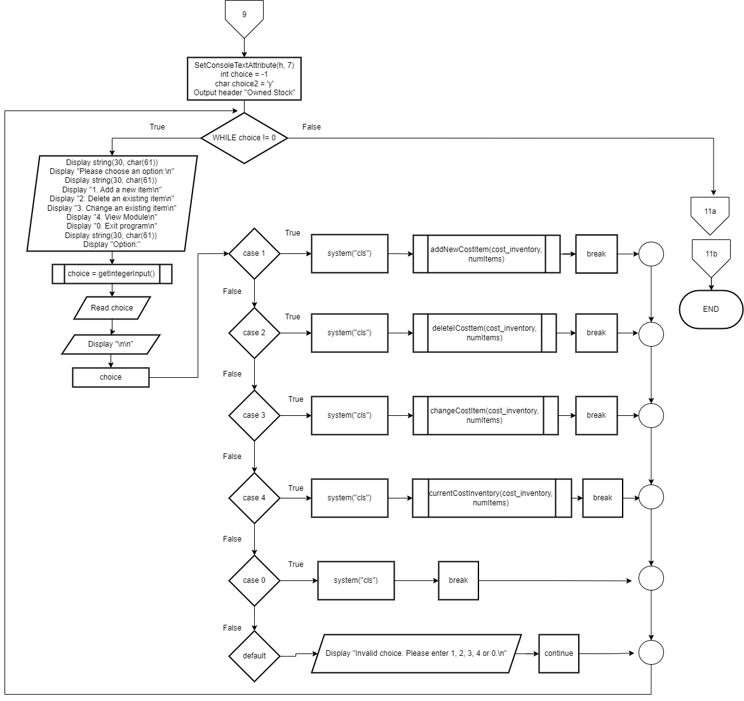

**Void financial_report()**

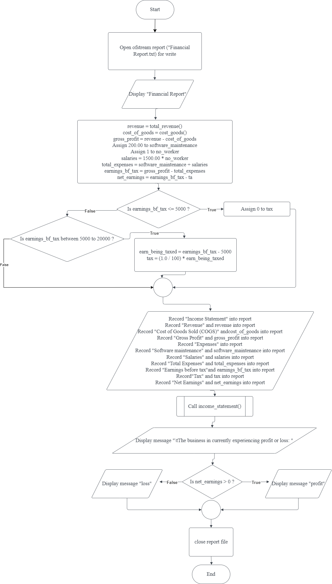

**Double cost_goods()**

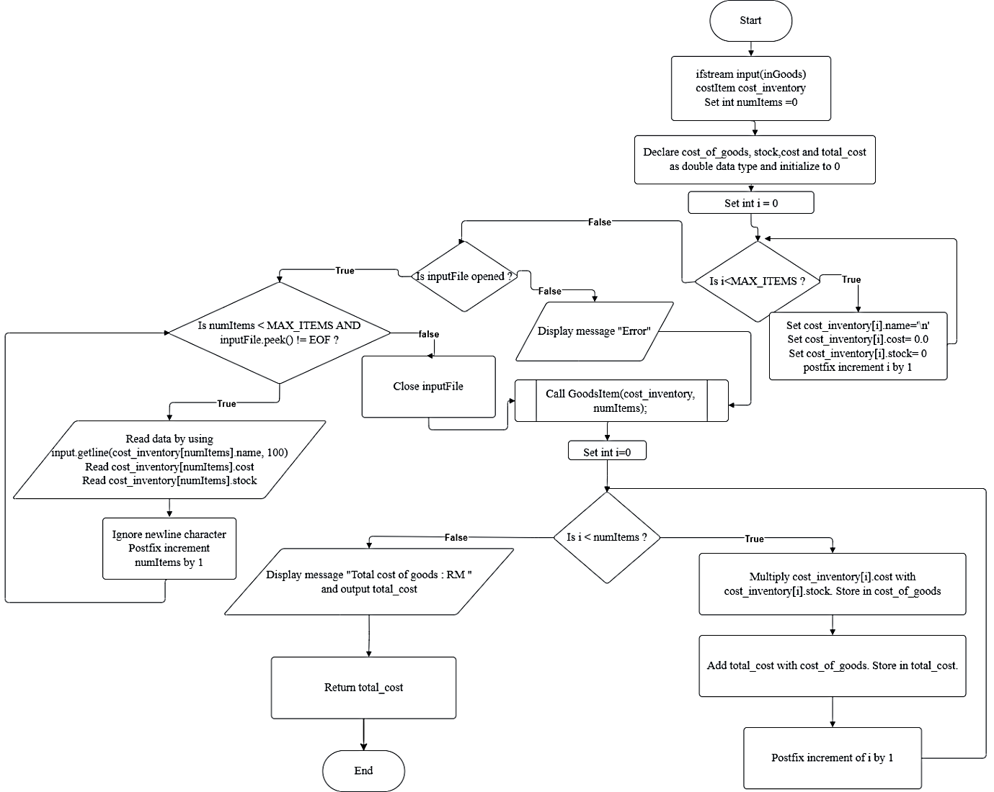

**Void ch1()**

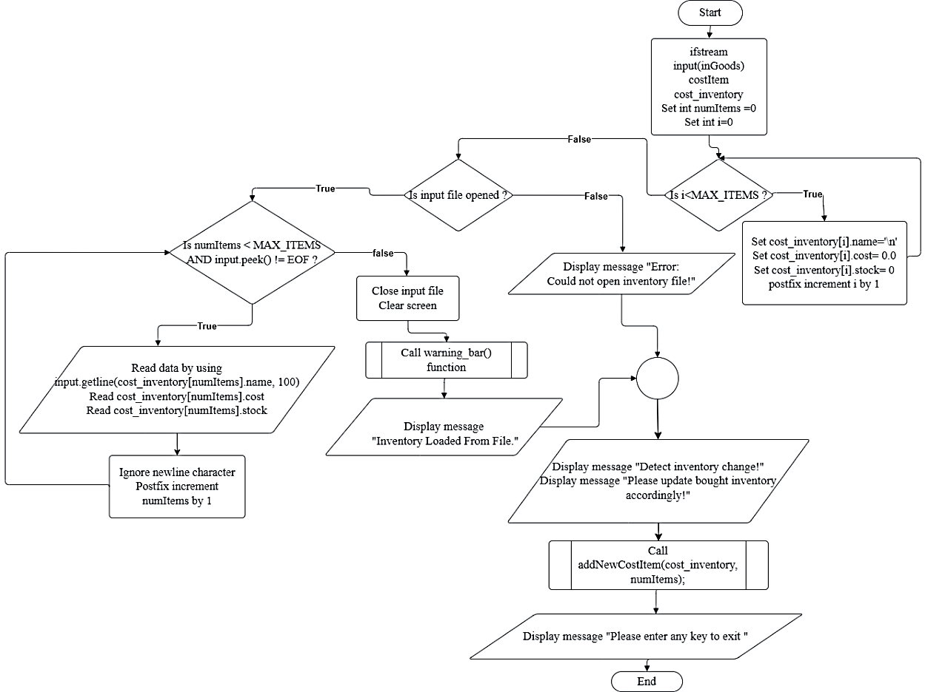

**Void ch2()**

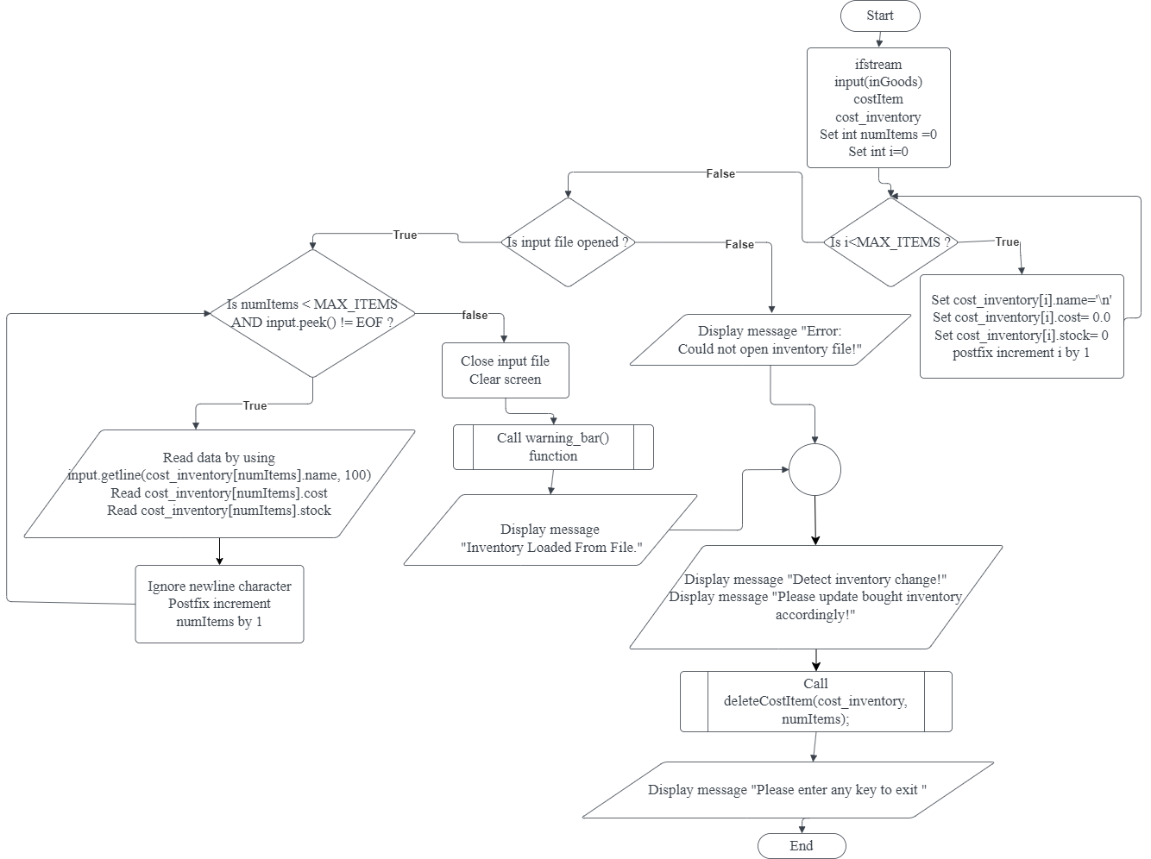

**Void ch3()**

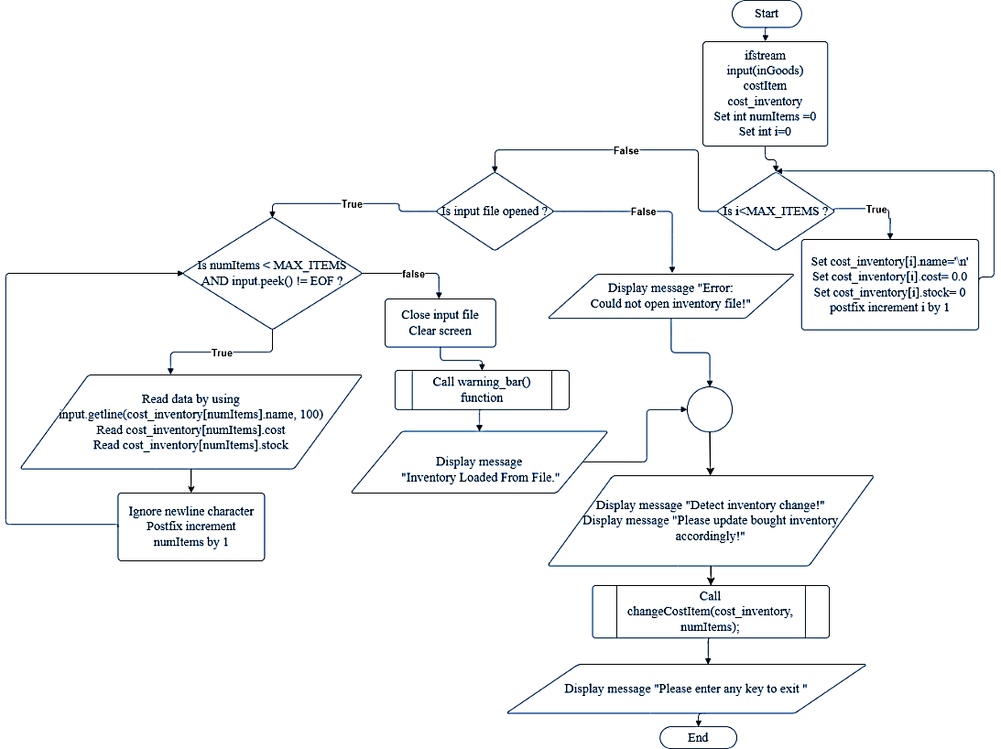

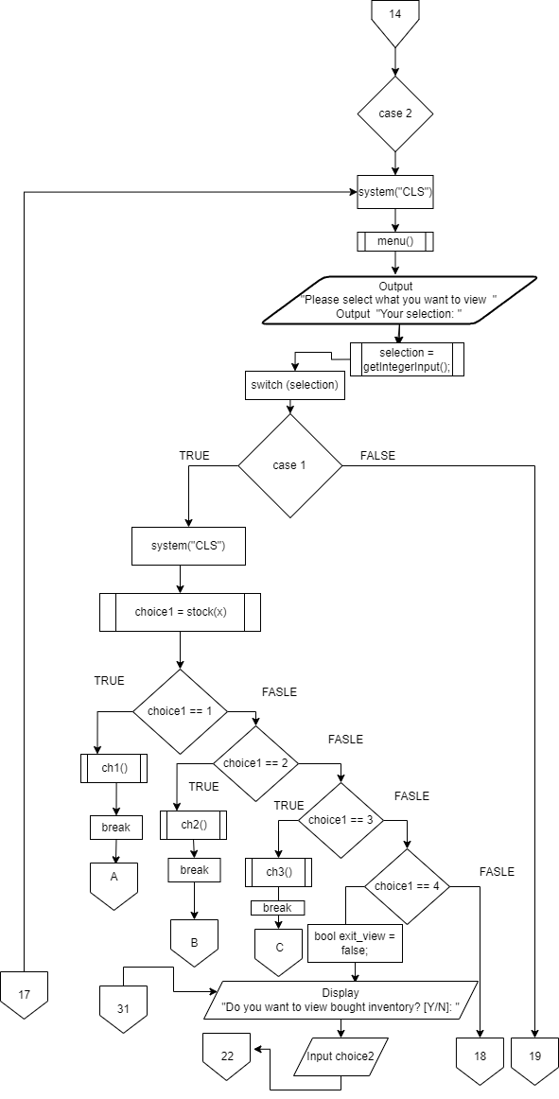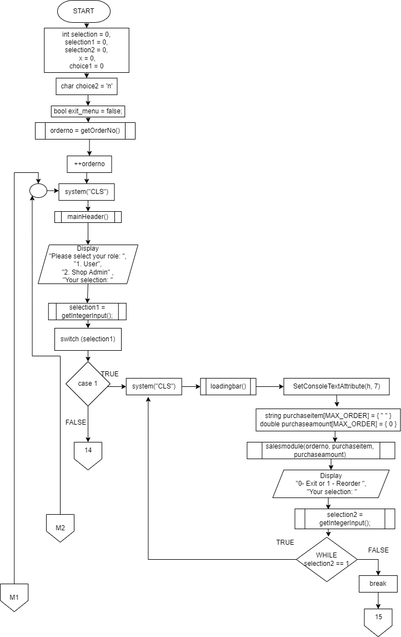**void main_menu()**

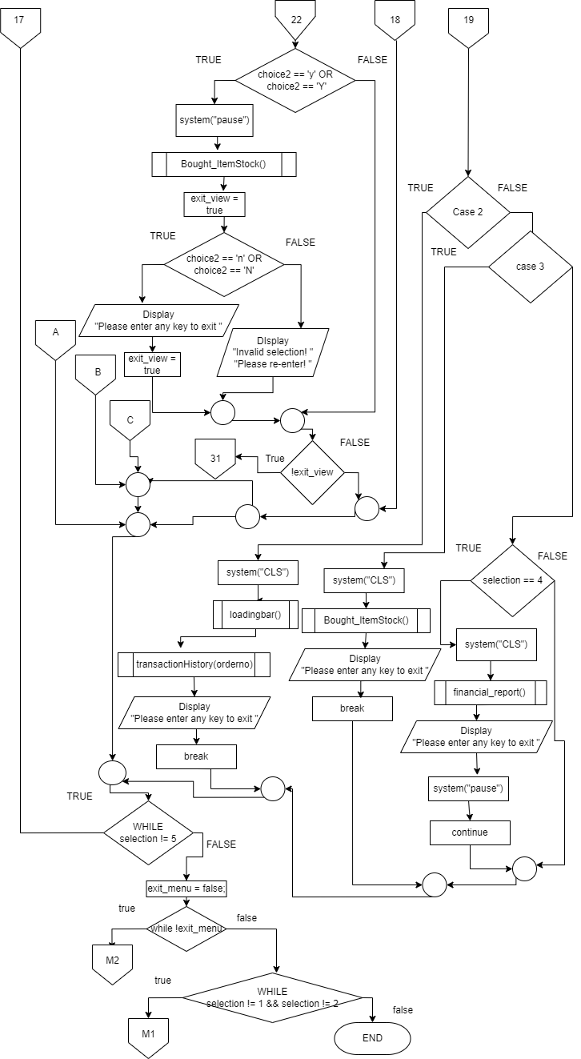

**Test cases**

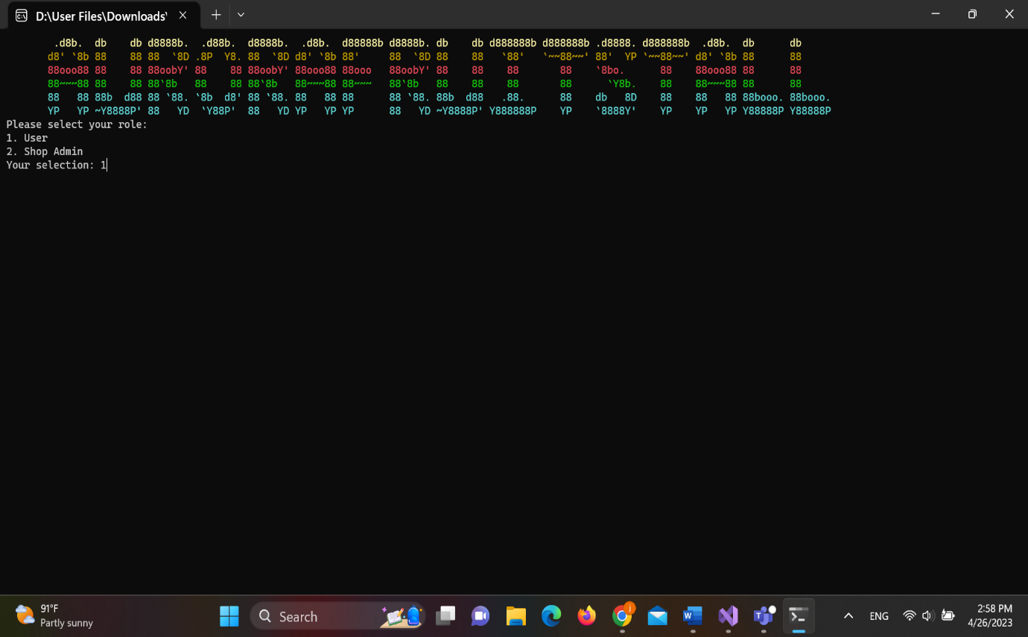

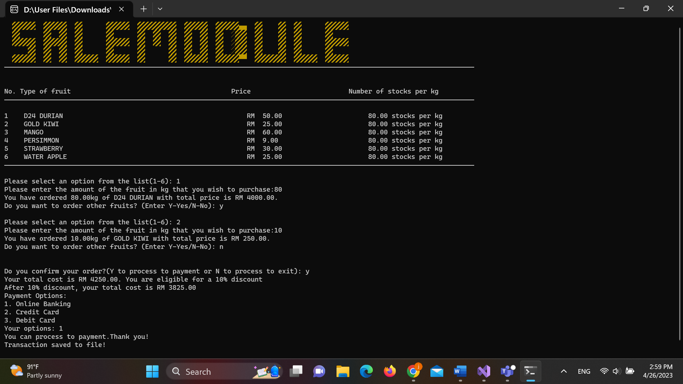

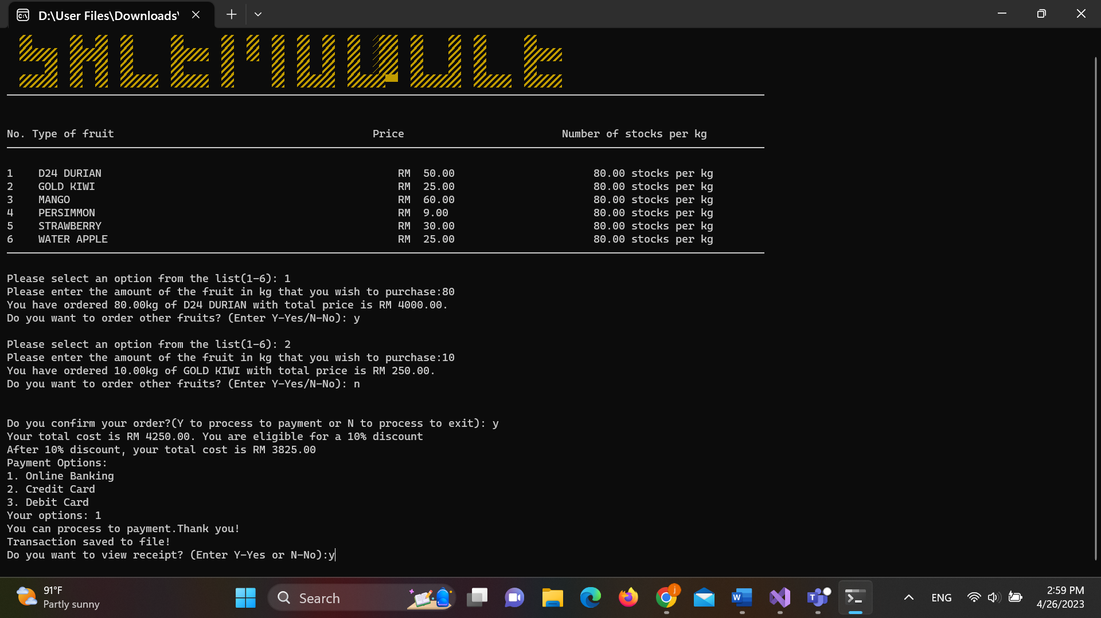

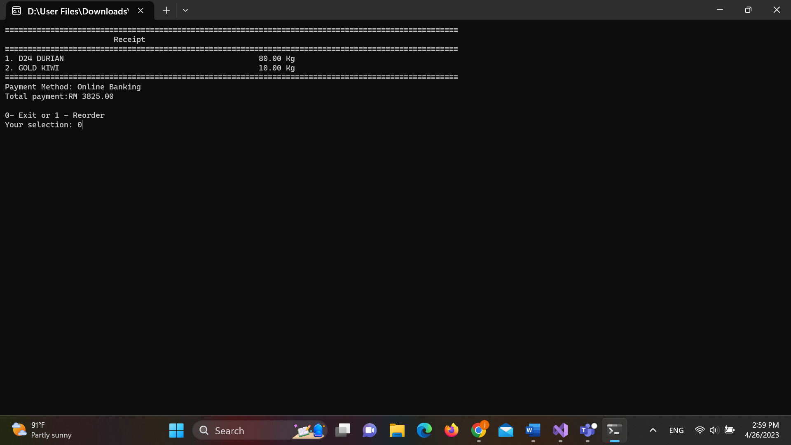

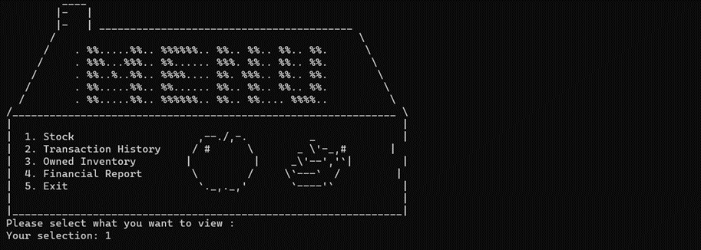

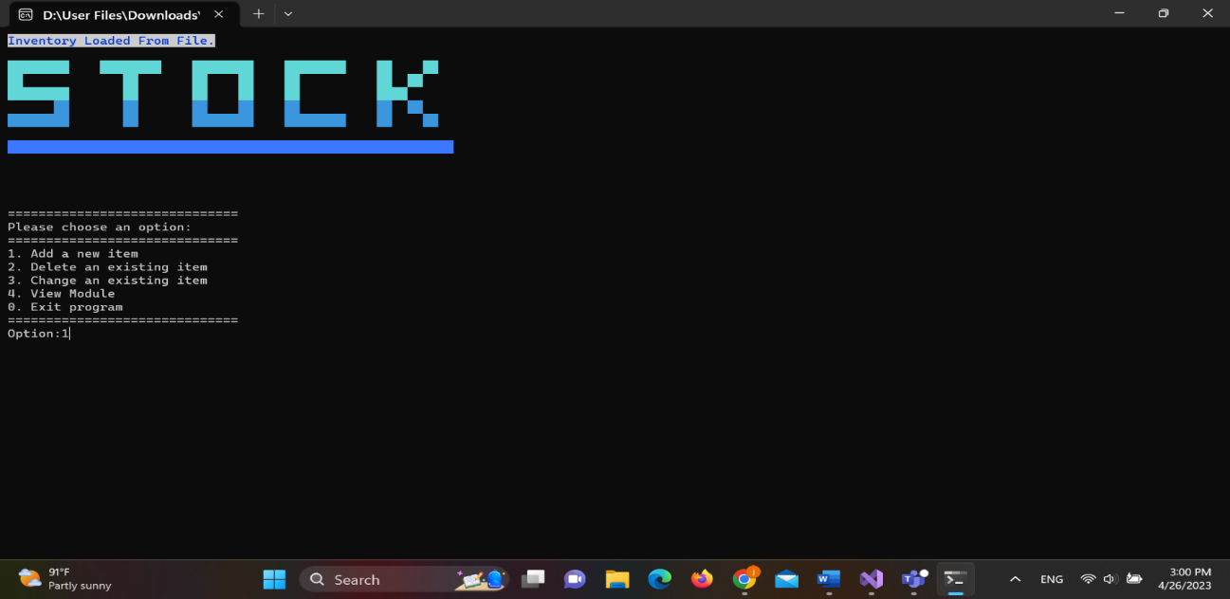

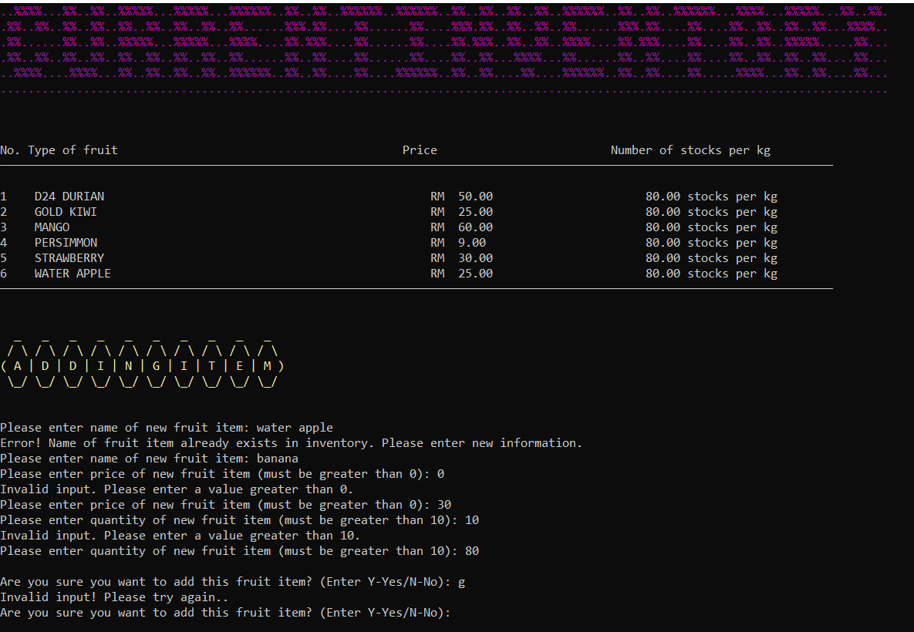

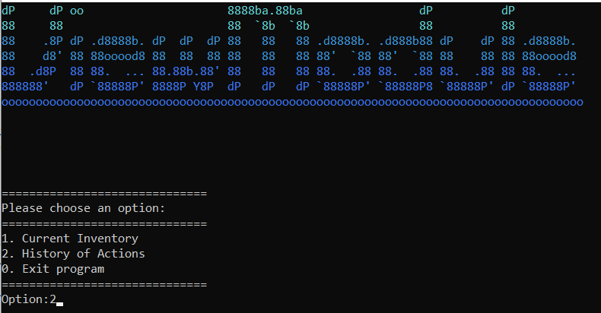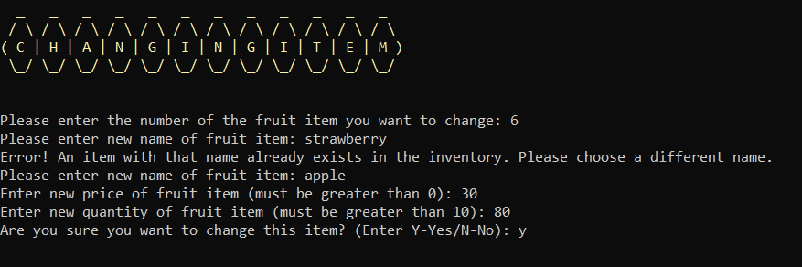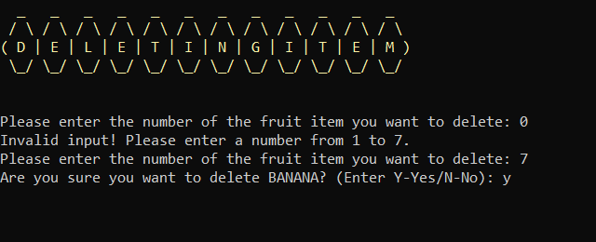

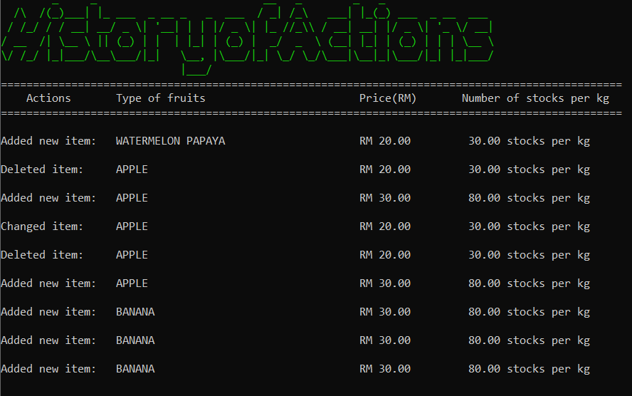

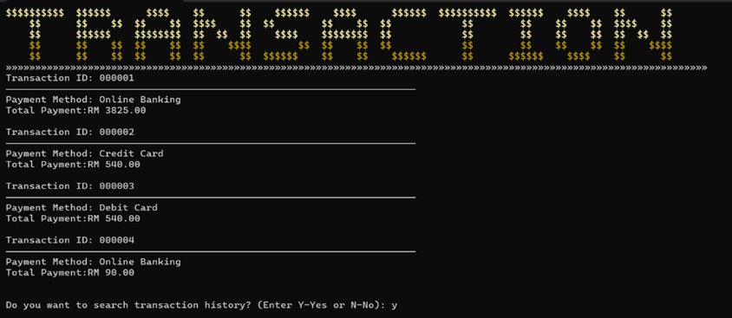

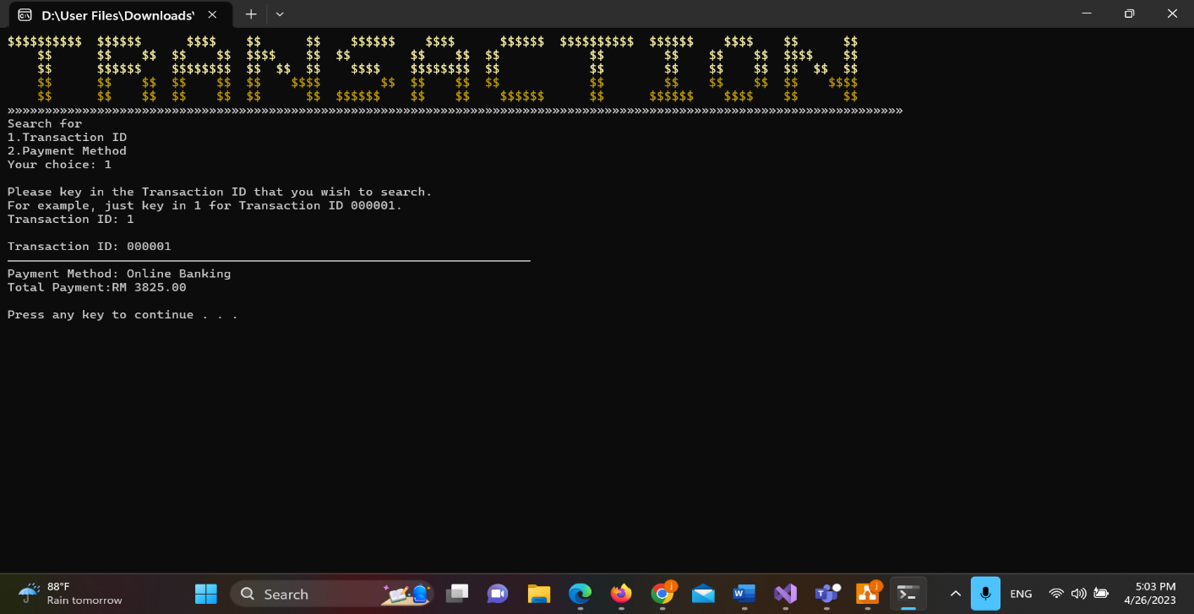

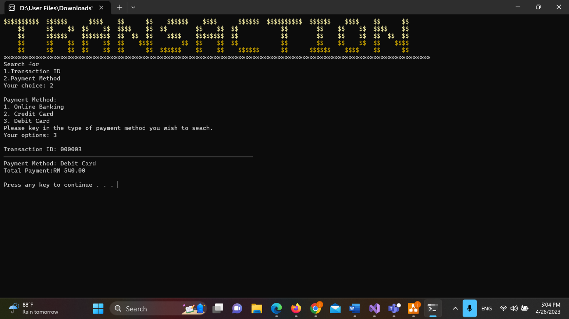

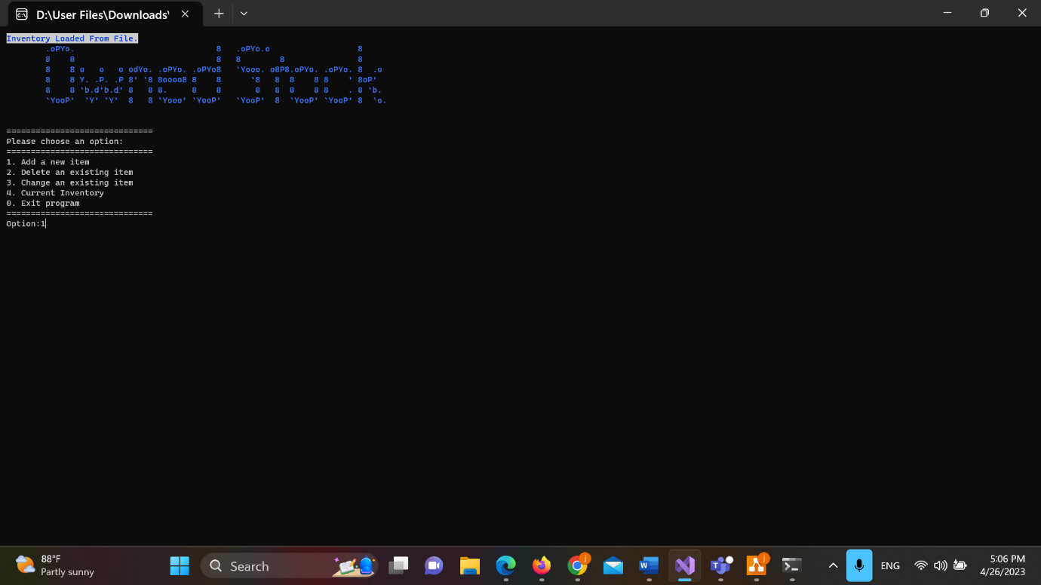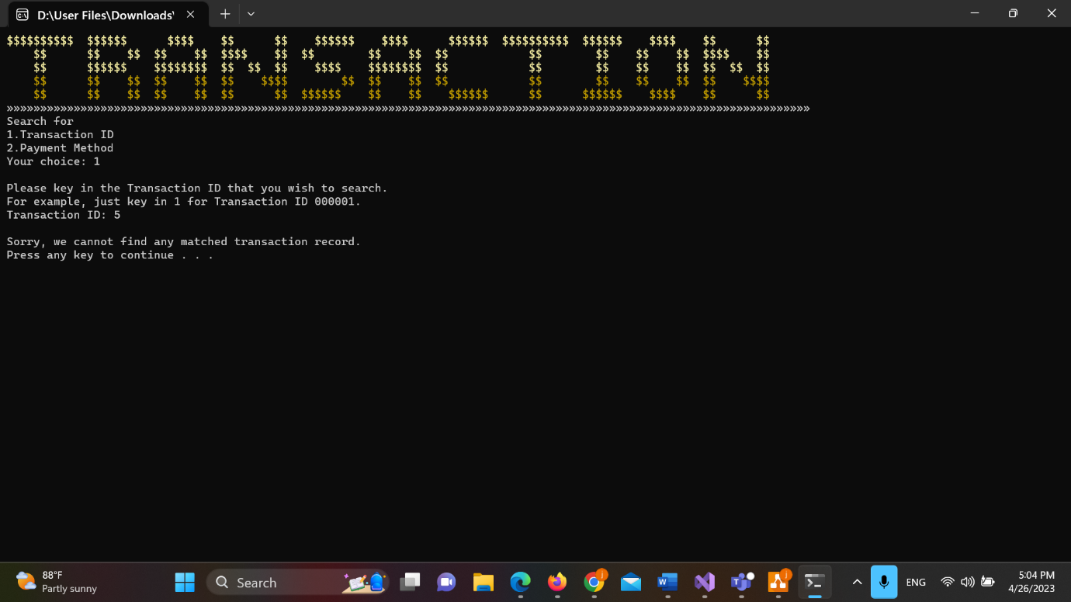

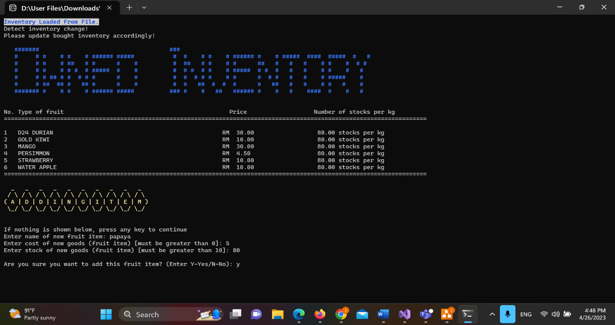

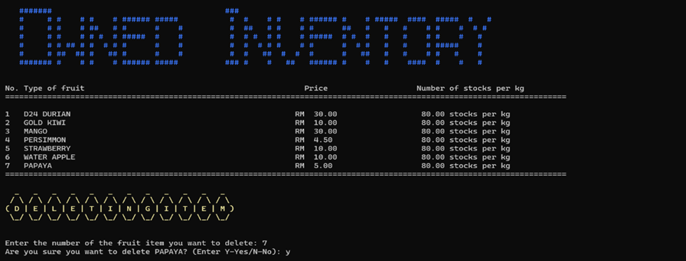

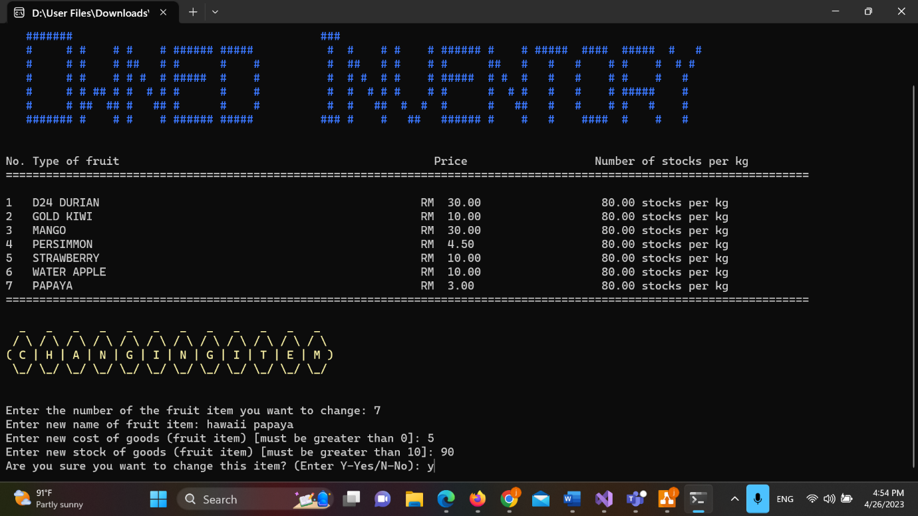

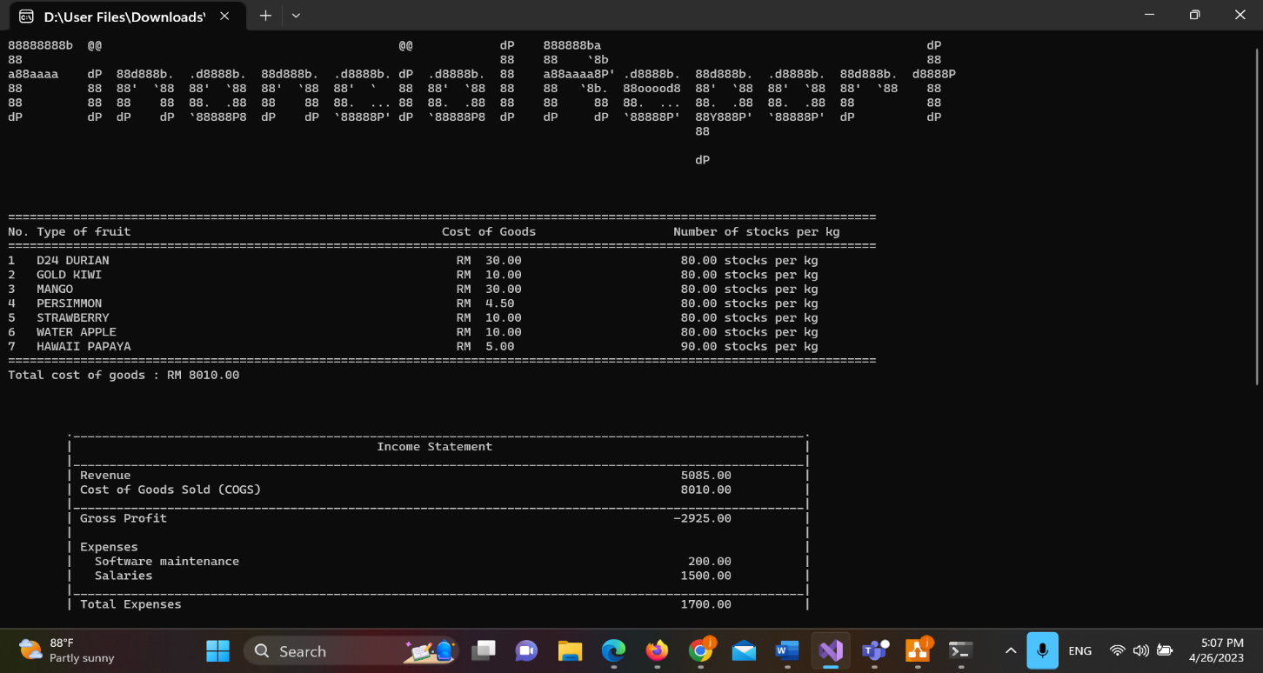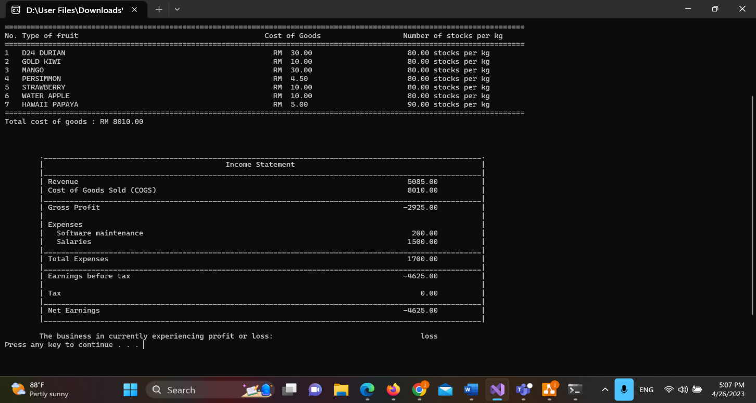

**Source code**

#include <iostream>

#include<iomanip>

#include<string>

#include<string.h>

#include<windows.h>

#include<fstream>

using namespace std;

HANDLE h = GetStdHandle(STD_OUTPUT_HANDLE);

double cost_goods(), total_cost, revenue, cost_of_goods, gross_profit, software_maintenance, total_expenses, earnings_bf_tax, tax, net_earnings, salaries, earn_being_taxed, cost = 0 /*global variable*/;

int getIntegerInput(), no_worker;

const int MAX_ITEMS = 100; /*Maximum number of items in inventory*/

const char fruitFile[] = "fruit_inventory.txt" /* Name of file to store inventory*/; const char inGoods[] = "CostGoods.txt"/* Name of file to store the cost of goods and num of stock*/;

const int MAX_ORDER = 100; // Maximum number of order item

struct fruitItem {

char name[100];

double price;

double quantity;

};

struct costItem {

char name[100];

double cost;

double stock;

};

void mainHeader() { //AURORA FRUIT STALL

SetConsoleTextAttribute(h, 14);

cout << " .d8b. db db d8888b. .d88b. d8888b. .d8b. d88888b d8888b. db db d888888b d888888b .d8888. d888888b .d8b. db db " << endl;

SetConsoleTextAttribute(h, 6);

cout << " d8' `8b 88 88 88 `8D .8P Y8. 88 `8D d8' `8b 88' 88 `8D 88 88 `88' `~~88~~' 88' YP `~~88~~' d8' `8b 88 88 " << endl;

SetConsoleTextAttribute(h, 12);

cout << " 88ooo88 88 88 88oobY' 88 88 88oobY' 88ooo88 88ooo 88oobY' 88 88 88 88 `8bo. 88 88ooo88 88 88 " << endl;

SetConsoleTextAttribute(h, 10);

cout << " 88~~~88 88 88 88`8b 88 88 88`8b 88~~~88 88~~~ 88`8b 88 88 88 88 `Y8b. 88 88~~~88 88 88 " << endl;

SetConsoleTextAttribute(h, 11);

cout << " 88 88 88b d88 88 `88. `8b d8' 88 `88. 88 88 88 88 `88. 88b d88 .88. 88 db 8D 88 88 88 88booo. 88booo." << endl;

cout << " YP YP ~Y8888P' 88 YD `Y88P' 88 YD YP YP YP 88 YD ~Y8888P' Y888888P YP `8888Y' YP YP YP Y88888P Y88888P " << endl;

SetConsoleTextAttribute(h, 7);

}

void saleHeader() {

SetConsoleTextAttribute(h, 6);

cout << string(2, ' ') << string(6, char(178)) << string(2, ' ') << string(6, char(178)) << string(2, ' ') << string(2, char(178)) << string(6, ' ') << string(6, char(178));

cout << string(2, ' ') << string(10, char(178)) << string(2, ' ') << string(6, char(178)) << string(2, ' ') << string(6, char(178)) << string(2, char(220)) << string(2, ' ') << string(2, char(178)) << string(4, ' ') << string(2, char(178)) << string(2, ' ') << string(2, char(178)) << string(6, ' ') << string(6, char(178)) << string(1, ' ') << endl;

cout << string(2, ' ') << string(2, char(178)) << string(6, ' ') << string(2, char(178)) << string(2, ' ') << string(2, char(178)) << string(2, ' ') << string(2, char(178)) << string(6, ' ') << string(2, char(178)) << string(4, ' ');

cout << string(2, ' ') << string(2, char(178)) << string(2, ' ') << string(2, char(178)) << string(2, ' ') << string(2, char(178)) << string(2, ' ') << string(2, char(178)) << string(2, ' ') << string(2, char(178)) << string(2, ' ') << string(2, char(178)) << string(2, ' ') << string(1, char(176)) << string(3, char(178)) << string(2, ' ') << string(2, char(178)) << string(4, ' ') << string(2, char(178)) << string(2, ' ') << string(2, char(178)) << string(6, ' ') << string(2, char(178)) << string(5, ' ') << endl;

cout << string(2, ' ') << string(6, char(178)) << string(2, ' ') << string(6, char(178)) << string(2, ' ') << string(2, char(178)) << string(6, ' ') << string(6, char(178));

cout << string(2, ' ') << string(2, char(178)) << string(2, ' ') << string(2, char(178)) << string(2, ' ') << string(2, char(178)) << string(2, ' ') << string(2, char(178)) << string(2, ' ') << string(2, char(178)) << string(2, ' ') << string(2, char(178)) << string(2, ' ') << string(1, char(176)) << string(3, char(178)) << string(2, ' ') << string(2, char(178)) << string(4, ' ') << string(2, char(178)) << string(2, ' ') << string(2, char(178)) << string(6, ' ') << string(6, char(178)) << string(1, ' ') << endl;

cout << string(6, ' ') << string(2, char(178)) << string(2, ' ') << string(2, char(178)) << string(2, ' ') << string(2, char(178)) << string(2, ' ') << string(2, char(178)) << string(6, ' ') << string(2, char(178)) << string(4, ' ');

cout << string(2, ' ') << string(2, char(178)) << string(6, ' ') << string(2, char(178)) << string(2, ' ') << string(2, char(178)) << string(2, ' ') << string(2, char(178)) << string(2, ' ') << string(2, char(178)) << string(2, ' ') << string(1, char(176)) << string(3, char(178)) << string(2, ' ') << string(2, char(178)) << string(4, ' ') << string(2, char(178)) << string(2, ' ') << string(2, char(178)) << string(6, ' ') << string(2, char(178)) << string(5, ' ') << endl;

cout << string(2, ' ') << string(6, char(178)) << string(2, ' ') << string(2, char(178)) << string(2, ' ') << string(2, char(178)) << string(2, ' ') << string(6, char(178)) << string(2, ' ') << string(6, char(178));

cout << string(2, ' ') << string(2, char(178)) << string(6, ' ') << string(2, char(178)) << string(2, ' ') << string(6, char(178)) << string(2, ' ') << string(6, char(178)) << string(2, char(223)) << string(2, ' ') << string(8, char(178)) << string(2, ' ') << string(6, char(178)) << string(2, ' ') << string(6, char(178)) << string(1, ' ') << endl;

SetConsoleTextAttribute(h, 7);

cout << string(120, char(196)) << endl << endl << endl;

}

void transactionHeader() {

SetConsoleTextAttribute(h, 14);

cout << "$$$$$$$$$$ $$$$$$ $$$$ $$ $$ $$$$$$ $$$$ $$$$$$ $$$$$$$$$$ $$$$$$ $$$$ $$ $$ " << endl;

cout << " $$ $$ $$ $$ $$ $$$$ $$ $$ $$ $$ $$ $$ $$ $$ $$ $$$$ $$ " << endl;

cout << " $$ $$$$$$ $$$$$$$$ $$ $$ $$ $$$$ $$$$$$$$ $$ $$ $$ $$ $$ $$ $$ $$ " << endl;

SetConsoleTextAttribute(h, 6);

cout << " $$ $$ $$ $$ $$ $$ $$$$ $$ $$ $$ $$ $$ $$ $$ $$ $$ $$$$" << endl;

cout << " $$ $$ $$ $$ $$ $$ $$ $$$$$$ $$ $$ $$$$$$ $$ $$$$$$ $$$$ $$ $$ " << endl;

SetConsoleTextAttribute(h, 7);

cout << string(120, char(175)) << endl;

}

int getIntegerInput() {// Function to validate integer input

int input;

while (true) {

cin >> input;

if (cin.fail()) { // Check if input failed

cin.clear(); // Clear error flags

cin.ignore(10000, '\n'); // Ignore invalid input

cout << "Invalid input. Please enter an integer:";

}

else {

cin.ignore(10000, '\n'); // Ignore any extra characters

return input;

}

}

}

double getDoubleInput() {// Function to validate double input

double input;

while (true) {

cin >> input;

if (cin.fail()) { // Check if input failed

cin.clear(); // Clear error flags

cin.ignore(10000, '\n'); // Ignore invalid input

cout << "Invalid input. Please enter a number:";

}

else {

cin.ignore(10000, '\n'); // Ignore any extra characters

return input;

}

}

}

int getOrderNo() {//This function gets the last order number in the transaction file.The order number is the same as the transaction ID.

int orderno = 0;

double totalpay;

string paymentmethod;

ifstream itransactionfile;

itransactionfile.open("transaction.txt");

if (itransactionfile.fail()) {

cout << "Unable to get Order ID.\n";

}

else {

while (!itransactionfile.eof()) {//loop until the latest order number

itransactionfile >> orderno;

itransactionfile.ignore();

itransactionfile >> totalpay;

itransactionfile.ignore();

getline(itransactionfile, paymentmethod);

}

}

itransactionfile.close();

return orderno;

}

void updateSale(fruitItem inventory[], int no_fruit) {//This function is to update the sold item in the inventory file.

ofstream outstockfile(fruitFile);

if (outstockfile.is_open()) {

for (int i = 0; i < no_fruit; i++) {

outstockfile << inventory[i].name << endl;

outstockfile << fixed << setprecision(2) << inventory[i].price << " " << inventory[i].quantity << endl;

}

cout << "You can process to payment.Thank you!\n";

}

else {

cout << "Sorry, we are unable to process the payment because we were unable to update the order in the file.\n";//If you are unable to open the inventory file and update it, the sale cannot be processed for payment.

}

outstockfile.close();

}

void currentInventoryHeader() {

SetConsoleTextAttribute(h, 13);

cout << "..%%%%...%%..%%..%%%%%...%%%%%...%%%%%%..%%..%%..%%%%%%..%%%%%%..%%..%%..%%..%%..%%%%%%..%%..%%..%%%%%%...%%%%...%%%%%...%%..%%." << endl;

cout << ".%%..%%..%%..%%..%%..%%..%%..%%..%%......%%%.%%....%%......%%....%%%.%%..%%..%%..%%......%%%.%%....%%....%%..%%..%%..%%...%%%%.." << endl;

cout << ".%%......%%..%%..%%%%%...%%%%%...%%%%....%%.%%%....%%......%%....%%.%%%..%%..%%..%%%%....%%.%%%....%%....%%..%%..%%%%%.....%%..." << endl;

SetConsoleTextAttribute(h, 5);

cout << ".%%..%%..%%..%%..%%..%%..%%..%%..%%......%%..%%....%%......%%....%%..%%...%%%%...%%......%%..%%....%%....%%..%%..%%..%%....%%..." << endl;

cout << "..%%%%....%%%%...%%..%%..%%..%%..%%%%%%..%%..%%....%%....%%%%%%..%%..%%....%%....%%%%%%..%%..%%....%%.....%%%%...%%..%%....%%..." << endl;

cout << "................................................................................................................................" << endl;

SetConsoleTextAttribute(h, 7);

cout << "\n\n\n";

}

void currentInventory(fruitItem inventory[], int numItems) {//Function to show users current inventory

cout << "No. " << "Type of fruit\t\t\t\t\t\t" << " Price\t\t\t\t" << " Number of stocks per kg" << endl;

cout << string(130, char(196));

cout << "\n\n";

for (int i = 0; i < numItems; i++) {

cout << left << setw(5) << i + 1 << left << setw(50) << inventory[i].name;

cout << "\t";

cout << right << setw(12) << "RM " << fixed << setprecision(2) << inventory[i].price;

cout << "\t\t\t";

if (inventory[i].quantity == 0) {

cout << "\t\tSold Out\n";

}

else {

cout << right << setw(10) << inventory[i].quantity << " stocks per kg\n";

}

}

cout << string(130, char(196)) << endl << endl;

}

void purchaseItem(fruitItem inventory[], int optionIndex, double& fruitamount, double& totalpayment) {//calculate the price of the order item

double itemprice;

bool validamount = false;//check for the valid input amount and initialize the loop

while (validamount == false) {// Set the validamount to false to allow the user to re-enter the amount

cout << "Please enter the amount of the fruit in kg that you wish to purchase:";

fruitamount = getDoubleInput();

if (fruitamount <= 0) {

cout << "Invalid quantity! Please key in a positive integer value.\n";

validamount = false;

}

else if (fruitamount > inventory[optionIndex].quantity) {

if (inventory[optionIndex].quantity == 0) {

cout << "Sorry," << inventory[optionIndex].name << " are sold out.\n";

fruitamount = 0;

validamount = true;

}

else {

cout << "Sorry, we only have " << inventory[optionIndex].quantity << "kg of " << inventory[optionIndex].name << " available.\n";

validamount = false;

}

}

else {

itemprice = fruitamount * inventory[optionIndex].price;

cout << "You have ordered " << fixed << setprecision(2) << fruitamount << "kg of ";

cout << inventory[optionIndex].name << " with total price is RM " << itemprice << "." << endl;

totalpayment += itemprice;

validamount = true;

}

}

}

void discount(double& total_cost) {//Function to check whether is the customer eligible for a discount //Once total cost is more than RM200, customer will be awarded a 10% discount and the total cost will be calculated

if (total_cost >= 200)

{

cout << "Your total cost is RM " << total_cost << ". You are eligible for a 10% discount" << endl;

total_cost *= (90.0 / 100);

cout << "After 10% discount, your total cost is RM " << fixed << setprecision(2) << total_cost << endl;

}

else {

cout << "Your total cost is RM " << total_cost << endl;

}

}

void updateTransactionRecord(double& totalpayment, int& orderno, string paymethod) {

ofstream otransactionfile;

otransactionfile.open("transaction.txt", ios::app);

if (otransactionfile.is_open()) {

otransactionfile << orderno << endl;

otransactionfile << fixed << setprecision(2) << totalpayment << endl;

otransactionfile << paymethod << endl;

cout << "Transaction saved to file!\n";

}

else {//if the transaction file unable to open, the user unable to save their transaction to file

cout << "Failed to save transaction to file.\n";

}

otransactionfile.close();

}

double total_revenue() {//function to calculate the total revenue of the sales which will be used in income statement

ifstream itransactionfile;

itransactionfile.open("transaction.txt");

double totalpayment = 0.0, revenue = 0.0;

int orderno = 0;

string paymethod;

char space = ' ';

if (itransactionfile.is_open()) {

while (!itransactionfile.eof()) {

itransactionfile >> orderno;

itransactionfile >> totalpayment;

// Read the rest of the line as the payment method

getline(itransactionfile >> space, paymethod);

revenue += totalpayment;

}

}

else {

cout << "Failed to open file.\n";

}

itransactionfile.close();

return revenue;

}

void payment_options() {//function that stores the payment options which will be used in the sales module function

cout << "1. Online Banking" << endl;

cout << "2. Credit Card" << endl;

cout << "3. Debit Card" << endl;

}

void getPaymentOpt(string& payMethod) {

int paymethodOpt;

do {

cout << "Your options: ";

paymethodOpt = getIntegerInput();

if (paymethodOpt == 1)

payMethod = "Online Banking";

else if (paymethodOpt == 2)

payMethod = "Credit Card";

else if (paymethodOpt == 3)

payMethod = "Debit Card";

else

cout << "Invalid option!\n";

} while (paymethodOpt != 1 && paymethodOpt != 2 && paymethodOpt != 3);

}

bool salesmodule(int& orderno, string purchaseitem[], double purchaseamount[]) {

fruitItem inventory[MAX_ITEMS];

int no_fruit = 0;//number of types of fruit in inventory

double fruitamount = 0.0, totalpayment = 0.0;

string paymethod;

int option, optionIndex;

char p_decision = 'Y', gopay, viewreceipt;

int noitem = 0;//record the total number of item purchased

for (int i = 0; i < MAX_ITEMS; i++) {

inventory[i].name[0] = '\0'; // set name to empty string

inventory[i].price = 0.0; // set price to zero

inventory[i].quantity = 0; // set quantity to zero

}

//load the name of the fruit, price of fruit, and quantity of fruit to display on the menu for the user

ifstream instockfile(fruitFile);

if (instockfile.is_open()) {

while (no_fruit < MAX_ITEMS && instockfile.peek() != EOF) {

instockfile.getline(inventory[no_fruit].name, 100);

instockfile >> inventory[no_fruit].price >> inventory[no_fruit].quantity;

no_fruit++;

instockfile.ignore();

}

}

else {

cout << "Unable to open inventory file.\n";

}

instockfile.close();

saleHeader();

currentInventory(inventory, no_fruit);

do {

cout << "Please select an option from the list(1-" << no_fruit << "): ";

option = getIntegerInput();

if (option < 1 || option > no_fruit) {

cout << "Invalid Input.Please pick a number from the list.\n";

p_decision = 'Y';

}

else {

optionIndex = option - 1;//because the index start from 0 so need to minus 1

purchaseItem(inventory, optionIndex, fruitamount, totalpayment);

if (fruitamount > 0) {

inventory[option - 1].quantity -= fruitamount;

purchaseitem[noitem] = inventory[option - 1].name;

purchaseamount[noitem] = fruitamount;

++noitem;

}

do {

cout << "Do you want to order other fruits? (Enter Y-Yes/N-No): ";

cin >> p_decision;

if (toupper(p_decision) != 'Y' && toupper(p_decision) != 'N') {

cout << "Invalid Input!" << endl;

}

} while (toupper(p_decision) != 'Y' && toupper(p_decision) != 'N');

}

cout << endl;

} while (toupper(p_decision) != 'N');

do {

cout << endl;

cout << "Do you confirm your order?(Y to process to payment or N to process to exit): ";

cin >> gopay;

if (gopay != 'Y' && gopay != 'N' && gopay != 'y' && gopay != 'n') {

cout << "Invalid Input!\n ";

}

} while (toupper(gopay) != 'Y' && toupper(gopay) != 'N');

if (toupper(gopay) == 'Y') {

discount(totalpayment);

cout << "Payment Options: " << endl;

payment_options();

getPaymentOpt(paymethod);

updateSale(inventory, no_fruit);

updateTransactionRecord(totalpayment, orderno, paymethod);//save transaction record to customer transaction history

orderno++;

do {

cout << "Do you want to view receipt? (Enter Y-Yes or N-No):";

cin >> viewreceipt;

cout << endl;

if (toupper(viewreceipt) == 'Y') {

system("cls");

cout << string(100, char(240)) << endl;

cout << "\t\t\tReceipt" << endl;

cout << string(100, char(240)) << endl;

for (int i = 0; i < noitem; i++) {

cout << i + 1 << ". " << left << setw(40) << purchaseitem[i] << "\t\t" << setw(6) << purchaseamount[i] << "Kg" << endl;

}

cout << string(100, char(240)) << endl;

cout << "Payment Method: " << paymethod << endl;

cout << "Total payment:RM " << fixed << setprecision(2) << totalpayment << endl;

}

} while (toupper(viewreceipt) != 'Y' && toupper(viewreceipt) != 'N');

return true;

}

else {

return false;

}

}

void displayTransaction(string orderNo, string paymentmethod, double totalpayment) {

string transactionid;

if (orderNo.length() < 6) {//Check the length of the order number in order to add zero in front of it.Set at least 6 digits for transaction ID

transactionid = string(6 - orderNo.length(), char(48)) + orderNo;

}

else {//if the transaction id more than six digits

transactionid = orderNo;

}

cout << "Transaction ID: " << transactionid << endl;

cout << string(70, char(196)) << endl;

cout << "Payment Method: " << paymentmethod << endl;

cout << "Total Payment:RM " << fixed << setprecision(2) << totalpayment << endl << endl;

}

void loadTransactionHistory(int& orderno) {

int i = 0;

string transactionid, orderNo, paymentmethod;//The order number stored as a string because we need to convert it to a transaction ID.

double totalpayment;

ifstream itransactionfile;

itransactionfile.open("transaction.txt");

if (itransactionfile.fail()) {

cout << "Unable to open transaction record file.\n";

}

else {// Read the order number, total payment, and payment method from the transaction file

while (i < orderno && itransactionfile.peek() != EOF) {//loop continues until i reaches the total number of orders

getline(itransactionfile, orderNo);

itransactionfile >> totalpayment;

itransactionfile.ignore();

getline(itransactionfile, paymentmethod);

if (totalpayment >= 0) {

displayTransaction(orderNo, paymentmethod, totalpayment);

i++;

}

}

if (i == 0) {

cout << "No transaction record !\n";

}

}

itransactionfile.close();

}

void searchResult(int orderno, string payMethod, string transactionID) {//Function check the search from the transaction file

int i = 0;

int searchNo = 0;//Record the number of matched search results.

string paymentmethod, transactionid, orderNo;//declare orderNo as string to create transaction id

double totalpayment;

ifstream itransactionfile;

itransactionfile.open("transaction.txt");

if (itransactionfile.fail()) {

cout << "Unable to open transaction record file.\n";

}

else {

while (i < orderno && itransactionfile.peek() != EOF) {

itransactionfile >> orderNo;

itransactionfile.ignore();

itransactionfile >> totalpayment;

itransactionfile.ignore();

getline(itransactionfile, paymentmethod);

if (orderNo == transactionID || paymentmethod == payMethod) {//check any matched search result

displayTransaction(orderNo, paymentmethod, totalpayment);

++searchNo;

}

i++;

}

if (searchNo == 0) {

cout << "Sorry, we cannot find any matched transaction record.\n";

}

}

itransactionfile.close();

}

void search(int& orderno) {// Get what the user want to search

int searchdecision;

int paymethodOpt = 0;

string transactionID, payMethod;

cout << "Search for \n";

cout << "1.Transaction ID " << endl;

cout << "2.Payment Method " << endl;

cout << "Your choice: ";

searchdecision = getIntegerInput();

while (searchdecision < 1 || searchdecision>2) {

cout << "Invalid Input! Please key in 1 or 2: ";

searchdecision = getIntegerInput();

}

cout << endl;

if (searchdecision == 1) {

cout << "Please key in the Transaction ID that you wish to search.\n";

cout << "For example, just key in 1 for Transaction ID 000001.\n";

cout << "Transaction ID: ";

cin >> transactionID;

}

else {//search for payment method

cout << "Payment Method:\n";

payment_options();

cout << "Please key in the type of payment method you wish to seach.\n";

getPaymentOpt(payMethod);

}

cout << endl;

searchResult(orderno, payMethod, transactionID);

}

void transactionHistory(int& orderno) {//display the transaction history

char searchOpt;

transactionHeader();

loadTransactionHistory(orderno);

cout << endl;

cout << "Do you want to search transaction history? (Enter Y-Yes or N-No): ";

cin >> searchOpt;

while (toupper(searchOpt) != 'Y' && toupper(searchOpt) != 'N') {

cout << "Invalid Input!\n";

cout << "Please key in Y if you want to search transaction history or N if you do not want to search transaction history: ";

cin >> searchOpt;

}

if (toupper(searchOpt) == 'Y') {

system("cls");

transactionHeader();

search(orderno);

}

system("pause");

}

bool itemExists(const fruitItem& newItem, const fruitItem inventory[], int numItems) {// Function to check if a fruit item already exists in the inventory

for (int i = 0; i < numItems; i++) {

if (strcmp(newItem.name, inventory[i].name) == 0) {

return true;

}

}

return false;

}

bool itemCostExists(const costItem& newItem, const costItem cost_inventory[], int numItems) {// Function to check if a fruit item already exists in the inventory

for (int i = 0; i < numItems; i++) {

if (strcmp(newItem.name, cost_inventory[i].name) == 0) {

return true;

}

}

return false;

}

void updateCostFile(costItem cost_inventory[], int& numItems) {// Function to update file with new inventory after deleting or changing an fruit item

ofstream outFile(inGoods);

if (outFile.is_open()) {

for (int i = 0; i < numItems; i++) {

outFile << cost_inventory[i].name << endl;

outFile << fixed << setprecision(2) << cost_inventory[i].cost << " " << cost_inventory[i].stock << endl;

}

outFile.close();

SetConsoleTextAttribute(h, 113);

cout << "Inventory updated.\n";

SetConsoleTextAttribute(h, 7);

}

else {

SetConsoleTextAttribute(h, 113);

cout << "Error! Could not open inventory file for writing.\n";

SetConsoleTextAttribute(h, 7);

}

SetConsoleTextAttribute(h, 7);

}

void currentCostInventory(costItem cost_inventory[], int& numItems) {//Function to show users current inventory

cout << "\n" << "\x1b[94m";

cout << " ####### ### " << endl;

cout << " # # # # # # ###### ##### # # # # # ###### # # ##### #### ##### # # " << endl;

cout << " # # # # ## # # # # # ## # # # # ## # # # # # # # # " << endl;

cout << " # # # # # # # ##### # # # # # # # # ##### # # # # # # # # # " << endl;

cout << " # # # ## # # # # # # # # # # # # # # # # # # # # ##### # " << endl;

cout << " # # ## ## # ## # # # # # ## # # # # ## # # # # # # " << endl;

cout << " ####### # # # # ###### ##### ### # # ## ###### # # # #### # # #" << endl;

cout << "\x1b[37m" << "\n\n";

cout << "No. " << "Type of fruit\t\t\t\t\t\t" << "Price\t\t\t" << "Number of stocks per kg" << endl;

cout << string(120, char(61)) << "\n\n";

for (int i = 0; i < numItems; i++) {

cout << left << setw(4) << i + 1 << left << setw(50) << cost_inventory[i].name << "\t";

cout << right << setw(10) << "RM " << fixed << setprecision(2) << cost_inventory[i].cost << "\t\t\t";

cout << right << setw(6) << cost_inventory[i].stock << " stocks per kg\n";

}

cout << string(120, char(61)) << endl;

}

void addNewCostItem(costItem cost_inventory[], int& numItems) {//Function to add a fruit item into the inventory

currentCostInventory(cost_inventory, numItems);

SetConsoleTextAttribute(h, 14);

cout << "\n" << " _ _ _ _ _ _ _ _ _ _ " << endl;

cout << " / \\ / \\ / \\ / \\ / \\ / \\ / \\ / \\ / \\ / \\ " << endl;

cout << "( A | D | D | I | N | G | I | T | E | M )" << endl;

cout << " \\_/ \\_/ \\_/ \\_/ \\_/ \\_/ \\_/ \\_/ \\_/ \\_/ " << "\n\n" << endl;

costItem newItem;

SetConsoleTextAttribute(h, 7);

cout << "If nothing is shown below, press any key to continue" << endl;

cin.ignore(); //ignore the newline character from previous input;

cout << "Enter name of new fruit item: ";

cin.getline(newItem.name, 100);

for (int i = 0; i < strlen(newItem.name); i++) {// Convert name to uppercase

newItem.name[i] = toupper(newItem.name[i]);

}

while (itemCostExists(newItem, cost_inventory, numItems)) {// Check if new fruit item already exists in inventory

cout << "Error! Name of fruit item already exists in inventory. Please enter new information.\n";

cout << "Enter name of new fruit item: ";

cin.getline(newItem.name, 100);

for (int i = 0; i < strlen(newItem.name); i++) {// Convert name to uppercase

newItem.name[i] = toupper(newItem.name[i]);

}

}

do {

cout << "Enter cost of new goods (fruit item) [must be greater than 0]: ";

newItem.cost = getDoubleInput();

if (newItem.cost <= 0) {

cout << "Invalid input. Please enter a value greater than 0." << endl;

}

} while (newItem.cost <= 0);

do {

cout << "Enter stock of new goods (fruit item) [must be greater than 10]: ";

newItem.stock = getDoubleInput();

if (newItem.stock <= 10) {

cout << "Invalid input. Please enter a value greater than 10." << endl;

}

} while (newItem.stock <= 10);

cout << endl;

SetConsoleTextAttribute(h, 7);

int itemIndex = -1;

costItem tempItem = cost_inventory[itemIndex]; // create a copy of the item before modifying it

char confirmation;

do {// Confirm the addition with the user

cout << "Are you sure you want to add this fruit item? (Enter Y-Yes/N-No): ";

cin >> confirmation;

if (toupper(confirmation) == 'N') {

cout << "Fruit item added canceled.\n";

cost_inventory[itemIndex] = tempItem; // restore the original values from the copy

}

else if (toupper(confirmation) == 'Y') {

if (numItems < MAX_ITEMS) {// Add new fruit item to inventory

cost_inventory[numItems] = newItem;

numItems++;

SetConsoleTextAttribute(h, 113);

cout << "New fruit item added successfully to inventory.\n";

}

else {

SetConsoleTextAttribute(h, 113);

cout << "Error! Maximum inventory capacity reached. Cannot add new item.\n";

return; //exit the function if maximum inventory capacity has been reached

}

ofstream outFile(inGoods);// Save updated inventory to file

if (outFile.is_open()) {

for (int i = 0; i < numItems; i++) {

outFile << cost_inventory[i].name << endl;

outFile << fixed << setprecision(2) << cost_inventory[i].cost << " " << cost_inventory[i].stock << endl;

}

outFile.close();

SetConsoleTextAttribute(h, 113);

cout << "Inventory saved to file.\n";

}

else {

SetConsoleTextAttribute(h, 113);

cout << "Error! Could not open inventory file for writing.\n";

}

}

else {

cout << "Invalid input! Please try again.." << endl;

}

} while (toupper(confirmation) != 'Y' && toupper(confirmation) != 'N');

SetConsoleTextAttribute(h, 7);

}

void deleteCostItem(costItem cost_inventory[], int& numItems) {// Function to delete a fruit item from the inventory

currentCostInventory(cost_inventory, numItems);

SetConsoleTextAttribute(h, 14);

cout << "\n" << " _ _ _ _ _ _ _ _ _ _ _ _ " << endl;

cout << " / \\ / \\ / \\ / \\ / \\ / \\ / \\ / \\ / \\ / \\ / \\ / \\ " << endl;

cout << "( D | E | L | E | T | I | N | G | I | T | E | M )" << endl;

cout << " \\_/ \\_/ \\_/ \\_/ \\_/ \\_/ \\_/ \\_/ \\_/ \\_/ \\_/ \\_/ " << "\n\n" << endl;

SetConsoleTextAttribute(h, 7);

int itemIndex = -1;

while (itemIndex == -1) {

cout << "Enter the number of the fruit item you want to delete: ";

itemIndex = getIntegerInput() - 1;

if (itemIndex < 0 || itemIndex >= numItems) {

cout << "Invalid input! Please enter a number between 1 and " << numItems << ".\n";

itemIndex = -1;

}

}

char confirm;

do {

cout << "Are you sure you want to delete " << cost_inventory[itemIndex].name << "? (Enter Y-Yes/N-No): ";

cin >> confirm;

if (toupper(confirm) == 'Y') {

for (int i = itemIndex; i < numItems - 1; i++) {// Shift all items after the deleted item back by one index

cost_inventory[i] = cost_inventory[i + 1];

}

numItems--;

cout << "--Fruit item deleted.--\n";

updateCostFile(cost_inventory, numItems);// Update file with new inventory

}

else if (toupper(confirm) == 'N') {

cout << "--Fruit item deleted cancel--" << endl;

updateCostFile(cost_inventory, numItems);

}

else {

cout << "Invalid input! Please enter again.." << endl;

}

} while (toupper(confirm) != 'Y' && toupper(confirm) != 'N');

}

void changeCostItem(costItem cost_inventory[], int& numItems) {// Function to change a fruit item in the inventory

currentCostInventory(cost_inventory, numItems); //display current inventory

SetConsoleTextAttribute(h, 14);

cout << "\n" << " _ _ _ _ _ _ _ _ _ _ _ _ " << endl;

cout << " / \\ / \\ / \\ / \\ / \\ / \\ / \\ / \\ / \\ / \\ / \\ / \\" << endl;

cout << "( C | H | A | N | G | I | N | G | I | T | E | M )" << endl;

cout << " \\_/ \\_/ \\_/ \\_/ \\_/ \\_/ \\_/ \\_/ \\_/ \\_/ \\_/ \\_/" << "\n\n" << endl;

SetConsoleTextAttribute(h, 7);

int itemIndex = -1;

while (itemIndex == -1) {

cout << "Enter the number of the fruit item you want to change: ";

itemIndex = getIntegerInput() - 1;

if (itemIndex < 0 || itemIndex >= numItems) {

cout << "Invalid input. Please enter a number from 1 to " << numItems << ".\n";

itemIndex = -1;

}

}

costItem tempItem = cost_inventory[itemIndex]; // create a copy of the item before modifying it

cout << "Enter new name of fruit item: ";

cin.getline(cost_inventory[itemIndex].name, 100);

for (int i = 0; i < strlen(cost_inventory[itemIndex].name); i++) {// Convert name to uppercase

cost_inventory[itemIndex].name[i] = toupper(cost_inventory[itemIndex].name[i]);

}

do {

cout << "Enter new cost of goods (fruit item) [must be greater than 0]: ";

cost_inventory[itemIndex].cost = getDoubleInput();

if (cost_inventory[itemIndex].cost <= 0) {

cout << "Invalid input. Please enter a value greater than 0." << endl;

}

} while (cost_inventory[itemIndex].cost <= 0);

do {

cout << "Enter new stock of goods (fruit item) [must be greater than 10]: ";

cost_inventory[itemIndex].stock = getDoubleInput();

if (cost_inventory[itemIndex].stock <= 10) {

cout << "Invalid input. Please enter a value greater than 10." << endl;

}

} while (cost_inventory[itemIndex].stock <= 10);

char confirmation;

do {// Confirm the change with the user

cout << "Are you sure you want to change this item? (Enter Y-Yes/N-No): ";

cin >> confirmation;

if (toupper(confirmation) == 'Y') {

cout << "Item updated successfully!\n";

updateCostFile(cost_inventory, numItems);// Update file with new inventory information

}

else if (toupper(confirmation) == 'N') {

cout << "Item change canceled.\n";

cost_inventory[itemIndex] = tempItem; // restore the original values from the copy

}

else {

cout << "Invalid input! Please try again.." << endl;

}

} while (toupper(confirmation) != 'Y' && toupper(confirmation) != 'N');

}

void loadingbar() {//Create a loading bar for user

int i = 1; //This is for loop

int x = 219; //This is for loading bar animation

int y = 177; //This is for initial bar

cout << "\n\n\n\n\n\n\n\n\n\n" << "\t\t\t\t\t\t";

cout << "## ####### ### ######## #### ## ## ######" << "\n\t\t\t\t\t\t";

cout << "## ## ## ## ## ## ## ## ### ## ## ##" << "\n\t\t\t\t\t\t";

cout << "## ## ## ## ## ## ## ## #### ## ##" << "\n\t\t\t\t\t\t";

cout << "## ## ## ## ## ## ## ## ## ## ## ## ####" << "\n\t\t\t\t\t\t";

cout << "## ## ## ######### ## ## ## ## #### ## ##" << "\n\t\t\t\t\t\t";

cout << "## ## ## ## ## ## ## ## ## ### ## ##" << "\n\t\t\t\t\t\t";

cout << "######## ####### ## ## ######## #### ## ## ###### " << endl;

cout << "\n\n" << "\t\t\t\t\t";

for (i = 1; i < 80; i++) {

cout << (char)y;

}

cout << "\r" << "\t\t\t\t\t";

for (i = 1; i < 80; i++) {//this loop for increase the Loading

SetConsoleTextAttribute(h, 13);

cout << (char)x;

Sleep(30);

}

system("cls");

}

void warning_bar() {//Warning Bar for user

int i = 1; //This is for loop

int x = 219; //This is for warning bar animation

int y = 177; //This is for initial bar

cout << "\n\n\n\n\n\n\n\n\n\n" << "\t\t\t" << endl;

cout << "\x1b[31m";

cout << string(15, ' ') << "\t\t\t '##:::::::'##::::'####::::'########:::'##:::: ##::'#####:'##::: ##:: '######:: :" << endl;

cout << string(15, ' ') << "\t\t\t ## :'## : ##:::'##：##::: :##.... ##:::###:: :## : .##:: ###:: ## : '##... ##::" << endl;

cout << string(15, ' ') << "\t\t\t ## : ## : ##:::'##:.##:: ：##:::: ##:::####: :##:: ##:: ####: ##: ##:::..:::" << endl;

cout << string(15, ' ') << "\t\t\t ## : ## : ## :'##:::.##: ：########::::## ## :##:: ##:: ## ## ##: ##::'#### :" << endl;

cout << string(15, ' ') << "\t\t\t ## : ## : ## : ######### :##.. ##:::::##. ####:: ##:: ##. #### : ##:: : ##::" << endl;

cout << string(15, ' ') << "\t\t\t ## : ## : ## : ##.... ## :##::. ##::::## : .###:: ##:: ## : .### : ##:: : ##::" << endl;

cout << string(15, ' ') << "\t\t\t . ###. ###:::::##:::: ## :##:: : .##::##::. ## :'#####: ##::. ##:. ######:::" << endl;

cout << string(15, ' ') << "\t\t\t : ...::...:: : ..:::: : ..::..:::: : ..::..::::..::....::..::::..:: : ......::::" << endl;

cout << string(60, ' ') << "Detected inventory change !!!!!" << endl;

cout << string(55, ' ') << "Please update bought inventory accordingly !!!!!" << endl;

cout << "\n\n" << string(2, ' ') << "\t\t\t\t\t";

for (i = 1; i < 80; i++) {

cout << (char)y;

}

cout << "\r" << "\t\t\t\t\t";

for (i = 1; i < 80; i++) { //this loop for increase the Loading

SetConsoleTextAttribute(h, 13);

cout << (char)x;

Sleep(30);

}

system("cls");

}

void Bought_ItemStock() {//Function to allow shop admin add, delete or change items in inventory

ifstream inFile(inGoods);

costItem cost_inventory[MAX_ITEMS];//Load existing inventory from file

int numItems = 0; // Current number of items in inventory

for (int i = 0; i < MAX_ITEMS; i++) {

cost_inventory[i].name[0] = '\0'; // set name to empty string

cost_inventory[i].cost = 0.0; // set cost to zero

cost_inventory[i].stock = 0; // set stock to zero

}

if (inFile.is_open()) {

while (numItems < MAX_ITEMS && inFile.peek() != EOF) {

inFile.getline(cost_inventory[numItems].name, 100);

inFile >> cost_inventory[numItems].cost >> cost_inventory[numItems].stock;

inFile.ignore(); // Ignore newline character

numItems++;

}

inFile.close();

loadingbar();

SetConsoleTextAttribute(h, 113);

cout << "Inventory Loaded From File." << endl;

}

else {

SetConsoleTextAttribute(h, 113);

cout << "Error: Could not open inventory file!" << endl;

}

SetConsoleTextAttribute(h, 7);

//Prompt user to add or change or delete an item

int choice = -1;

cout << "\x1b[94m";

cout << " .oPYo. 8 .oPYo.o 8 " << endl;

cout << " 8 8 8 8 8 8 " << endl;

cout << " 8 8 o o o odYo. .oPYo. .oPYo8 `Yooo. o8P8.oPYo. .oPYo. 8 .o " << endl;

cout << " 8 8 Y. .P. .P 8' `8 8oooo8 8 8 `8 8 8 8 8 ' 8oP' " << endl;

cout << " 8 8 `b.d'b.d' 8 8 8. 8 8 8 8 8 8 8 . 8 `b. " << endl;

cout << " `YooP' `Y' `Y' 8 8 `Yooo' `YooP' `YooP' 8 `YooP' `YooP' 8 `o. " << endl;

cout << "\x1b[37m";

while (choice != 0) {

cout << "\n\n" << string(30, char(61)) << endl;

cout << "Please choose an option:\n";

cout << string(30, char(61)) << endl;

cout << "1. Add a new item\n";

cout << "2. Delete an existing item\n";

cout << "3. Change an existing item\n";

cout << "4. Current Inventory\n";

cout << "0. Exit program\n";

cout << string(30, char(61)) << endl;

cout << "Option:";

choice = getIntegerInput();

cout << "\n\n";

switch (choice) {

case 1: // Add a new item

system("cls");

addNewCostItem(cost_inventory, numItems);

break;

case 2: // Delete an existing item

system("cls");

deleteCostItem(cost_inventory, numItems);

break;

case 3: // Change an existing item

system("cls");

changeCostItem(cost_inventory, numItems);

break;

case 4: // Change an existing item

system("cls");

currentCostInventory(cost_inventory, numItems);

break;

case 0: // Exit program

break;

default:

cout << "Invalid choice. Please enter 1, 2, 3, 4 or 0.\n";

continue;

}

}

ofstream outFile(inGoods);//Save inventory to file

if (outFile.is_open()) {

for (int i = 0; i < numItems; i++) {

outFile << cost_inventory[i].name << endl;

outFile << fixed << setprecision(2) << cost_inventory[i].cost << " " << cost_inventory[i].stock << endl;

}

outFile.close();

SetConsoleTextAttribute(h, 113);

cout << "Inventory saved to file.\n";

}

else {

SetConsoleTextAttribute(h, 79);

cout << "Error: Could not open inventory file for writing.\n";

}

SetConsoleTextAttribute(h, 7);

}

void updateFile(fruitItem inventory[], int& numItems) {// Function to update file with new inventory after deleting or changing an fruit item

ofstream outputFile(fruitFile);

if (outputFile.is_open()) {

for (int i = 0; i < numItems; i++) {

outputFile << inventory[i].name << endl;

outputFile << fixed << setprecision(2) << inventory[i].price << " " << inventory[i].quantity << endl;

}

outputFile.close();

SetConsoleTextAttribute(h, 113);

cout << "Inventory updated.\n";

SetConsoleTextAttribute(h, 7);

}

else {

SetConsoleTextAttribute(h, 79);

cout << "Error! Could not open inventory file for writing.\n";

SetConsoleTextAttribute(h, 7);

}

SetConsoleTextAttribute(h, 7);

}

void addNewItem(fruitItem inventory[], int& numItems) {//Function to add a fruit item into the inventory

currentInventoryHeader();

currentInventory(inventory, numItems);

SetConsoleTextAttribute(h, 14);

cout << "\n" << " _ _ _ _ _ _ _ _ _ _ " << endl;

cout << " / \\ / \\ / \\ / \\ / \\ / \\ / \\ / \\ / \\ / \\ " << endl;

cout << "( A | D | D | I | N | G | I | T | E | M )" << endl;

cout << " \\_/ \\_/ \\_/ \\_/ \\_/ \\_/ \\_/ \\_/ \\_/ \\_/ " << "\n\n" << endl;

fruitItem newItem;

SetConsoleTextAttribute(h, 7);

do {

cout << "Please enter name of new fruit item: ";

cin.getline(newItem.name, 100);

for (int i = 0; i < strlen(newItem.name); i++) {// Convert name to uppercase

newItem.name[i] = toupper(newItem.name[i]);

}

if (itemExists(newItem, inventory, numItems)) {

cout << "Error! Name of fruit item already exists in inventory. Please enter new information.\n";

}

} while (itemExists(newItem, inventory, numItems));

do {

cout << "Please enter price of new fruit item (must be greater than 0): ";

newItem.price = getDoubleInput();

if (newItem.price <= 0) {

cout << "Invalid input. Please enter a value greater than 0." << endl;

}

} while (newItem.price <= 0);

do {

cout << "Please enter quantity of new fruit item (must be greater than 10): ";

newItem.quantity = getDoubleInput();

if (newItem.quantity <= 10) {

cout << "Invalid input. Please enter a value greater than 10." << endl;

}

} while (newItem.quantity <= 10);

cout << endl;

SetConsoleTextAttribute(h, 7);

int itemIndex = -1;

fruitItem tempItem = inventory[itemIndex]; // create a copy of the item before modifying it

char confirmation;

do {// Confirm the addition with the user

cout << "Are you sure you want to add this fruit item? (Enter Y-Yes/N-No): ";

cin >> confirmation;

if (toupper(confirmation) == 'N') {

cout << "Fruit item added canceled.\n";

inventory[itemIndex] = tempItem; // restore the original values from the copy

}

else if (toupper(confirmation) == 'Y') {

if (numItems < MAX_ITEMS) {// Add new fruit item to inventory

inventory[numItems] = newItem;

numItems++;

SetConsoleTextAttribute(h, 113);

cout << "New fruit item added successfully to inventory.\n";

ofstream logFile("inventory_log.txt", ios::app);

if (logFile.is_open()) {//Update the history of actions

logFile << "\n";

logFile << left << setw(15) << "Added new item: " << left << setw(30) << inventory[numItems - 1].name;

logFile << "\t";

logFile << "RM " << fixed << setprecision(2) << left << setw(6) << inventory[numItems - 1].price;

logFile << "\t";

logFile << right << setw(6) << inventory[numItems - 1].quantity << " stocks per kg\n";

logFile.close();

}

else {

cout << "Error: Could not open log file for writing!\n";

}

}

else {

SetConsoleTextAttribute(h, 113);

cout << "Error! Maximum inventory capacity reached. Cannot add new item.\n";

}

ofstream outputFile(fruitFile);// Save updated inventory to file

if (outputFile.is_open()) {

for (int i = 0; i < numItems; i++) {

outputFile << inventory[i].name << endl;

outputFile << fixed << setprecision(2) << inventory[i].price << " " << inventory[i].quantity << endl;

}

outputFile.close();

SetConsoleTextAttribute(h, 113);

cout << "Inventory saved to file.\n";

}

else {

SetConsoleTextAttribute(h, 79);

cout << "Error! Could not open inventory file for writing.\n";

}

}

else {

cout << "Invalid input! Please try again.." << endl;

}

} while (toupper(confirmation) != 'Y' && toupper(confirmation) != 'N');

SetConsoleTextAttribute(h, 7);

}

void deleteItem(fruitItem inventory[], int& numItems) {// Function to delete a fruit item from the inventory

currentInventoryHeader();

currentInventory(inventory, numItems);

SetConsoleTextAttribute(h, 14);

cout << "\n" << " _ _ _ _ _ _ _ _ _ _ _ _ " << endl;

cout << " / \\ / \\ / \\ / \\ / \\ / \\ / \\ / \\ / \\ / \\ / \\ / \\ " << endl;

cout << "( D | E | L | E | T | I | N | G | I | T | E | M )" << endl;

cout << " \\_/ \\_/ \\_/ \\_/ \\_/ \\_/ \\_/ \\_/ \\_/ \\_/ \\_/ \\_/ " << "\n\n" << endl;

SetConsoleTextAttribute(h, 7);

int itemIndex = -1;

while (itemIndex == -1) {

cout << "Please enter the number of the fruit item you want to delete: ";

itemIndex = getIntegerInput() - 1;

if (itemIndex < 0 || itemIndex >= numItems) {

cout << "Invalid input! Please enter a number from 1 to " << numItems << ".\n";

itemIndex = -1;

}

}

char confirm;

do {

cout << "Are you sure you want to delete " << inventory[itemIndex].name << "? (Enter Y-Yes/N-No): ";

cin >> confirm;

if (toupper(confirm) == 'Y') {

for (int i = itemIndex; i < numItems - 1; i++) {// Shift all items after the deleted item back by one index

inventory[i] = inventory[i + 1];

}

numItems--;

cout << "--Fruit item deleted.--\n";

updateFile(inventory, numItems);// Update file with new inventory

ofstream logFile("inventory_log.txt", ios::app);

if (logFile.is_open()) { //Update the history of actions

logFile << "\n";

logFile << left << setw(15) << "Deleted item: " << left << setw(30) << inventory[itemIndex].name;

logFile << "\t";

logFile << "RM " << fixed << setprecision(2) << left << setw(6) << inventory[itemIndex].price;

logFile << "\t";

logFile << right << setw(6) << inventory[itemIndex].quantity << " stocks per kg\n";

logFile.close();

}

else {

cout << "Error: Could not open log file for writing!\n";

}

}

else if (toupper(confirm) == 'N') {

cout << "--Fruit item deleted cancel--" << endl;

updateFile(inventory, numItems);

}

else {

cout << "Invalid input! Please enter again.." << endl;

}

} while (toupper(confirm) != 'Y' && toupper(confirm) != 'N');

}

void changeItem(fruitItem inventory[], int& numItems) {// Function to change a fruit item in the inventory

currentInventoryHeader();

currentInventory(inventory, numItems);

SetConsoleTextAttribute(h, 14);

cout << "\n" << " _ _ _ _ _ _ _ _ _ _ _ _ " << endl;

cout << " / \\ / \\ / \\ / \\ / \\ / \\ / \\ / \\ / \\ / \\ / \\ / \\" << endl;

cout << "( C | H | A | N | G | I | N | G | I | T | E | M )" << endl;

cout << " \\_/ \\_/ \\_/ \\_/ \\_/ \\_/ \\_/ \\_/ \\_/ \\_/ \\_/ \\_/" << "\n\n" << endl;

SetConsoleTextAttribute(h, 7);

int itemIndex = -1;

while (itemIndex == -1) {

cout << "Please enter the number of the fruit item you want to change: ";

itemIndex = getIntegerInput() - 1;

if (itemIndex < 0 || itemIndex >= numItems) {

cout << "Invalid input. Please enter a number from 1 to " << numItems << ".\n";

itemIndex = -1;

}

}

char newName[50];

bool nameExists;

do {

cout << "Please enter new name of fruit item: ";

cin.getline(newName, 50);

// Convert name to uppercase

for (int i = 0; i < strlen(newName); i++) {

newName[i] = toupper(newName[i]);

}

nameExists = false;

for (int i = 0; i < numItems; i++) {

if (i != itemIndex && strcmp(inventory[i].name, newName) == 0) {

nameExists = true;

break;

}

}

if (nameExists) {

cout << "Error! An item with that name already exists in the inventory. Please choose a different name.\n";

}

} while (nameExists);

strcpy_s(inventory[itemIndex].name, newName);

do {

cout << "Enter new price of fruit item (must be greater than 0): ";

inventory[itemIndex].price = getDoubleInput();

if (inventory[itemIndex].price <= 0) {

cout << "Invalid input. Please enter a value greater than 0." << endl;

}

} while (inventory[itemIndex].price <= 0);

do {

cout << "Enter new quantity of fruit item (must be greater than 10): ";

inventory[itemIndex].quantity = getDoubleInput();

if (inventory[itemIndex].quantity <= 10) {

cout << "Invalid input. Please enter a value greater than 10." << endl;

}

} while (inventory[itemIndex].quantity <= 10);

char confirmation;

do {// Confirm the change with the user

cout << "Are you sure you want to change this item? (Enter Y-Yes/N-No): ";

cin >> confirmation;

if (toupper(confirmation) == 'Y') {

cout << "Item updated successfully!\n";

updateFile(inventory, numItems);// Update file with new inventory information

ofstream logFile("inventory_log.txt", ios::app);

if (logFile.is_open()) { //Update the history of actions

logFile << "\n";

logFile << left << setw(15) << "Changed item: " << left << setw(30) << inventory[itemIndex].name;

logFile << "\t";

logFile << "RM " << fixed << setprecision(2) << left << setw(6) << inventory[itemIndex].price;

logFile << "\t";

logFile << right << setw(6) << inventory[itemIndex].quantity << " stocks per kg\n";

logFile.close();

}

else {

cout << "Error: Could not open log file for writing!\n";

}

}

else if (toupper(confirmation) == 'N') {

cout << "Item change canceled.\n";

//inventory[itemIndex] = tempItem; // restore the original values from the copy

}

else {

cout << "Invalid input! Please try again.." << endl;

}

} while (toupper(confirmation) != 'Y' && toupper(confirmation) != 'N');

}

void viewLog() {

ifstream logFile("inventory_log.txt");

if (logFile.is_open()) {

string line;

while (getline(logFile, line)) {

cout << line << endl;

}

logFile.close();

}

else {

cout << "Error: Could not open log file for reading!\n";

}

}

void historyheader() {

SetConsoleTextAttribute(h, 10);

cout << " _ _ __ _ _ _ " << endl;

cout << " /\\ /(_)___| |_ ___ _ __ _ _ ___ / _| /_\\ ___| |_(_) ___ _ __ ___ " << endl;

cout << " / /_/ / / __| __/ _ \\| '__| | | |/ _ \\| |_ //_\\\\ / __| __| |/ _ \\| '_ \\/ __|" << endl;

cout << "/ __ /| \\__ \\ || (_) | | | |_| | (_) | _/ _ \\ (__| |_| | (_) | | | \\__ \\" << endl;

cout << "\\/ /_/ |_|___/\\__\\___/|_| \\__, |\\___/|_| \\_/ \\_/\\___|\\__|_|\\___/|_| |_|___/" << endl;

cout << " |___/ " << endl;

}

void viewModule() {

ifstream inputFile(fruitFile);

fruitItem inventory[MAX_ITEMS];

int numItems = 0; // Current number of items in inventory

for (int i = 0; i < MAX_ITEMS; i++) {

inventory[i].name[0] = '\0'; // set name to empty string

inventory[i].price = 0; // set price to zero

inventory[i].quantity = 0; // set quantity to zero

}

if (inputFile.is_open()) {

while (numItems < MAX_ITEMS && inputFile.peek() != EOF) {

inputFile.getline(inventory[numItems].name, 100);

inputFile >> inventory[numItems].price >> inventory[numItems].quantity;

inputFile.ignore(); // Ignore newline character

numItems++;

}

inputFile.close();

loadingbar();

SetConsoleTextAttribute(h, 113);

}

else {

SetConsoleTextAttribute(h, 79);

cout << "Error: Could not open inventory file!" << endl;

}

SetConsoleTextAttribute(h, 11);

cout << "dP dP oo 8888ba.88ba dP dP " << endl;

cout << "88 88 88 `8b `8b 88 88 " << endl;

SetConsoleTextAttribute(h, 3);

cout << "88 .8P dP .d8888b. dP dP dP 88 88 88 .d8888b. .d888b88 dP dP 88 .d8888b. " << endl;

cout << "88 d8' 88 88ooood8 88 88 88 88 88 88 88' `88 88' `88 88 88 88 88ooood8 " << endl;

SetConsoleTextAttribute(h, 9);

cout << "88 .d8P 88 88. ... 88.88b.88' 88 88 88 88. .88 88. .88 88. .88 88 88. ... " << endl;

cout << "888888' dP `88888P' 8888P Y8P dP dP dP `88888P' `88888P8 `88888P' dP `88888P' " << endl;

cout << "ooooooooooooooooooooooooooooooooooooooooooooooooooooooooooooooooooooooooooooooooooooo" << "\n\n\n" << endl;

SetConsoleTextAttribute(h, 7);

int choice = -1;

while (choice != 0) {

cout << "\n\n" << string(30, char(61)) << endl;

cout << "Please choose an option:\n";

cout << string(30, char(61)) << endl;

cout << "1. Current Inventory\n";

cout << "2. History of Actions\n";

cout << "0. Exit program\n";

cout << string(30, char(61)) << endl;

cout << "Option:";

choice = getIntegerInput();

cout << "\n\n";

switch (choice) {

case 1: //List out the current inventory

system("cls");

currentInventoryHeader();

currentInventory(inventory, numItems);

break;

case 2: //List out the history of actions

system("cls");

historyheader();

SetConsoleTextAttribute(h, 7);

viewLog();

break;

case 0: // Exit program

system("cls");

break;

default:

cout << "Invalid choice. Please enter 1, 2, or 0.\n";

break;

}

}

}

void stockHeader() {

SetConsoleTextAttribute(h, 11);

cout << string(8, char(219)) << string(4, ' ') << string(8, char(219)) << string(4, ' ') << string(8, char(219)) << string(4, ' ') << string(8, char(219)) << string(4, ' ') << string(2, char(219)) << string(4, ' ') << string(2, char(219)) << endl;

cout << string(2, char(219)) << string(13, ' ') << string(2, char(219)) << string(7, ' ') << string(2, char(219)) << string(4, ' ') << string(2, char(219)) << string(4, ' ') << string(2, char(219)) << string(10, ' ') << string(2, char(219)) << string(2, ' ') << string(2, char(219)) << endl;

cout << string(8, char(219)) << string(7, ' ') << string(2, char(219)) << string(7, ' ') << string(2, char(219)) << string(4, ' ') << string(2, char(219)) << string(4, ' ') << string(2, char(219)) << string(10, ' ') << string(4, char(219)) << endl;

SetConsoleTextAttribute(h, 3);

cout << string(6, ' ') << string(2, char(219)) << string(7, ' ') << string(2, char(219)) << string(7, ' ') << string(2, char(219)) << string(4, ' ') << string(2, char(219)) << string(4, ' ') << string(2, char(219)) << string(10, ' ') << string(2, char(219)) << string(2, ' ') << string(2, char(219)) << endl;

cout << string(8, char(219)) << string(7, ' ') << string(2, char(219)) << string(7, ' ') << string(8, char(219)) << string(4, ' ') << string(8, char(219)) << string(4, ' ') << string(2, char(219)) << string(4, ' ') << string(2, char(219)) << "\n" << endl;

SetConsoleTextAttribute(h, 9);

cout << string(58, char(219)) << "\n\n" << endl;

}

int stock(int x) {// Function to allow shop admin add, delete or change items in inventory

ifstream inputFile(fruitFile);

fruitItem inventory[MAX_ITEMS];//Load existing inventory from file

int numItems = 0; // Current number of items in inventory

for (int i = 0; i < MAX_ITEMS; i++) {

inventory[i].name[0] = '\0'; // set name to empty string

inventory[i].price = 0.0; // set price to zero

inventory[i].quantity = 0; // set quantity to zero

}

if (inputFile.is_open()) {

while (numItems < MAX_ITEMS && inputFile.peek() != EOF) {

inputFile.getline(inventory[numItems].name, 100);

inputFile >> inventory[numItems].price >> inventory[numItems].quantity;

inputFile.ignore(); // Ignore newline character

numItems++;

}

inputFile.close();

loadingbar();

SetConsoleTextAttribute(h, 113);

cout << "Inventory Loaded From File." << endl;

}

else {

SetConsoleTextAttribute(h, 79);

cout << "Error: Could not open inventory file!" << endl;

}

SetConsoleTextAttribute(h, 7);

//Prompt user to add or change or delete an item

int choice = -1;

char choice2 = 'y';

while (choice != 0) {

cout << "\n";

stockHeader();

SetConsoleTextAttribute(h, 7);

cout << "\n\n" << string(30, char(61)) << endl;

cout << "Please choose an option:\n";

cout << string(30, char(61)) << endl;

cout << "1. Add a new item\n";

cout << "2. Delete an existing item\n";

cout << "3. Change an existing item\n";

cout << "4. View Module\n";

cout << "0. Exit program\n";

cout << string(30, char(61)) << endl;

cout << "Option:";

choice = getIntegerInput();

x = choice;

cout << "\n\n";

switch (choice) {

case 1: // Add a new item

system("cls");

addNewItem(inventory, numItems);

break;

case 2: // Delete an existing item

system("cls");

deleteItem(inventory, numItems);

break;

case 3: // Change an existing item

system("cls");

changeItem(inventory, numItems);

break;

case 4: // View Module

system("cls");

viewModule();

break;

case 0: // Exit program

break;

default:

cout << "Invalid choice. Please enter 1, 2, 3, 4 or 0.\n";

continue;

}

return x;

}

ofstream outputFile(fruitFile);//Save inventory to file

if (outputFile.is_open()) {

for (int i = 0; i < numItems; i++) {

outputFile << inventory[i].name << endl;

outputFile << fixed << setprecision(2) << inventory[i].price << " " << inventory[i].quantity << endl;

}

outputFile.close();

SetConsoleTextAttribute(h, 113);

cout << "Inventory saved to file.\n";

}

else {

SetConsoleTextAttribute(h, 79);

cout << "Error: Could not open inventory file for writing.\n";

}

SetConsoleTextAttribute(h, 7);

}

void income_statement() {//income statement used in financial report

cout << string(7, ' ') << " " << char(46) << string(101, char(95)) << char(46) << endl;

cout << string(7, ' ') << " " << char(124) << string(42, ' ') << "Income Statement" << string(43, ' ') << char(124) << endl;

cout << string(7, ' ') << " " << char(124) << string(101, char(95)) << char(124) << endl;

cout << string(7, ' ') << " " << char(124) << " " << left << setw(70) << "Revenue" << right << setw(20) << revenue << setw(11) << right << char(124) << endl;

cout << string(7, ' ') << " " << char(124) << " " << left << setw(70) << "Cost of Goods Sold (COGS)" << right << setw(20) << cost_of_goods << setw(11) << right << char(124) << endl;

cout << string(7, ' ') << " " << char(124) << string(101, char(95)) << char(124) << endl;

cout << string(7, ' ') << " " << char(124) << " " << left << setw(70) << "Gross Profit" << right << setw(20) << gross_profit << setw(11) << right << char(124) << endl;

cout << string(7, ' ') << " " << char(124) << string(101, ' ') << char(124) << endl;

cout << string(7, ' ') << " " << char(124) << " " << left << setw(70) << "Expenses" << right << setw(31) << char(124) << endl;

cout << string(7, ' ') << " " << char(124) << string(3, ' ') << left << setw(70) << "Software maintenance" << right << setw(18) << software_maintenance << setw(11) << right << char(124) << endl;

cout << string(7, ' ') << " " << char(124) << string(3, ' ') << left << setw(70) << "Salaries" << right << setw(18) << salaries << setw(11) << right << char(124) << endl;

cout << string(7, ' ') << " " << char(124) << string(101, char(95)) << char(124) << endl;

cout << string(7, ' ') << " " << char(124) << " " << left << setw(70) << "Total Expenses" << right << setw(20) << total_expenses << setw(11) << right << char(124) << endl;

cout << string(7, ' ') << " " << char(124) << string(101, char(95)) << char(124) << endl;

cout << string(7, ' ') << " " << char(124) << " " << left << setw(70) << "Earnings before tax" << right << setw(20) << earnings_bf_tax << setw(11) << right << char(124) << endl;

cout << string(7, ' ') << " " << char(124) << string(101, ' ') << char(124) << endl;

cout << string(7, ' ') << " " << char(124) << " " << left << setw(70) << "Tax" << right << setw(20) << tax << setw(11) << right << char(124) << endl;

cout << string(7, ' ') << " " << char(124) << string(101, char(95)) << char(124) << endl;

cout << string(7, ' ') << " " << char(124) << " " << left << setw(70) << "Net Earnings" << right << setw(20) << net_earnings << setw(11) << right << char(124) << endl;

cout << string(7, ' ') << " " << char(124) << string(101, char(95)) << char(124) << endl;

}

void financial_report() {//financial report to show current business status

ofstream report;

report.open("Financial Report.txt"); // save data inside the file named "Financial Report"

cout << "88888888b @@ @@ dP 888888ba dP " << endl;

cout << "88 88 88 `8b 88 " << endl;

cout << "a88aaaa dP 88d888b. .d8888b. 88d888b. .d8888b. dP .d8888b. 88 a88aaaa8P' .d8888b. 88d888b. .d8888b. 88d888b. d8888P " << endl;

cout << "88 88 88' `88 88' `88 88' `88 88' ` 88 88' `88 88 88 `8b. 88ooood8 88' `88 88' `88 88' `88 88 " << endl;

cout << "88 88 88 88 88. .88 88 88 88. ... 88 88. .88 88 88 88 88. ... 88. .88 88. .88 88 88 " << endl;

cout << "dP dP dP dP `88888P8 dP dP `88888P' dP `88888P8 dP dP dP `88888P' 88Y888P' `88888P' dP dP " << endl;

cout << " 88 " << endl;

cout << " dP " << endl;

revenue = total_revenue(); // Call the total revenue function and assign the value of total revenue to revenue

cost_of_goods = cost_goods();

gross_profit = revenue - cost_of_goods;

software_maintenance = 200.00;

no_worker = 1; //number of workers

salaries = 1500.00 * no_worker;

total_expenses = software_maintenance + salaries;

earnings_bf_tax = gross_profit - total_expenses;

net_earnings = earnings_bf_tax - tax;

//Tax rate provided by LDHN Malaysia is used as reference //Tax rate below only illustrates the tax rate for category A and B

if (earnings_bf_tax <= 5000)

tax = 0;

else if (earnings_bf_tax > 5000 && earnings_bf_tax <= 20000)

{

earn_being_taxed = earnings_bf_tax - 5000;

tax = (1.0 / 100) * earn_being_taxed;

}

//record data into financial report

report << fixed << setprecision(2);

report << left << string(60, char(95)) << endl;

report << right << string(23, ' ') << "Income Statement " << endl;

report << left << string(60, char(95)) << endl;

report << left << setw(30) << "Revenue " << setw(30) << right << revenue << endl;

report << left << setw(30) << "Cost of Goods Sold (COGS) " << setw(30) << right << cost_of_goods << endl;

report << left << string(60, char(95)) << endl;

report << left << setw(30) << "Gross Profit " << setw(30) << right << gross_profit << endl;

report << string(100, ' ') << endl;

report << left << setw(30) << "Expenses " << endl;

report << left << setw(30) << " Software maintenance " << setw(30) << right << software_maintenance << endl;

report << left << setw(30) << " Salaries" << setw(30) << right << salaries << endl;

report << left << string(60, char(95)) << endl;

report << left << setw(30) << "Total Expenses " << setw(30) << right << total_expenses << endl;

report << left << string(60, char(95)) << endl;

report << left << setw(30) << "Earnings before tax " << setw(30) << right << earnings_bf_tax << endl;

report << string(100, ' ') << endl;

report << left << setw(30) << "Tax " << setw(30) << right << tax << endl;

report << left << string(60, char(95)) << endl;

report << left << setw(30) << "Net Earnings: " << setw(30) << right << net_earnings << endl;

cout << fixed << setprecision(2);

cout << endl << endl << endl;

income_statement();

cout << "\n" << "\tThe business in currently experiencing profit or loss: ";

if (net_earnings > 0)

cout << string(33, ' ') << "profit " << endl;

else

cout << string(33, ' ') << "loss" << endl;

report.close(); // close the file

}

void GoodsItems(costItem inventory[], int& numItems) {//Function to show items inside CostGoods file

cout << "\n\n" << string(120, char(61)) << "\n" << endl;

cout << "No. " << "Type of fruit\t\t\t\t\t " << "Cost of Goods\t\t " << "Number of stocks per kg" << endl;

cout << string(120, char(61)) << "\n" << endl;

for (int i = 0; i < numItems; i++) {

cout << left << setw(4) << i + 1 << left << setw(50) << inventory[i].name;

cout << "\t" << right << setw(10) << "RM " << fixed << setprecision(2) << inventory[i].cost;

cout << "\t\t\t" << right << setw(10) << inventory[i].stock << " stocks per kg\n";

}

cout << string(120, char(61)) << endl;

}

double cost_goods() {//calculate cost of goods (COGS) to be used in income statement

cout << fixed << setprecision(2);

ifstream inputFile(inGoods);

costItem cost_inventory[MAX_ITEMS];

int numItems = 0;

double cost_of_goods = 0, stock = 0, cost = 0, total_cost = 0;

for (int i = 0; i < MAX_ITEMS; i++) {

cost_inventory[i].name[0] = '\0'; // set name to empty string

cost_inventory[i].cost = 0.0; // set price to zero

cost_inventory[i].stock = 0; // set quantity to zero

}

if (inputFile.is_open()) {

while (numItems < MAX_ITEMS && inputFile.peek() != EOF) {

inputFile.getline(cost_inventory[numItems].name, 100);

inputFile >> cost_inventory[numItems].cost >> cost_inventory[numItems].stock;

inputFile.ignore(); // Ignore newline character

numItems++;

}

inputFile.close();

}

else {

cout << "Error" << endl;

}

GoodsItems(cost_inventory, numItems);

for (int i = 0; i < numItems; i++) {// Calculate cost of goods and total cost

double cost_of_goods = cost_inventory[i].cost * cost_inventory[i].stock;

total_cost += cost_of_goods;

}

cout << "\n" << "Total cost of goods : RM " << total_cost << endl;

return total_cost;

}

void menu() {//menu page for admin to choose the operation wanted to be done

cout << " ____ " << endl;

cout << " |- |" << endl;

cout << " |- | _________________________________________" << endl;

cout << " / \\" << endl;

cout << " / . %%.....%%.. %%%%%%.. %%.. %%.. %%.. %%. \\" << endl;

cout << " / . %%%...%%%.. %%...... %%%. %%.. %%.. %%. \\" << endl;

cout << " / . %%..%..%%.. %%%%.... %%. %%%.. %%.. %%. \\" << endl;

cout << " / . %%.....%%.. %%...... %%.. %%.. %%.. %%. \\" << endl;

cout << " / . %%.....%%.. %%%%%%.. %%.. %%.... %%%%.. \\" << endl;

cout << " / ......................................... \\" << endl;

cout << "/______________________________________________________________ \\" << endl;

cout << "| |" << endl;

cout << "| 1. Stock ,--./,-. _ |" << endl;

cout << "| 2. Transaction History / # \\ _ \\'-_,# |" << endl;

cout << "| 3. Owned Inventory | | _\\'--','`| |" << endl;

cout << "| 4. Financial Report \\ / \\`---` / |" << endl;

cout << "| 5. Exit `._,._,' `----'` |" << endl;

cout << "| |" << endl;

cout << "|_______________________________________________________________|" << endl;

}

void ch1() {

ifstream input(inGoods);

costItem cost_inventory[MAX_ITEMS];

int numItems = 0;// Current number of items in inventory

for (int i = 0; i < MAX_ITEMS; i++) {

cost_inventory[i].name[0] = '\0'; // set name to empty string

cost_inventory[i].cost = 0.0; // set price to zero

cost_inventory[i].stock = 0; // set quantity to zero

}

if (input.is_open()) {

while (numItems < MAX_ITEMS && input.peek() != EOF) {

input.getline(cost_inventory[numItems].name, 100);

input >> cost_inventory[numItems].cost >> cost_inventory[numItems].stock;

input.ignore(); // Ignore newline character

numItems++;

}

input.close();

system("CLS");

warning_bar();

SetConsoleTextAttribute(h, 113);

cout << "Inventory Loaded From File." << endl;

}

else {

SetConsoleTextAttribute(h, 113);

cout << "Error: Could not open inventory file!" << endl;

}

SetConsoleTextAttribute(h, 7);

cout << "Detect inventory change!" << endl;

cout << "Please update bought inventory accordingly!" << endl;

addNewCostItem(cost_inventory, numItems);

cout << "Please enter any key to exit " << endl;

}

void ch2() {

ifstream input(inGoods);

costItem cost_inventory[MAX_ITEMS];

int numItems = 0;// Current number of items in inventory

for (int i = 0; i < MAX_ITEMS; i++) {

cost_inventory[i].name[0] = '\0'; // set name to empty string

cost_inventory[i].cost = 0.0; // set price to zero

cost_inventory[i].stock = 0; // set quantity to zero

}

if (input.is_open()) {

while (numItems < MAX_ITEMS && input.peek() != EOF) {

input.getline(cost_inventory[numItems].name, 100);

input >> cost_inventory[numItems].cost >> cost_inventory[numItems].stock;

input.ignore(); // Ignore newline character

numItems++;

}

input.close();

system("CLS");

warning_bar();

SetConsoleTextAttribute(h, 113);

cout << "Inventory Loaded From File." << endl;

}

else {

SetConsoleTextAttribute(h, 113);

cout << "Error: Could not open inventory file!" << endl;

}

SetConsoleTextAttribute(h, 7);

cout << "Detect inventory change!" << endl;

cout << "Please update bought inventory accordingly!" << endl;

deleteCostItem(cost_inventory, numItems);

cout << "Please enter any key to exit " << endl;

}

void ch3() {

ifstream input(inGoods);

costItem cost_inventory[MAX_ITEMS];

int numItems = 0;// Current number of items in inventory

for (int i = 0; i < MAX_ITEMS; i++) {

cost_inventory[i].name[0] = '\0'; // set name to empty string

cost_inventory[i].cost = 0.0; // set price to zero

cost_inventory[i].stock = 0; // set quantity to zero

}

if (input.is_open()) {

while (numItems < MAX_ITEMS && input.peek() != EOF) {

input.getline(cost_inventory[numItems].name, 100);

input >> cost_inventory[numItems].cost >> cost_inventory[numItems].stock;

input.ignore(); // Ignore newline character

numItems++;

}

input.close();

system("CLS");

warning_bar();

SetConsoleTextAttribute(h, 113);

cout << "Inventory Loaded From File." << endl;

}

else {

SetConsoleTextAttribute(h, 113);

cout << "Error: Could not open inventory file!" << endl;

}

SetConsoleTextAttribute(h, 7);

cout << "Detect inventory change!" << endl;

cout << "Please update bought inventory accordingly!" << endl;

changeCostItem(cost_inventory, numItems);

cout << "Please enter any key to exit " << endl;

}

void main_menu() {

int selection = 0, selection1 = 0, selection2 = 0, x = 0, choice1 = 0;

char choice2 = 'n';

int orderno = getOrderNo(); //get the order number

++orderno;

bool exit_menu = false;

do {

do {

system("CLS");

mainHeader();

cout << "Please select your role: " << endl;

cout << "1. User" << endl;

cout << "2. Shop Admin" << endl;

cout << "Your selection: ";

selection1 = getIntegerInput();

switch (selection1)

{

case 1:

do {

system("CLS");

loadingbar();

SetConsoleTextAttribute(h, 7);

string purchaseitem[MAX_ORDER] = { " " };

double purchaseamount[MAX_ORDER] = { 0 };

salesmodule(orderno, purchaseitem, purchaseamount);

cout << endl;

cout << "0- Exit or 1 - Reorder \n";

cout << "Your selection: ";

selection2 = getIntegerInput();

} while (selection2 == 1);

break;

case 2:

do {

system("CLS");

menu();

cout << "Please select what you want to view : " << endl;

cout << "Your selection: ";

selection = getIntegerInput();

switch (selection)

{

case 1:

system("CLS");

choice1 = stock(x);

if (choice1 == 1) {

ch1();

break;

}

else if (choice1 == 2) {

ch2();

break;

}

else if (choice1 == 3) {

ch3();

break;

}

else if (choice1 == 4) {

bool exit_view = false;

do

{

cout << "Do you want to view bought inventory? [Y/N]: ";

cin >> choice2;

if (choice2 == 'y' || choice2 == 'Y')

{

system("pause");

Bought_ItemStock();

exit_view = true;

}

else if (choice2 == 'n' || choice2 == 'N')

{

cout << "Please enter any key to exit " << endl;

exit_view = true;

}

else

{

cout << "Invalid selection! " << endl;

cout << "Please re-enter! " << endl;

}

} while (!exit_view);

break;

}

case 2:

system("CLS");

loadingbar();

SetConsoleTextAttribute(h, 7);

transactionHistory(orderno);

cout << "Please enter any key to exit " << endl;

break;

case 3:

system("CLS");

Bought_ItemStock();

cout << "Please enter any key to exit " << endl;

break;

case 4:

system("CLS");

financial_report();

system("pause");

cout << "Please enter any key to exit " << endl;

break;

}

} while (selection != 5);

}exit_menu = false;

} while (!exit_menu);

} while (selection1 != 1 && selection1 != 2);

}

int main() {

main_menu();

system("pause");

return 0;

}